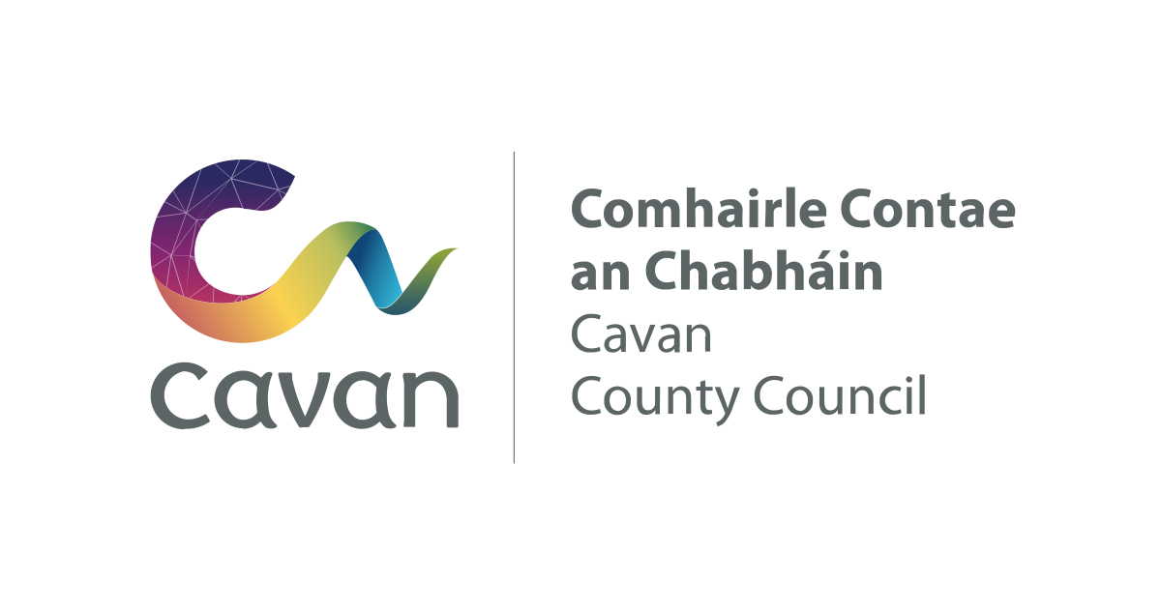
Who we are and why do we require your information?
Cavan County Council (Council) is the data controller for personal data processed in connection with the preparation, maintenance, and administration of the Register of Electors for County Cavan. This notice explains what information we collect, why we use it, who we share it with, how long we keep it and your data protection rights.

Why do we have a privacy statement?
The Council (Data Controller) has created this privacy statement to demonstrate our firm commitment to privacy and transparency and to describe in clear terms, the personal data that the Register of Electors administrative process collects about individuals, why it is needed, the legal basis, how it is used and how individuals may interact with the Council in relation to their personal data and the Register of Electors administrative process. It outlines the rights of individuals under data protection legislation.
We are committed to processing personal data lawfully, fairly, and transparently, using it only for specified electoral purposes, limiting it to what is necessary, keeping it accurate and secure, and retaining it only for as long as required.

What information and categories of personal data do we collect in relation to the Register of Electors:
- Name (First & Last)
- Address including Eircode (current and previous)
- Date of Birth
- Nationality (and previously nationality if changed)
- Contact details (email and/or telephone)
Personal Public Service Number (PPSN).
Where do we obtain your personal data?
- From you directly
- From a person authorised to act on your behalf
- Another local authority

How we use this information:
The personal data provided to us is used for the following specific purpose:
- To compile, maintain and publish an accurate and up-to-date Register of Electors (statutory register of persons eligible to vote at Local, National, European and Presidential Elections, and at referenda)
- To determine and record an individual’s eligibility to vote, including electoral category and voting entitlements.
- To allow individuals to register as new voters
- To allow individuals to check their electoral details
- To allow individuals to update or correct their electoral details, including changes of address and citizenship
- To support identity verification and register integrity checks, including the prevention of duplicate or inaccurate registrations.
- To administer associated electoral processes, including the preparation of electoral lists and the issue of polling cards
- To enable secure and efficient electoral processes.

The published Register of Electors contains name, address and Eircode only, as required by law. All other personal data (including PPSN, date of birth and contact details) is not published and is use solely for administrative, verification and integrity purposes in accordance with electoral legislation and data protection law.

What is our lawful basis for processing your Personal Data?
Cavan County Council processes personal data relating to the Register of Electors in accordance with the General Data Protection Regulation (GDPR) and applicable Irish law. The lawful basis relied upon for the processing of personal data are:
Article 6(1)(c) GDPR: Processing is necessary for compliance with a legal obligation to which Cavan County Council is subject.
Article 6(1)(e) GDPR: Processing is necessary for the performance of a task carried out in the public interest or in the exercise of official authority vested in Cavan County Council. Personal data relating to the Register of Electors is processed in accordance with Cavan County Council’s statutory obligations under the following legislation:
Electoral Act 1992 (as amended), Electoral Reform Act 2022, Juries Act 1976.

Who might we share your personal data with?
Personal data may be shared with:
- Other local authorities – where a change of address is to an area outside the County, relevant application details may be shared with the appropriate local authority to update the Register of Electors.
- Department of Social Protection – for identity verification purposes.
- Elected Representatives – (Councillors, TDs, MEPs and Senators) and political parties – only information published in the Register of Electors, as required under the Electoral Reform Act 2022.
- County Registrar and Election Returning Officer – only information published in the Register of Electors, as required under the Electoral Reform Act 2022.
- Courts Service – only information published in the Register of Electors, as required un the Juries Act 1976.
- An Post – for the purposes of issuing An Litir Thoghcháin (polling card), using information published in the Register of Electors, in accordance with electoral legislation.
Where personal data is shared externally, Cavan County Council ensures that appropriate safeguards are in place, such as contracts, memoranda or understanding or information-sharing agreements, to comply with data protection legislation.

We may share your data with the following categories of third parties (where relevant):-
- IT service providers and software providers
- Legal and professional advisors
- Government departments and statutory bodies
- Regulatory or law enforcement authorities (where required by law)
- The Local Government Management Agency (LGMA) supports and administers Electoral Management System used by local authorities to manage and maintain the Register of Electors

International Transfer
The Council does not routinely transfer personal data processed for Register of Electors purposes outside the European Economic Area.

How do we protect your information?
The Council will implement the appropriate organisation and technical measures to safeguard and protect your personal data, both paper and electronic formats, and we will only make it available to those who have a right to access the data.

Examples of security measures include:
- encryption, meaning that information is hidden so that it cannot be read without special knowledge (such as a password). This is done with a secret code or what’s called a ‘cypher’. The hidden information is said to then be ‘encrypted’,
- pseudonymisation, meaning that we’ll use a different name, so we can hide parts of your personal information from view. This means that someone outside of the Council could work on your information for us without ever knowing it was yours,
- controlling access to systems and networks allows us to stop people who are not allowed to view your personal information from getting access to it,
- controlling access to office buildings and to the filing and storage facilities,
- staff training and awareness programmes ensure staff are clear and competent in safeguarding the personal data they use to create and maintain the register of electors.
- Regular testing of our technology and ways of working including keeping up to date on the latest security updates (commonly called patches).

Register of Electors Retention Policy
- The information supplied for inclusion on the Electoral Register will be retained on the voter.ie system for as long as you remain on the Register.
- The original application (online or paper) will be retained until after elections and at a maximum for 5 years. Note: Voter.ie has replaced the iReg system and the reason for retaining applications is that on election day when the public query their vote, we have back up as to why they were either added, deleted and change of address.

Your Data Protection Rights
Depending on the circumstances and the legal basis for processing, you may have the right to:
- request access to personal data held about you;
- request the correction of inaccurate or incomplete information;
- request the restriction of processing in certain circumstances;
- object to processing carried out in the public interest or in the exercise of official authority; and
- request the erasure of information where there is no lawful basis for its continued retention.
Some of these rights may be restricted where the Council is legally required to process or retain information for electoral purposes. Each request will be considered in accordance with data protection and electoral legislation.
To exercise your rights, contact the Register of Electors Section or the Data Protection Officer using the contact details below.

Contact Details:
Register of Electors Section
Postal Address: Register of Electors, The Courthouse, Farnham Street, Cavan
Tel. 049 4378300
Email: register@cavancoco.ie

Data Protection Officer
Postal Address: Johnston Central Library, Farnham Street, Cavan
Tel. 049 4378300
Email: dpo@cavancoco.ie

How to make a complaint: If you believe that we have not processed your personal data in accordance with applicable data protection legislation, you have a right to lodge a complaint with a supervisory authority (including the Data Protection Commission, contact details below) as well as a right to seek a judicial remedy.

Data Protection Commissioner:
Email: info@dataprotection.ie
Website: www.dataprotection.ie

