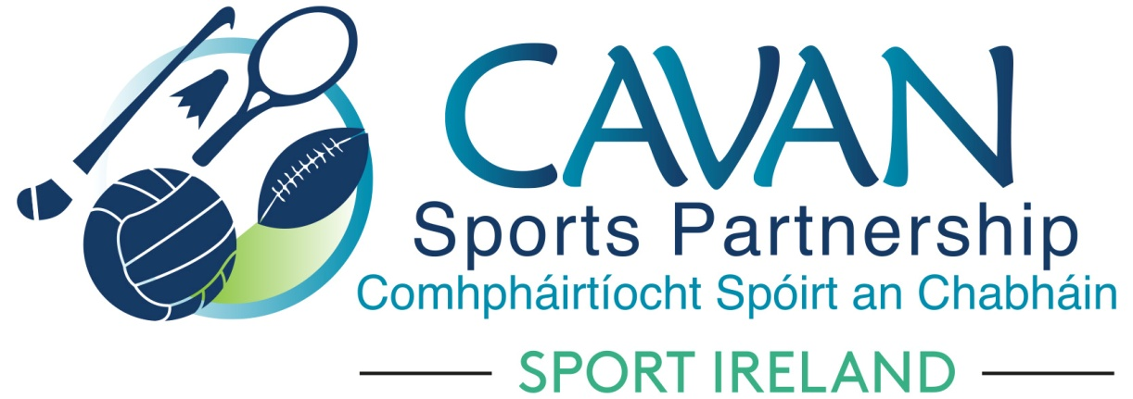
Date of Meeting: 23rd Feb 2023 |  | Venue: Board Room, Hotel Kilmore
Present: John Donohoe, Monica McCrory, Maureen McIntyre (Online), Enda O’Reilly, Pamela Carney, Brian Donohoe, Martin Cahill, Noel O’Gorman, Cllr Madeline Argue, Cllr. Paddy McDonald, Cllr. Brendan Fay
Apologies: Larry McQuaid, Pat McEnroe, Cllr. Patricia Walsh
In Attendance: Nadine McCormilla, Regina Duffy
Agenda Item | Discussion / Action
1. Welcome
Cllr Brendan Fay welcomed everyone to meeting.
Cllr Brendan Fay also extended a warm welcome to Martin Cahill to his first CSP Board Meeting.
Cllr Brendan Fay requested a “Get Well” wishes card to be sent to Liam McCabe.
2. Conflicts of Interest/Loyalty
None
3. Correspondence
Correspondence from Sport Ireland regarding Sport Ireland 2023 Core Allocation: Nadine outlined it:
Chairperson Cllr Brendan Fay and Cavan County Council representative John Donohoe to sign this on behalf of CSP Board

4. Matters arising and adoption of minutes of board meetings 23rd Feb 2023
None
Proposed: Cllr Paddy McDonald
Seconded: Pamela Carney

5. CSP Operational Plan | Nadine outlined programmes contained with CSP Operational Plan 2023 as per attached powerpoint presentation
6. CSP Sub Committee’s Update | (A) Finance & grant sub committee (Chairperson: John Donohoe)  The sub committee had a meeting in Hotel Kilmore 10am on 23rd Feb 23.  Nadine gave an overview of the subcommittee meeting:  CSP Financial Report as of 15/02/2023:  - Total income: €25,377  - Total expenditure: €92,470.85  SI core grant allocation 2023: €291,267. Nadine explained reasons for Deferred Income  CSP Sports Club grant scheme 2023:  - Total fund €31,000  - Clubs have 4 options to apply under  - Club Development Grant  - Participation Grant with 3 strands – (i) Cycling (ii) Women in Sport (iii) Inclusion Camps  - Equipment Grant  - Training Grant  Upcoming Grant schemes  - Dormant Accounts funding 2023 (Deadline 11th April 2023)  - Sport Ireland Evaluation grant scheme 2023 (Deadline 14th April 2023)  (B) Inclusion Sub Committee (Chairperson: Pamela Carney)  The subcommittee had an online meeting 15th February 2023  - Update of programmes was given by Regina.  - FAI delivering a Football For All workshop for coaches in Bailieborough on March 7th  - Cavan Sports Partnership continue to work towards achieving the CARA Bronze Xcessible award  - CSP Club Grant Scheme 2023: Strand to apply for Inclusion Camps  (C) Schools Sub Committee (Chairperson Brian Donohoe)  Brian gave an overview of:  - Programmes occurring in Pre, Primary and secondary Schools  - Action proposed: to complete a Primary and Secondary School Calendar for physical activity and sporting events.  - Community Coaching Programme: Aim to have more CSP coaches available to deliver school programmes.  - Athletics funding: to be used to train community coaches to deliver athletics programmes. To support primary school track field events. To create plans for school sports hall athletics for sept-dec blocks  - Dormant Account Funding 2023: This funding application will be open and suggestions will be required from subcommittee  (D) Sports Forum Sub Committee  Pat updated:  (GET UPDATE FROM MORNA)
7. Governance | Board Members Effectiveness Review  Review continuing.  Sub committee members from CSP Board to be reviewed during 2023.
8. Communications Support 2023 | Nadine outlined the process of appointment of additional Communications Support for CSP.  This will be finalised and Board briefed of new appointed Communications Support by next CSP Board meeting.  Additional financial support will be available from Sport Ireland for this.
9.AOB | Nadine outlined Sport Ireland statement of ambition and the future of the LSP’s (launch 2nd March)  Three new officers for each LSP (fully funded for 5 years):  - Physical activity for health officer (DOH)  - European Social fund  - Outdoor recreation (DRCO)  Slieve Rusheen Project:  Pamela outlined that CCLD has been approached by Mannock through Innovating Communities regarding the development of this site. They are inviting communities to put forward ideas/projects as part of a wider application. They were looking at walking/cycling tracks, water activities, zip lining and other outdoor activities. Details to be forwarded to Morna O’Hanlon, CSP Outdoor Development Officer  4 Day All Star Easter Camp in the dome at Killygarry  Pamela outlined that the Health and Wellbeing Committee of Cavan County GAA Board are hosting a 4 day camp and expression of interest has gone out to all clubs looking for volunteers/SNAs to help run the Camp
10. Date of Next meeting | Move date of next CSP Meeting from 9th May forward to 28th March with earlier start time of 10.15am.  Sub Committee’s to meet in person before Main Board Meeting in March.

