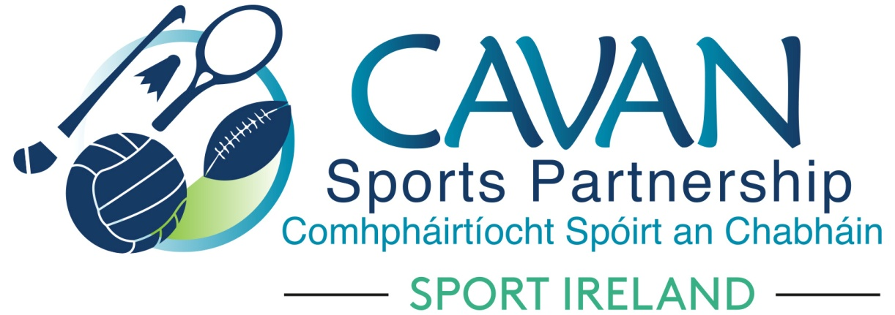
Date of Meeting: 6th Dec 2022 |  | Venue: Board Room, Hotel Kilmore
Present: John Donohoe, Monica McCrory, Maureen McIntyre, Enda O’Reilly, Pamela Carney, Larry McQuaid, Pat McEnroe, Noel O’Gorman, Cllr. Patricia Walsh, Cllr Madeline Argue, Cllr. Paddy McDonald, Cllr. Brendan Fay
Apologies: Brian Donohoe, Lisa Clerkin, Liam McCabe, Cllr Craig Lovett
In Attendance: Nadine Mc Cormilla, Regina Duffy, Dean McElroy, Morna O’Hanlon
Agenda Item | Discussion / Action
1. Welcome
Cllr Brendan Fay welcomed everyone to meeting.
Cllr Brendan Fay also extended a warm welcome to Monica McCrory and Morna O’Hanlon to their first CSP Board Meeting.
2. Conflicts of Interest/Loyalty
None
3. Correspondence
Correspondence from Sport Ireland regarding Sport Ireland Strategic Plan: Nadine outlined it:
One overall strategic plan with several ambitions, one of which will be for Local Sports Partnerships.
As part of the National Sports Policy, Cavan County Council are tasked with development of a Local Sports Plan. CSP will support Cavan Co.Co. in the development of this plan.
Policy actions within these documents will steer the development of CSP Strategic Plan 2023 to 2028.

4. Matters arising and adoption of minutes of board meetings 11th October 2022
None
Proposed: Cllr Patricia Walsh
Seconded: Pamela Carney
5. CSP Sub Committee’s Update | (A) Finance & grant sub committee (Chairperson: John Donohoe)  The sub committee had a meeting in Hotel Kilmore 10am.  Nadine gave an overview of the sub committee meeting:  CSP Financial Report as of 30/11/2022:  - Total income: €818,491 (includes DAF 2022 of €119,900)  - Total expenditure: €461,598  Key dates for funding:  Letters of Allocation for Core 2023 and Covid-19 restart fund will be 16th December.  Covid Restart Fund 2022:  Thanks to the stakeholders who forwarded applications under this fund. €57,563 has been applied for. Spend will need to be by end of quarter 1. Dean McElroy will be the lead officer for administration of these grants.  (B) Inclusion Sub Committee (Chairperson: Pamela Carney)  The sub committee had an online meeting 29th November,  - Update of 2022 programmes was given by Pamela Carney.  - Chairperson Cllr Brendan Fay signed a letter of commitment to the CARA Xccessible Programme  (C) Schools Sub Committee (Chairperson Brian Donohoe)  Aisling Maguire has taken over the Role of CSDO and will be secretary to the schools sub committee.  (D) Sports Forum Sub Committee  Morna O’Hanlon will be secretary to this sub committee.  Main aim of this sub committee will be to develop relationships between clubs and development officers.
6. Governance | Board Members Effectiveness Review 2022  Nadine encouraged all board members to complete the circulated survey and thanked those who had already completed it.  Nadine outlined some of the comments which were submitted.  A physical session will also take place in 1st quarter of 2023.  This is good time to complete this review as CSP Strategic Plan 2023 – 2028 needs to be completed.  Strategic Plan 2023 – 2028  Proposal to Board: To delay commencing the process of CSP Strategic Plan 2023 – 2028 until Sport Ireland launch their Strategic Plan and more knowledge is received of the Local Authority ‘Local Sports Plans’. Both of these documents will have a direct impact on the CSP strategic plan.  Proposed: Noel O’Gorman  Seconded: Cllr Patricia Walsh
7. CSP Annual Report 2021 | Dean presented to Board  - key findings of the 2021 Annual Report  CSP annual report 2021 adopted.  Proposed: Cllr. Madeline Argue  Seconded: Cllr. Paddy Mc Donald
8.AOB | Communications  Following discussion from previous Board Meeting, Nadine proposed the following to the Board:  - CSP to seek part time external support for Communications  - Budget required from CSP reserves is €6,000  Proposed: Enda O’Reilly  Seconded: Pat McEnroe  NGB Partnership  Nadine outlined that discussions are ongoing with the following NGB’s to get dedicated resources to County Cavan.  - Basketball Ireland  - Badminton Ireland  - Swim Ireland.
Date of Next meeting | 2023 Board Meeting Dates:  - Tues 21st Feb 2023  - Tues 9th May 2023  - Tues 3rd Oct 2023  - Tues 5th Dec 2023  Dates subject to change pending Sport Ireland deadlines.  The board requested the option to have blended meetings to be explored for 2023.

