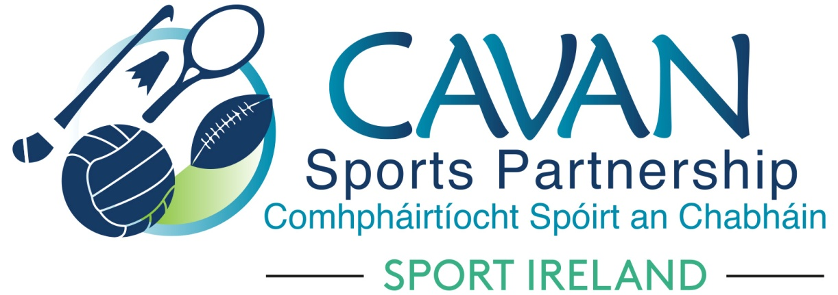
Date of Meeting: 11th Oct 2022 |  | Venue: Board Room, Hotel Kilmore
Present: Maureen McIntyre, Enda O’Reilly, Pamela Carney, Brian Donohoe, Larry McQuaid, Pat McEnroe, Cllr. Patricia Walsh, Cllr. Paddy McDonald, Cllr. Brendan Fay
Apologies: John Donohoe, Monica McCrory, Lisa Clerkin, Liam McCabe, Noel O’Gorman, Cllr Madeline Argue, Cllr Craig Lovett
In Attendance: Nadine Mc Cormilla, Regina Duffy, Dean McElroy, Aisling Maguire
Agenda Item | Discussion / Action
1. Welcome
Cllr Brendan Fay welcomed everyone to meeting.
2. Conflicts of Interest/Loyalty
None

3. Matters arising and adoption of minutes of board meetings 11th May 2022
None
Proposed: Cllr Paddy McDonald
Seconded: Larry McQuaid

4. Election of Chairperson | Cllr Brendan Fay elected as Chairperson  Proposed: Cllr Patricia Walsh  Seconded: Cllr Paddy McDonald  Pamela Carney elected as Vice Chairperson  Proposed: Cllr Patricia Walsh  Seconded: Cllr Brendan Fay  Cllr Brendan Fay welcomed Maureen McIntyre to the Board (replaces John Kearney)  Cllr Brendan Fay advised that Monica McCrory has replaced Colm Casey as HSE representative on Board.  Cllr Brendan Fay acknowledged and thanked Colm Casey’s valuable contribution to CSP Board.
5. CSP Sub Committee’s Update | Finance & grant sub committee ( Chairperson: John Donohoe)  The sub committee had a meeting in Hotel Kilmore 10am.  Nadine outlined sub committee’s meeting to board:  - CSP Financial Report as of 31/08/2022  Total Income: €597,821  Total Expenditure: €311,601  - Grant Scheme Update:  There are 60 out of 97 Grant Reports submitted.  Closing date 30th October 2022  - Sport Ireland has confirmed funding reallocation of €30,000 from 2021 Covid 19 Small Grant Scheme to NGB Partnership with Basketball & Badminton  - Covid Restart 2022 Funding Application is open with closing date 28th Oct 2022. Opportunity for Board Partners to access funding. Funding will be allocated in Dec 2022 with spend date by Quarter 1. Funding can be accessed under Area 3: Resumption of Sport & Physical Activity  - Sport Ireland Core Funding Application 2023 was presented by Nadine  Proposed: Pamela Carney  Seconded: Brian Donohoe
6. Governance | Annual Assurance Statement & Compliance Record Form Nov 2021  The compliance record form had been circulated to board members prior to the meeting. Nadine outlined to the board that as part of the governance protocols, the board are required to review our compliance form and sign an assurance statement to accompany the CORE application each year.  CSP formally adopted the governance code on 21st November 2021 and board members were satisfied that the compliance form remained the same on 11th October 2022. The annual assurance statement was signed by the Chairperson to accompany the CORE 2023 budget submission.
7. CSP Annual Report 2021 (Draft) | Nadine thanked Dean for compiling the Annual Report.  Each Board Member to read and send comments before next board meeting  Dean will present the key findings from Annual Report at next board meeting
8. Staff Presentations | Nadine informed the board that Aisling Maguire had formally taken up the role of Community Sports Development Officer. The role of Sports hub development officer is now vacant and Nadine will work with HR in Cavan Co.Co. on filling this role.  Dean ( SSDO/SIDO) and Aisling ( CSDO) presented to their operational plan updates to the board.
9.AOB | CSP Tutor Fees  Due to the rising cost of living Nadine proposed to increase the hourly Tutor Fee to €55 and Coach Fee to €35. This is the first rise since CSP inception in 2008.  Proposed: Pat McEnroe  Seconded: Larry McQuaid  Board review process  Cllr Brendan Faye informed the board that the annual board effectiveness review will be discussed at the next board meeting.
Date of Next meeting | 6th Dec in Hotel Kilmore Board Room at 11am

