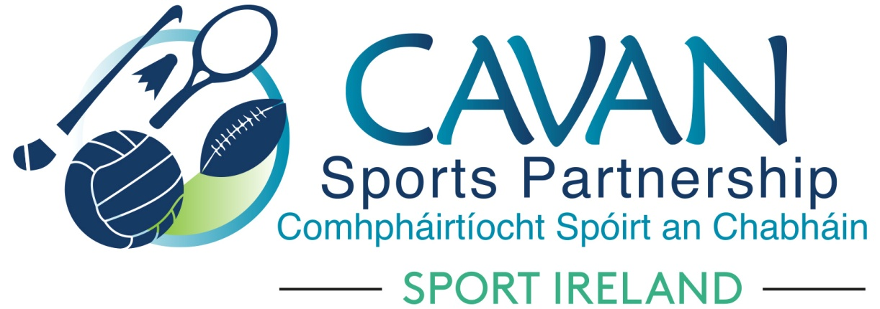
Date of Meeting: 11th May 2022 |  | Venue: Online Zoom Meeting
Present: John Donohoe, Cllr Brendan Fay, Cllr Patricia Walsh, Larry McQuaid, Lisa Clerkin, Colm Casey, Cllr Paddy McDonald, Pamela Carney, Noel O’Gorman, Liam McCabe, Cllr Craig Lovett
Apologies: Enda O Reilly, Pat McEnroe, Ronan Molloy
In Attendance: Nadine Mc Cormilla, Regina Duffy
Agenda Item | Discussion / Action
1. Welcome
Cllr Brendan Fay welcomed everyone to meeting..
2. Conflicts of Interest/Loyalty
None

3. Matters arising and adoption of minutes of board meetings 1st Feb 2022 and 4th April 2022
None
Proposed: John Donohoe
Seconded: Cllr Brendan Fay

3. Sub committees update | Finance & grant sub committee ( Chairperson: John Donohoe)  The sub committee had a meeting via zoom on 5th May 2022.  John Donohoe outlined sub committee’s meeting to board:  - Update given on 2022 Club Grant Scheme  - Update given on Mid Year Reporting for Dormant Account Funding 2021  - CSP Financial Report  Action: to approve the following:  - Final figures for Income, Expenditure and Deferred income of 2021 as per attached powerpoint presentation  - €14,980 to be moved to Capitalisation to cover €11,000 salary contingency and €3,980 programme reserves  - 2022 income and expenditure figures dated 28th April 2022 as per attached powerpoint presentation (Note AFS complete therefore Deferred income has been carried over)  Proposed: Colm Casey  Seconded: Pamela Carney  Inclusion Sub Committee (Chairperson: Pamela Carney):  The sub committee had a meeting via zoom  Pamela Carney outlined sub committee’s meeting to board:  - Full breakdown of current programmes was given  Schools Sub Committee (Chairperson: Brian Donohoe):  The following was outlined from sub committee’s meeting to board  - Full breakdown of current programmes occurring in primary, secondary schools & 3rd level.  - Upcoming initiatives for September 2022  - Current challenges – a) Lack of coaches b) Teacher Training: Poor uptake for Gymnastics Teacher Training
5. Governance | Sport Ireland extension to Heads of Agreement:  Letter requesting an extension for one year (from 15th January 2022 to 15th January 2023) to the current Heads of Agreement between Cavan LSP and Sport Ireland was shared by Nadine as shown on attached power point presentation.  This is to allow time for Sport Ireland to complete a Strategy for the Local Sports Partnerships.  Lobbying Act 2015  John Donohoe outlined the boards obligations under the Lobbying Act 2015. The following was agreed:  “that the committee will comply with the Transparency code of the Public Lobbying Act 2015. This will be done by regular circulation of minutes and the agenda of committee working groups / task force meetings on the Council website. The website will also detail membership and terms of reference of the committee.”
4. A.O.B. | Nadine requested the following:  Action: To use a portion of the balance of Sport Ireland Covid Restart Fund 2021 (subject to Sport Ireland approval) to fund Discretionary Grants Scheme for Community Groups delivering physical activity for Ukrainians  Proposed: Pamela Carney  Seconded: John Donohoe
Date of next meeting | Tuesday 20th September 11am Council Chamber, Courthouse, Cavan.

