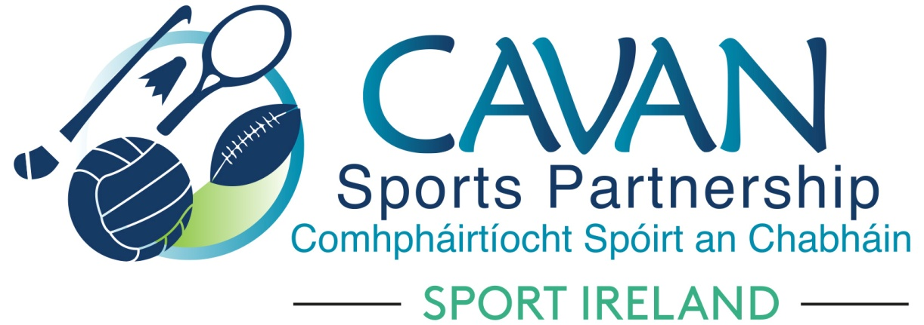
Date of Meeting: 4th April 2022 |  | Venue: Online Zoom Meeting
Present: John Donohoe, Cllr Madeline Argue, Cllr Brendan Fay, Cllr Patricia Walsh, Larry McQuaid, Pat Mc Enroe
Apologies: Enda O Reilly
In Attendance: Nadine Mc Cormilla
Agenda Item | Discussion / Action
1. Welcome
As John Kearny has left his position as CE of CMETB, Cllr Brendan Fay acted in the role as Chairperson.
2. Conflicts of Interest/Loyalty
The following were declared throughout the meeting
John Donohoe : Treasurer of St. Felims community games and member of Lacken Healthy Club Committee
Pat Mc Enroe: Treasurer of Cavan golf club

3. CSP sports club grant scheme – Grant sub committees | Finance & grant sub committee ( Chairperson: John Donohoe)  The sub committee had a meeting via zoom at 10am on 4th April 2022.  Nadine outlined what was discussed:  2022 CSP Sports club grant scheme: John Donohoe informed the board that the sub committee members received the grant scheme master and summary sheets prior to the board meeting. Nadine gave a presentation outline to the board under each grant scheme heading. Nadine discussed the Covid restart grant underspend of €38,200 and the proposals submitted to Sport Ireland for this. Nadine will update the board on the outcome of this. The €25,000 fund allocated by SI for the 2022 sports club grant scheme has been spent under this fund.  Cllr Madeline Argue and Cllr Patricia Walsh complemented CSP on the grant scheme and the work undertaken.  CSP grant scheme approved by the board:  Proposed: Cllr. Madeline Argue Seconded : Cllr. Patricia Walsh
4. A.O.B. | Cllr Brendan Fay enquired about coaches/ tutors for schools as part of active schools week. Nadine informed the board that CSP have received numerous requests from schools for tutors/coaches and that there was a shortage of active tutors post covid.
Date of next meeting | Tuesday May 10th time to be confirmed.

