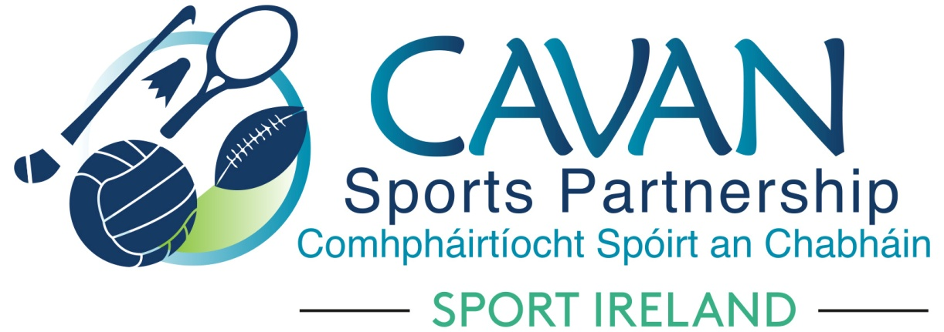
Date of Meeting: 1st Feb 2022 |  | Venue: Online Zoom Meeting
Present: John Kearney, Enda O’Reilly, John Donohoe, Cllr Brendan Fay, Cllr Patricia Walsh, Cllr Paddy McDonald, Cllr Craig Lovett, Pat Mc Enroe, Noel O’Gorman, Lisa Clerkin, Colm Casey
Apologies: Cllr Madeline Argue, Larry McQuaid, Brian Donohoe, John Donohoe
In Attendance: Nadine Mc Cormilla
Agenda Item | Discussion / Action
1. Welcome
John Kearny Chairperson welcomed everyone to the meeting
2. Conflicts of Interest/Loyalty
2. Conflicts of Interest/Loyalty
The following were declared throughout the meeting
Pamela Carney : Member of Kildallan GAA
2 (b). Adoption of Previous Board Minutes
Proposed: Cllr Brendan Fay
Seconded: Cllr Paddy McDonald

Matter Arising: None

3. CSP Sub Committee’s Update | - Finance & grant sub-committee (Chairperson: John Donohoe)  The sub committee had a meeting via zoom on 31st January 2022.  Nadine outlined what was discussed:  2021 Sport Ireland End of Year Budget Report:  Total Expenditure in code 45100019 = €377,611 and Total income in code 45100019 = €1,003,254. This report requests reporting on all income sources but only SI expenditure. This was Proposed by Cllr Brendan Fay, Seconded by Lisa Clerkin  Nadine explained that Cavan County Council AFS was not completed until end of March. Therefore a detailed final finance breakdown for 2021 will be presented at May meeting including carryover and capitalisation.  Funding Applications Update:  - Sport Ireland Core grant allocation 2022 = €285,781. This allocation is the highest to date.  - Sport Ireland COVID 2021 Support Fund = €107,951  (Breakdown Covid 19 Small Grants Scheme €76,000, Grassroots Restart Fund Programme €9,490, Sports Capital €22,461)  Update on CSP 2021 Grant Scheme:  7 Clubs remaining to drawdown this grant scheme. Continued support from Development Officers will be given to these clubs to finalise this drawdown.  Update on CSP 2022 Grant Scheme:  Total fund available to Clubs and Community groups who deliver activity is €96,500. This is accumulated by the following funding sources:  - Sport Ireland Core allocation to Club Grant Scheme  - Sport Ireland COVID 2021 Support Fund  - Sport Ireland COVID 2020 Community Support Fund for indoors and Women in Sport (Balance remaining from €25,000)  - Sport Ireland Core allocation to communications  - Dormant Account Funding allocation to Training and Education  - Dormant Account Funding allocation to Hubs to support local clubs  - InspirHER fund  - HSE Otago Fund  Nadine outlined the criteria for the 2022 Grant Application form and Guidelines. Final versions will be circulated to Finance and Grant Sub Committee, with their recommendations then to full Board. Proposed launch date has been forward to 28th February due to Cavan County Council current Community Grant Scheme.  - Inclusion Sub Committee (Chairperson: Pamela Carney)  The sub committee had a meeting via zoom on 27th January 2022.  Pamela outlined what was discussed:  Inclusion Mission Statement:  Pamela explained that CSP are on a journey to achieve Xcessible Bronze Award. A requirement to achieve this is that CSP Board must adopt CSP Inclusion Mission Statement. Statement was read and discussed.  Proposed Cllr Patricia Walsh  Seconded John Kearney  CSP Club/Community Grant Scheme  Pamela outlined examples from inclusive projects from 2021 applicants. Pamela suggested sharing this information directly with both Cavan Disability Network and Cavan PPN.  Update on Sports Inclusion Programmes:  Pamela outlined the following programmes:  - 6 week Online Martial Arts programme for services running with 66 participants from 5 services  - IWA Multi- Sport Club to launch in Stradone on February 8th for children with a physical disability  - Disability Awareness in Sport Online workshop taking place February 15th at 7pm  - IWA Sit N Fit programme taking place at Mullagh Sports Centre on Wednesday with both Cavan and Navan IWA taking part.  - Schools Sub Committee  The subcommittee was unable to meet before this meeting.  Enda O’Reilly advised that Rounders Foundation Training Course was organised and that a blitz day will be held at Cavan Institute.
4. CSP Operational Plan 2022 | CSP Operational Plan 2022 was sent to Board Members before this meeting. Nadine gave an overview of Actions Areas’s.
5.Governance | Conflicts of Interest  This item to be included at beginning of Agenda.  Board was asked if there were any Conflicts of Interest: Pamela Carney advised that she would withdraw in any discussion in relation to Sports Clubs Grants.  Health & Safety:  Risk Assessment for Cavan Sports Partnership has been updated and sent to Cavan County Council Health & Safety Officer. Nadine advised that a request will be sent to Cavan County Council Health & Safety Officer to join the Governance Sub Committee.
A.O.B | None
Date of next meeting | Tuesday May 10th at 4pm (Physical Meeting)  Tuesday July 19th / Tuesday 20th September  Tuesday Dec 6th  Dates could change as a result of requirements from Sport Ireland

