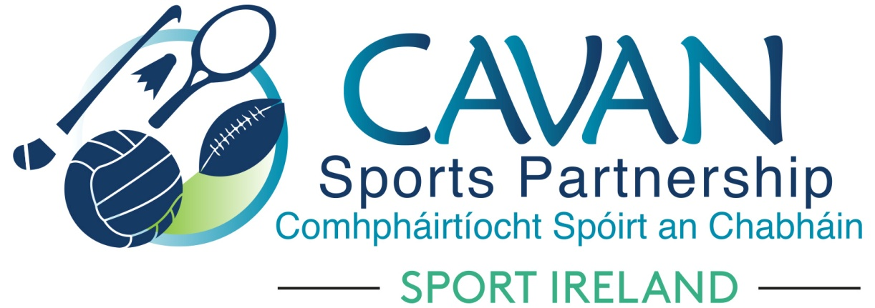
Date of Meeting: 30th Nov 2021 |  | Venue: Online Zoom Meeting
Present: Colm Casey, Pamela Carney, Cllr Paddy McDonald, John Donohoe, Cllr Madeline Argue, Noel O’Gorman, Cllr Brendan Fay, Brian Donohoe, Lisa Clerkin, Enda O’Reilly, Liam McCabe, Cllr Patricia Walsh, Larry McQuaid, John Kearney
Apologies: Pat McEnroe
In Attendance: Nadine Mc Cormilla, Regina Duffy, Aine O’Reilly, Dean McElroy
Agenda Item | Discussion / Action
1. Welcome
John Kearney Chairperson welcomed everyone to the meeting.
2. Matters arising from previous meeting
None
Minutes of previous Board Meeting
The minutes of the previous board meeting were adopted.
Proposed: Pamela Carney Seconded: Cllr Paddy McDonald
3.Sub Committees Update | Finance Sub Committee Meeting  Sub Committee had meeting on 30th November via zoom.  Nadine outlined what was discussed:  - 2021 Club Grant Scheme Update : Closing date was 5pm 30th Nov 2021. 6 Clubs requested extension of time to submit their documentation. It was proposed that Clubs cannot apply for 2022 Club Grant Scheme if they have outstanding documentation to submit for 2021 Club Grant Scheme. Any outstanding amount not drawn down will go forward into 2022 Club Grant Scheme: Proposed: John Donohoe Seconded Cllr Brendan Fay  - Finance Update : Total Income as of 29th Nov 2021 : €731,374.34 (€253,901.34 Deferred Income, €123,331 DAF 2021, €23,450) Participant Income). Total expenditure as of 29th Nov 2021 : €359,832  - Funding Applications Update: The following funding was applied under the SI Covid 2021 Covid Support:  A) Capital Funding Scheme €22,400 from Department of Tourism, Culture, Arts, Gaeltacht, Sport & Media – Must show evidence that expenditure has hit accounts by 31st December 2021.  B) Small Club Grant Scheme €82,000 – Only clubs and community groups that are not affiliated to NGB’s can apply.  C) Grassroots funds for three partnership projects – a) Athletics €4,500, b) Inclusion hockey €2,800, c) Camogie €4,000.  Dormant account funding 2022 application due 6th December (deadline extended because of COVID support fund)
4. Governance Code | Nadine outlined the final steps for CSP governance compliance that needed to be submitted to Sport Ireland.  - Update and approve CSP Board Handbook – Nadine presented the Board Handbook (attached) and outlined the changes in yellow:  - Role of Coordinator  - Role of CSP Staff  - To Review CSP Board Handbook every 3 years and a Policy Schedule implemented to monitor this  - How Board Meetings to be hosted – Virtually and Physical  - Procedure for Board Members regarding declaration of Conflicts of Interest and gifts/benefits  - Appendix attachment updated – “Conflicts of Interest & Conflicts of Loyalty Policy.  Discussion arose and the following are noted:  Governance Sub Committee to be established in 2022.  That one board meeting per year be hosted at a venue which has gained from funding through CSP.( P.Carney)  That Conflicts of Interest be a fixed item on all CSP Board Meetings going forward. ( J.Kearny)  Proposal: Additions to be added to Revised Board Handbook  Proposed: Brian Donohoe Seconded: Liam McCabe  Proposal: Approval of Appendix: Conflicts of Interest and Conflicts of Loyalty Policy  Proposed : Cllr Patricia Walsh Seconded: Noel O’Gorman  - Nadine presented the compliance record form and a discussion on actions within took place.  - Explain forms: Nadine presented the explain forms to the board and outlined the rationale for non compliance with these actions.  - Nadine presented the public statement of compliance to the board.  Action: John Kearney Chairperson to sign the Public Statement of Compliance on behalf of the CSP Board.  Signed Public Statement of compliance and explain forms to be submitted to Sport Ireland.
- CSP Staff Presentation | Dean McElroy and Aine O’Reilly outlined their highlights for 2021.  Nadine informed the board that the new Programmes officer, Brian O Donnell would take up position on December 14th.  Power point presentation attached.
6. AOB | Nadine outlined that Operation Transformation Programme will be filmed from Mullagh Activity Hub.
Date of next meeting | Tuesday 1st Feb at 11am via zoom.

