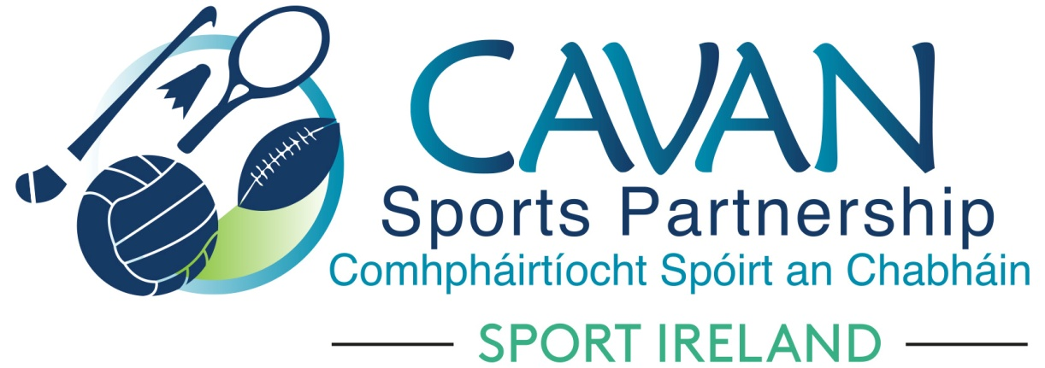
Date of Meeting: 28th Sept 2021 at 4pm |  | Venue: Online Zoom Meeting
Present: Pat McEnroe, Colm Casey, Pamela Carney, Cllr Paddy McDonald, John Donohoe, Enda O’Reilly, Cllr Madeline Argue, Noel O’Gorman, Cllr Brendan Fay, Brian Donohoe, Lisa Clerkin, Enda O’Reilly, Liam McCabe
Apologies: Cllr Patricia Walsh, John Kearney, Larry McQuaid
In Attendance: Nadine Mc Cormilla, Regina Duffy,
Agenda Item | Discussion / Action
1. Welcome
In the absence of the Chairperson, Vice Chairperson Cllr Brendan Fay welcomed everyone to the meeting.
2. Matters arising from previous meeting
None
Minutes of previous Board Meeting
The minutes of the previous board meeting were adopted.
Proposed: Cllr Madeline Argue Seconded: Cllr Paddy McDonald
3.Sub Committees Update | Sports Inclusion Sub Committee Meeting  Sub Committee had meeting on 27th September via zoom.  Pamela Carney outlined what was discussed:  - Dormant Accounts Sports Inclusion Capital fund : Ramor Water Sports Club accessible boat and Living Water Equestrian Centre Cootehill, Cavan Leisure Centre Hoist  - Sport Ireland Core programme for 2022 funding : Inclusive Golf programme for children and Archery for Adults  - Update on current and upcoming programmes  Schools Sub Committee Update  Sub Committee me on Monday 27th September.  Pamela Carney updated the board of items discussed.  - Pre-School: Development of ‘Fun Moves’ initiative.  - Primary Schools: Focus on Gymnastics and Athletics for 2022 with continued expansion of Orienteering. Funding deferred from 2021 for Gymnastics and Athletics to be delivered in schools. Funding for Teacher Training to be sourced via Dormant accounts Training and Education Strand.  - Secondary Schools: Focus on minority sport development – Boxing, Rounders. Funding to be sourced via Sport Ireland Core funding for participation programmes and Dormant Account Training and Education Fund. Strength and Conditioning workshops to be delivered for tutors and teachers – funding to be sourced via Dormant Accounts.  - Third Level: Secondary school participation programme (Rounders) to feed into Third level annual Blitz.  - Inclusion – Traveller girls/Youthreach funding to be sourced via Sport Oreland core funding to provide physical activity participation opportunities.  Finance and Grant Sub Committee Report presented by Nadine (John Donohoe had technical issues)  - Sport Ireland Core Grant Application:  Nadine presented table below. Once notification of funding is received a full breakdown will be presented to the Board in Q1 2022. 2022 Core Programme Funding application is down from last year as deferred programme funding is being carried over due to constraints from Covid 19 to deliver all programmes during 2021. Dormant Account Funding estimate for 2022 has increased.  Sport Ireland CORE 2022 application  Dormant account 2022 application  - Dormant Account Funding 2022 Application – Nadine outlined that 7 Community Groups went through the Expression of Interest process with S3 Consultants. The following is the outcome/recommendations of this process:  The Grant Sub Committee has proposed the following to go forward for funding under DAF 2022  Proposed Cllr Madeline Argue Seconded John Donohoe  Dormant account 2022 application  Nadine advised that details of “new” Covid Support Fund will be circulated.  Nadine advised that 4th Oct is the start date for a new 5 week national “Lets Get Back” support campaign. This will promote confidence to return to indoor sporting activity. Sport Ireland will distribute PR packs to each sports partnership.
  Strand | Programme/description | € amount
  Salaries |  | €226,838
  Operating costs | Office / IT/ travel/ communications & marketing / insurance etc | €17,800
  Club Grants |  | €25,000
  Training & Education | Safe guarding training | €500
  Women in Sport | Open Water Swimming/Women on Water  Lawn Bowls  HEROUTDOORS | €1000  €600  €1000
  Other programmes | Secondary School/ Disadvantaged | €1500
   | Inclusive Archery for Adults with a Disability  Golf For All, For Children with a Disability | €1000  €1200
  Total |  | €276,438
  Strand | Programme/description | € amount
  Community Sports Hubs | Belturbet phase 4 | €20,000
   | Mullagh phase 2 | €40,000
  Urban outdoor adventure | Bailieborough outdoor adventure initiative | €45,000
  Sports Inclusion Capital | Ramor Water Sports Club- Wheelchair accessible boat and Living Water Equestrian Horse Mounting Block | €20,000
  Volunteer supports | Teacher Training/Strength & Conditioning/ Water safety training | €4500
  Teenage girls |  | €15,000
  Total |  | €144,500
  Scheme | Group | Status/project description
  Community sports hubs ( 5 years duration initiative) | Shercock sports and recreational facilities Ltd | Withdrew from process
   | Laragh Sports Partnership | Withdrew from process
   | Lavey GAA | Withdrew from process
   | Redhills GAC & Community | Comments from CSP:  Capital grant required for walking track in EOI ( phase 5 of Killybandrick way) but not detailed in the final application. Good detail on suggested programmes for Teens, young children, older adults and wellness programmes ( current and capital).  Recommendation  Application is in the early stages of development and CSP need to work with the community further to develop a 5 year plan…  Redhills is supported as a community transformation area  Redhills is supported to apply for participation strand of CSP funding.
   | Belturbet and district men’s shed | Comments from CSP:  Capital grant required for refurb/building works for the development of a Boules area.  Current grant for a series of participation programmes.  Mens shed is a target group of the existing Belturbet Activity hub.  Recommendation: Belturbet activity hub and the Sports Inclusion officer in CSP can provide the requested participation activities for the Men’s Shed through local funds.  The capital grant requested does not meet the remit of the sports hub funding but there may be an opportunity to sign post the group to other external funding streams for the project.
  Urban outdoor adventure initiative ( 1 year duration initiative) | Ramor Watersports Club | Comments from CSP:  Excellent needs analysis conducted  Excellent project targeting people with a disability and providing accessible opportunities for boating in Cavan.  Researched model of delivery ( Free of charge service – donations/contributions towards maintenance etc)  Recommendation:  €15,000 towards the requested cost for the accessible boat to be submitted under the dormant accounts SIDP ( Sports Inclusion Capital Programme).  Ramor is supported to apply for participation strand of CSP funding.
   | Bailieborough Outdoor adventure project | Comments from CSP:  Excellent needs analysis conducted  Detailed, objectives and actions to include training & education. CSP to work with community on detailing the sustainability element of their application.  Recommendation:  Support the application towards submission on Dormant Accounts funding 2021
  Strand | Programme/description | € amount
  Community Sports Hubs | Belturbet phase 4 | €20,000
   | Mullagh phase 2 | €40,000
  Urban outdoor adventure | Bailieborough outdoor adventure initiative | €45,000
  Sports Inclusion Capital | Ramor Water Sports Club- Wheelchair accessible boat and Living Water Equestrian Horse Mounting Block | €20,000
  Volunteer supports | Teacher Training/Strength & Conditioning/ Water safety training | €4500
  Teenage girls |  | €15,000
  Total |  | €144,500
4. Governance Code | Due to capacity this action has not progressed. Nadine advised that there are 6 incomplete actions which will be completed for sign off at the November board meeting
- AOB | New Programmes Officer has accepted the job offer.  Website will be ready to soft launch by next board meeting
6. Date of next meeting | 30th November at 11am  Physical meeting is the preferred option by board members. CSP to circulate venue details.

