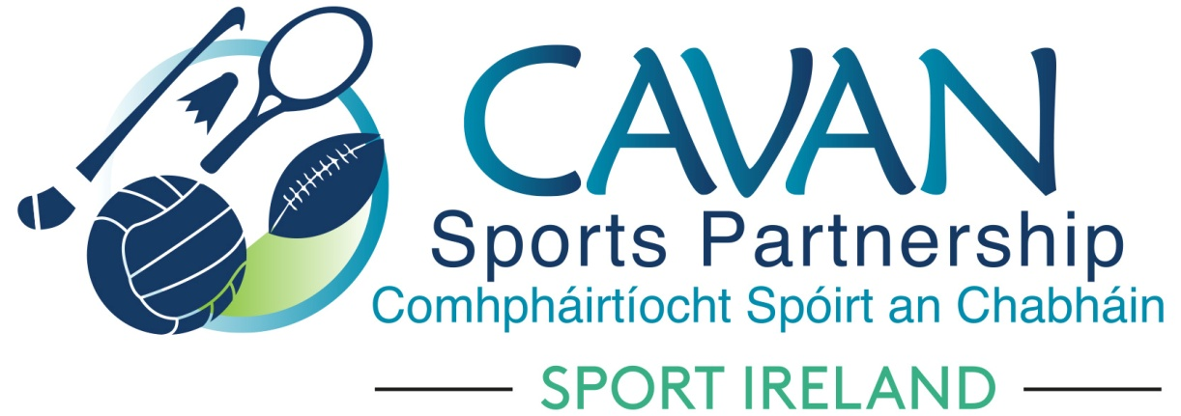
Date of Meeting: 7th Sept 2021 |  | Venue: Online Zoom Meeting
Present: Cllr Patricia Walsh, John Kearney, Larry McQuaid, Pat McEnroe, Colm Casey, Pamela Carney, Cllr Paddy McDonald, John Donohoe, Enda O’Reilly, Cllr Madeline Argue, Cllr Craig Lovett
Apologies: Brian Donohoe, Noel O’Gorman, Lisa Clerkin
In Attendance: Nadine McCormilla, Regina Duffy,
Agenda Item | Discussion / Action
1. Welcome
Colm Casey welcomed everyone to the meeting. (John Kearney had technical issues)
2. Matters arising from previous meeting
None
Minutes of previous Board Meeting
The minutes of the previous board meeting were adopted.
Proposed: John Donohoe Seconded: Cllr Patricia Walsh
3. Operational Plan Update | Nadine updated the board on the following actions in the Operational Plan:  - Women in Sport:  - HERoutdoors week – Nadine advised of the successful events which occurred during HERoutdoors Weeks  - Girls get active pilot project : ‘Inspire her’ Nadine advised that CSP are working in collaboration with Arts Department in Cavan County Council to deliver this SI Pilot Project  - CSP 2020 Annual report  – Proposed by John Donohoe Seconded by Cllr Patricia Walsh  - CSP cycling hub - Nadine updated board about venue for the Cycling Hub and that negotiations are at advanced stage to purchase container.  - Reporting – Sport Ireland (SI) 2021 and DA 2020 report submission deadline is 13th September. Nadine explained reasons why actions were highlighted in red in the 2021 Operational Plan.  - Upcoming funding applications: SI 2022 core funding and DA 2022  - closing date for both submissions are 4th October 2021 and board meeting will be scheduled in advance of submission to discuss applications  - S3 Solutions are supporting CSP through an expression of interest process which will assist clubs applying for funding under Dormant Account 2022 for sports hubs and outdoor adventure initiatives. The applications will be discussed at the Finance & grant subcommittee and a recommendation will follow at the next board meeting. (Further update below from Finance and Grant Subcommittee report).  - CSP Programme officer position: Interviews have taken place. 13 people applied for the position. Awaiting result from Cavan County Council HR Department  - National bike week 12th September: €5,000 funding was secured from Department of Transport to run a number of cycling events during this week. Nadine gave a brief outline to the board of these events  - European Week of Sport 23rd September: Nadine gave a brief outline to the board of events planned for this week to celebrate European Week of Sport.
4. Governance Code | Nadine advised that deadline to comply with Sports Governance Code is 31st December 2021. This document will be presented to Governance Sub Committee who will propose it to full board.  Regarding Action 1.3 of the Governance Code (Action stated below)  John Donohoe, Cavan County Council Rep on Board confirmed to the board that Action 1.3 is in place by Cavan County Council on behalf of Cavan Sports Partnership.
  1.3(a)
  Make sure contracts and employment policies are in place and that they cover:
  recruitment;
  induction;
  supervision;
  appraisals;
  grievance; and
  disciplinary procedures.
  Give responsibility for implementation of board-approved human resource policies and employment contracts to Chief Executive Officer (CEO).
  1.3 (b)
  Make sure:
  · formal arrangements are set up for the ongoing supervision and development of staff; and
  · formal arrangements are set up for the supervision and development of the CEO. This should include a yearly or twice-yearly appraisal.
5.Sub Committees Update | Finance and Grant Sub Committee Report presented by John Donohoe  - CSP sports club grant scheme : 40% of equipment grants have been drawn down. CSP staff will focus on supporting groups to draw down the participation grants ( 31 grants) before year end.  - Dormant accounts reporting - committee are happy with the required 60% expenditure achieved for Kilnaleck and Belturbet activity hubs. Committee are satisfied that the rationale for the delay on expenditure on the Urban outdoor initiative ( cycle hub), Sports inclusion capital ( hoist and sports wheelchairs) and volunteer supports are due to delays on equipment and capacity for training delivery from providers owing to COVID 19.  - Committee are satisfied with the mid year financial reporting to Sport Ireland for 2021 and the end of year audited accounts ( signed off by Head of finance CCC) for 2020 as per the May board meeting.  - Dormant accounts 2022 - Expressions of interest received - 5 applications for sports hubs and 2 for outdoor adventure initiatives. Groups attended a support session on conducting community needs assessment on 6th September. All groups will be supported to complete applications which will be presented to the board ( via the sub committee) at the next board meeting on Tuesday 28th September. - Deadline for submission to Sport Ireland is Monday 4th October.  - Sport Ireland core application 2022 - Funding for CSP salaries, operational costs, women in sport and other programme funding closes on Oct 4th. Submission will be presented to board via the sub committee at the board meeting on Tuesday 28th September. The sub committees of schools and inclusion are also feeding into the Core application process.  Sports Inclusion Sub Committee Report presented by Pamela Carney  - Pamela Carney elected as Chairperson, Colm Casey elected as Vice Chairperson and Dean McElroy elected as secretary for this sub committee  - Sub Committee was advised by Dean McElroy the purpose of the sub committee  - Sub Committee was advised by Dean McElroy regarding the Dormant Account Funding Application and that information would be circulated to group to ascertain ideas for the funding application.  - Co-opting to the sub committee will occur on a needs basis  - Colm Casey advised that there will be opportunities for more funding through HSE  Schools Sub Committee Report presented by Enda O’Reilly  - Apologies from Brian Donohoe who could not attend meeting, Enda O’Reilly presented to the board.  - Brain Donohoe was elected Chairperson and Aine O’Reilly elected as secretary.  - Sub Committee was advised by Aine O’Reilly of the structure and process of this sub committee  - Aine O’Reilly to distribute Microsoft Forms to all members of sub committee to ascertain needs in their respective areas, deadline by 23rd September.  - Date of next meeting 27th September
6.AOB | Vote of Congratulations from Cavan Sports Partnership Board be sent to Leona Maguire on her recent Solheim Cup success and to Britney Arendse on her success at Tokyo Paralympics 2021  Proposed Cllr Paddy McDonald Seconded Cllr Patricia Walsh
8. Date of next meeting | Tuesday 28th September at 4.30pm via Zoom

