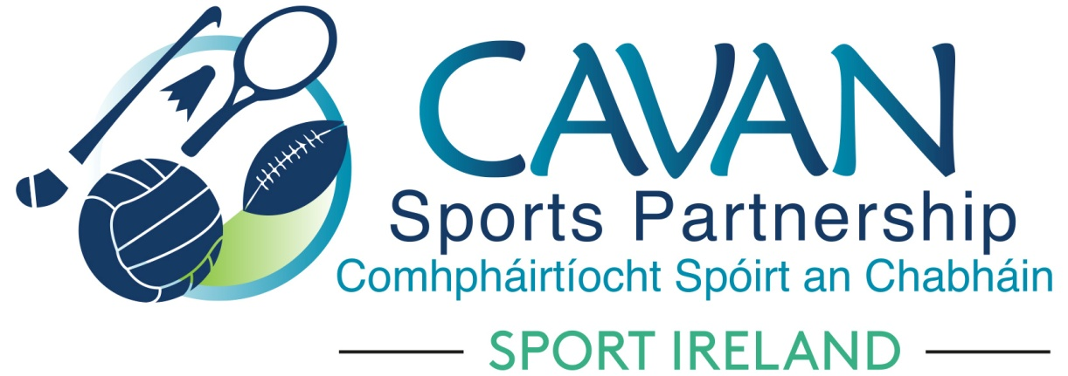
Date of Meeting: 29th June 2021 |  | Venue: Online Zoom Meeting
Present: Cllr Patricia Walsh, John Kearney, Brian Donohoe, Larry McQuaid, Pat McEnroe, Noel O’Gorman, Colm Casey, Pamela Carney, Liam McCabe, Cllr Paddy McDonald, Lisa Clerkin, John Donohoe
Apologies: Enda O’Reilly, Cllr Craig Lovett, Cllr Madeline Argue, Cllr. Brendan Fay,
In Attendance: Nadine McCormilla, Regina Duffy,
Agenda Item | Discussion / Action
1. Welcome
John Kearney welcomed everyone to the meeting.
2. Matters arising from previous meeting
None
Minutes of previous Board Meeting
The minutes of the previous board meeting were adopted.
Proposed: Liam McCabe Seconded: Brian Donohoe
3. Operational Plan Update | Nadine updated the board on the following actions in the Operational Plan:  - Funding received for Dormant Account Funding 2021 – Total €148,010  - Women in Sport – Girls Get Active Pilot Project – Funding received €12,500 for Arts & Physical Activity Programme  - CSP Cycling Update – Venue confirmed at Cavan Leisure Centre for an urban cycling hub for Cavan. Due to covid there is a delay in sourcing the container. Procurement is with Cycling Ireland.  - CSP 2020 Annual Report – At draft stage  - Report Deadlines for Sport Ireland – 13th Sept for SI 2020 Core End of Year, SI 2021 Core Mid Year & DAF 2020  - Upcoming Applications – Closing Date 4th Oct for SI Core 2022 and DAF 2022 funding applications  - CSP Programme Officer Position – Closing Date 2nd July 2021 for applicants.  - Walking Month of June – Great Success, over 240 people attended, delivered within covid guidelines of pods of 15, it highlighted the appetite for people to return to activity.
4. Sub Committee’s Update | Nadine gave a brief overview of members of subcommittees. Finance and Grants subcommittee will comprise of Board members with the other four subcommittees coopting external members onto it. Development Officers will schedule sub-committee meetings before the next Board Meeting. If any board member is not happy with their selected sub-committee’s please follow up with Nadine after this board meeting.  John Donohoe chairperson of Finance and Grants Subcommittee updated the board of their sub-committee meeting:  - There was €45,315 awarded to 80 clubs from 2021 CSP Club Grant Scheme  - Evidence of 100% receipts will not be required for participation activity but CSP Development Officers will supervise this and a detailed Participation Report will be required from clubs where clubs are using their own resources.  - LGFA School Club Link – 5 clubs have been selected from their grant application forms (Killygarry, Cavan Gaels, Templeport, Belturbet and Crosserlough). By utilising LGFA clubs, CSP are meeting a key target area of Women in Sport objective contained in their CSP Strategic Plan.  Proposed: Cllr Paddy McDonald Seconded: Pamela Carney  - Nadine gave Finance Update:  Total Expenditure dated 29th June 2021 - €165,546  Total Income dated 29th June 2021 - €564,789 (This includes carryover figure of €217,162, Actual 2021 income is €348,627)  - Nadine gave update on the Governance Code  - Mid year review submission due 13th September  - Clarity is needed from Sport Ireland in relation to financial controls/auditing for Local Authority LSP’s  - Key areas for compliance will be CSP Board Member Handbook and CSP Website  - CSP Governance sub committee to meet prior to CSP Board September Meeting.
6.AOB | Nadine advised that HSE Section 39 funding of €25,000 has been received by CSP. This will support CSP Senior Staff Development Officer programme role and salary. Nadine thanked Colm Casey for his support for this successful grant funding allocation.  Cllr Paddy McDonald acknowledge the successful visit from Sport Ireland to Bailieborough recently.
8. Date of next meeting | Tuesday 7th September at 4pm  (Date changed from 21st September as a result of Sport Ireland finance mid year submission deadline of 13th Sept)

