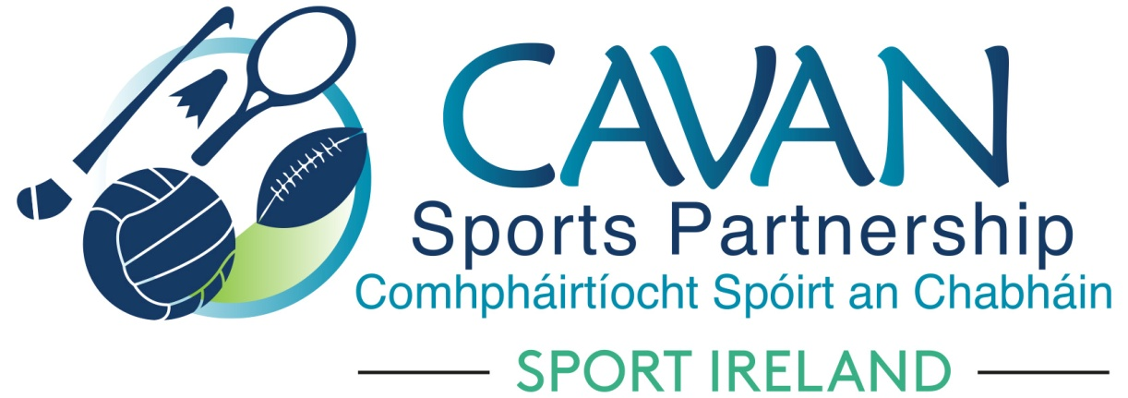
Date of Meeting: 11th May 2021 |  | Venue: Online Zoom Meeting
Present: Cllr Madeline Argue, Cllr Patricia Walsh, Cllr. Brendan Fay, John Kearney, Brian Donohoe, Larry McQuaid, Pat McEnroe, Noel O’Gorman, Colm Casey, Pamela Carney, Liam McCabe
Apologies: Cllr Paddy McDonald, Enda O’Reilly, Cllr Craig Lovett, John Donohoe
In Attendance: Nadine McCormilla, Regina Duffy, Dean McElroy, Aine O’Reilly, Aisling Maguire, Dr. Tony Lenehan
Agenda Item | Discussion / Action
1. Welcome
Cllr Brendan Fay welcomed everyone to the meeting.
2. Matters arising from previous meeting
None
Minutes of previous Board Meeting
The minutes of the previous board meeting were adopted.
Proposed: Cllr Patricia Walsh Seconded: Cllr Madeline Argue
3. Operational Plan & Governance Code Update | Nadine updated the board on the following actions in the Operational Plan:  - Preparation of the Sport Ireland Mid-Year Returns  - New CSP Programme Officer Position  - 2020 CSP & SI Club Grant Scheme update  - Launch date for the 2021 Club Grant Scheme  - Update on CSP Website Redesign  - CARA Centre – update on CSP application for Bronze Inclusion Award  - Governance Code update with deadline of the end of 2021  - Upcoming Programmes:  - Club Communications and Fundraising Webinars  - Community Sports Leader training course  - WIS Programmes; Intro to Lawn Bowls, Lets for Fishing for Women, Open Water Swimming  - Walking Month of June  - Lets go Fishing Programme for Men  - Active Adults Outdoor Tai Chi  - Inclusion Programmes; Outdoor Summer Camps, Walks for Wellbeing and outdoor Activator Programme  - Hubs Programmes; Table Tennis, Kids Yoga, Lets go Rowing, Kids Rinka dance class
4. Finance Update | Regina presented the following finance powerpoint update :  - Brief overview of the major finance deadline dates and how they are incorporated into the Operational Plan  - Breakdown of 2020 Budget:  - Total Income; €620,403.23  - Total Expenditure; €403,240.81  - Total Carryover and rationale for same; €225,330.64  - Total Contingency and plan for amount sent to Capital Code in 2020; €8,167  (€7,000 to Salary Contingency & €1,167 to Programme Reserves)
5. CSP 2021 Sub-Committee formation | Nadine gave an overview of how the new structure of Board Sub committees would operate. The sub-committee updates will become standing orders on the agenda for CSP board meetings. A member of the CSP Staff will be the secretary to each of these subcommittees. Each subcommittee will have a chairperson who will report back into the full CSP board meeting. Board Members Handbooks and Governance Code will all need to be updated to reflect these changes.  Nadine introduced Dr Tony Lenehan, Centre of Competitiveness and thanked him and John Kearney for their work with progressing this new structure. Dr Tony Lenehan presented to the board how the sub committees will operate. He explained that they are a method of “creating a voice for Board Members” and not an exercise for creating additional workload. A microsoft form will be distributed to each Board Member after the meeting and board members were asked to state their preference for subcommittees to join.
6.AOB | GAA - Liam McCabe requested approval for a ‘proxy’ to facilitate his seat as GAA representative. The proxy will be Kevin Smith (Development Officer with Cavan GAA County Board). The board approved this proposal given the circumstances of Liam Mc Cabes retirement in 2022. John Kearney advised that this will be reviewed in 12 months. He advised that this is an exceptional circumstance and will be a once off occurrence. This to be recorded in the Board Members Handbook
8. Date of next meeting | Tuesday 29th June at 4pm via zoom

