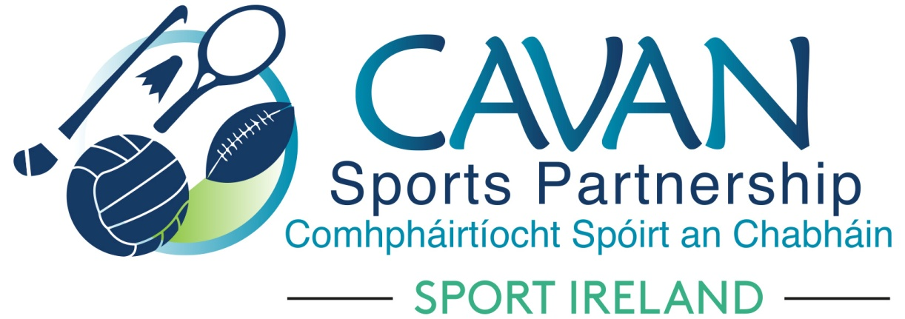
Date of Meeting: 27th April 2021 |  | Venue: Online Zoom Meeting
Present: Cllr Madeline Argue, Cllr Paddy McDonald, Cllr Patricia Walsh, Cllr. Brendan Fay, John Donohoe, Enda O’Reilly, Brendan O’Reilly, John Kearney, Brian Donohoe, Larry McQuaid, Pat McEnroe, Noel O’Gorman
Apologies: David Cahill, Ronan Molloy had technical issues logging on, Pamela Carney
In Attendance: Nadine McCormilla, Regina Duffy, Aine O’Reilly, Dean McElroy, Aisling Maguire
Agenda Item | Discussion / Action
1. Welcome
John Kearney welcomed everyone to the meeting. Everyone introduced themselves and outlined their interest in joining the Board.
2. Matters arising from previous meeting
Strategic Plan Review document was formally adopted by the board.
Minutes of previous Board Meeting
The minutes of the previous board meeting were adopted.
Proposed: Cllr Madeline Argue Seconded: Cllr Paddy McDonald
3. Election of Officers | Election of Chairperson and Vice Chairperson for Board Term 2021 to 2024;  - Cllr Madeline Argue proposed and Cllr Patricia Walsh seconded John Kearney to be Chairperson  - Cllr Paddy McDonald proposed and Cllr Patricia Walsh seconded Cllr Brendan Fay to be Vice Chairperson  John Kearney thanked outgoing members for all their commitment over the lifetime of previous board term. He also welcomed new members to the board.
4. Information Session from CSP Staff | Nadine outlined the aims of CSP and the main focus of the Strategic Plan going forward  - Covid Care  - Outdoor Sports and Recreation  - Women in Sport  - Stakeholder Engagement  Development Officers outlined their roles within Cavan Sports Partnership  Dean McElroy – Sports Inclusion and Older Adults  Aine O’Reilly – Schools, Communities, working with NGB’s to support development of minority sports, training and education and Healthy Cavan initiatives  Aisling Maguire – Hubs Co-Ordinator and Women in Sport
5. CSP Board Meeting Dates | Nadine outlined the following dates (Advising that they are subject to change if required by Sport Ireland)  Discussion of the times of board meetings took place and following times and dates were agreed:  - Tuesday 11th May at 11am  - Tuesday 29th June at 4pm  - Tuesday 21st Sept at 11am  - Tuesday 30th Nov at 4pm
6.CSP Grant Scheme 2021 | Nadine advised that the Grant Sub Committee had a meeting on Monday 26th April and recommended the following:  - Three strands to the grants – Equipment, Training and Education and Participation  - Only one strand to be apply for per club/community group  - Participation Strand to have three levels – Gold, Silver and Bronze  - Option available to launch Grant scheme twice within the year. First launch will be 29th April with closing date of 20th May. There is the potential for a second launch of funding in August ( with unallocated money from the first round). This will depend on number of applications received on first round and if more funding streams become available from Sport Ireland.  - Training and Education grant fund to remain open for the year with a deadline of 30th November.  - CSP staff have developed a communications plan to advertise this Grant Scheme  - Full criteria will be forwarded to Board Members and attached to these minutes.
8. Date of next meeting | Tuesday 11th May at 11am
9. AOB

