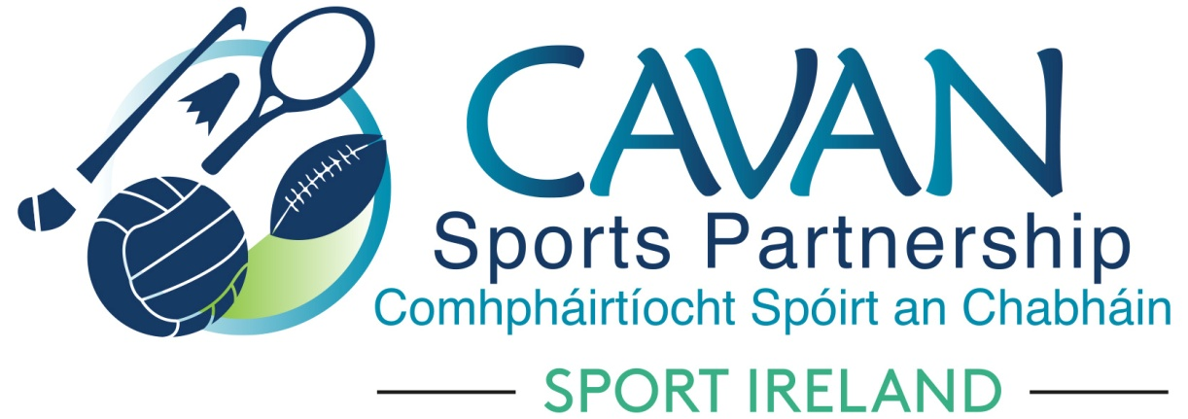
Date of Meeting: 9th Feb 2021 |  | Venue: Online Zoom Meeting
Present: Cllr Madeline Argue, Cllr Paddy McDonald, Cllr Patricia Walsh, Cllr. Brendan Fay, John Donohoe, Enda O’Reilly, Brendan O’Reilly, Colm Casey, Liam McCabe, John Kearney, Terry Hyland, David Cahill
Apologies: Tom Downes
In Attendance: Nadine McCormilla, Regina Duffy,
Agenda Item | Discussion / Action
1. Welcome
John Kearney welcomed everyone to the meeting.
2. Matters arising from previous meeting
None
Minutes of previous Board Meeting
The minutes of the previous board meeting were adopted.
Proposed: Cllr Brendan Fay Seconded: Cllr Madeline Argue
3. Finance Update | Nadine outlined the Funding Allocations 2021. Points to note are that Sport Ireland awarded;  - Extra funding for Human Resources (Nadine outlined the proposed role of new ‘programmes officer’)  - Allocation for Club Sports Grants increased to €25,000  - Allocation for Marketing increased to €11,800  - Extra Supplementary Programme Funding of €11,095  - Application has been forwarded to HSE Section 39 for €25,000  Income as of 5th Feb 2021 = €1,005 (Carryover not transferred yet from 2020)  Expenditure as of 5th Feb 2021 = €38,163
4. CSP Work Update | Nadine presented CSP Work Update  - Virtual Operation KEEP WELL  - CSP Operational Plan update  - National Governing Bodies networking session  - CSP 2020 Newsletter printed and distributed.  - CSP Grant Scheme –outlined the number of Clubs/Community groups who are outstanding to draw down 2020 CSP Club Grant Schemes and Sports Ireland PPE Grants.  Nadine proposed that the CSP 2021 Club grant scheme to be opened in April 2021. Sport Ireland has advised that club grant aid must be distributed within the current year.  Proposed: David Cahill Seconded: Cllr Brendan Fay  Members of Club Grant Scheme elected: Cllr Brendan Fay, Cllr. Madeline Argue, Cllr Patricia Walsh, David Cahill
5. Governance Code | Nadine outlined that CSP has begun the adoption process of the Governance Code for community, voluntary and sporting organisation. Deadline for completion is 31/12/2021. Governance Code subcommittee from the board will be required.
6.CSP Strategic Plan Review | Nadine outlined that the lifetime of the Strategic Plan has been extended 2021 – 2022. The focus will be:  - Women in Sport  - Outdoor Sport and Recreation  - Covid Care  - Governance and Stakeholder Engagement  Sport Ireland has endorsed the extension of the strategic plan to coincide with the SI strategy statement.  Nadine asked Board Members to review the document and forward comments to her before the next board meeting.  Adoption of the extension of Strategic Plan to be completed at next board meeting.
7. CSP Board Member Review | Nadine outlined that all board members representing statutory & community organisations will receive nomination forms via email. A call for the nomination of sporting representatives to the board of CSP will be made through local and social media channels. Elected members will reman the same. Gender diversity and a range of sporting reps ( indoor & outdoor) will be required. There will be an induction process for new board members.
8. Date of next meeting | Tuesday 13th April at 11am online via zoom
9. AOB | Cllr Brendan Fay proposed that CSP Sign be installed at “new” office at Belturbet.  John Kearney thanked the board for accommodating a meeting start time of 10.30

