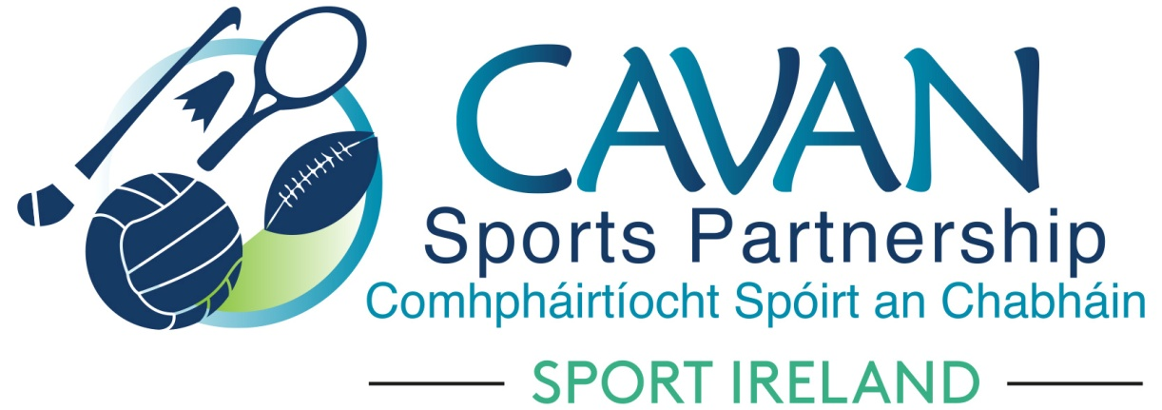
Date of Meeting: 12th Nov 2020 |  | Venue: Online Zoom Meeting
Present: Cllr Madeline Argue, Cllr Paddy McDonald, Cllr Patricia Walsh, Cllr. Brendan Fay, John Donohoe, Enda O’Reilly, Brendan O’Reilly, Colm Casey, Liam McCabe
Apologies: John Kearney, Terry Hyland, David Cahill
In Attendance: Nadine McCormilla, Regina Duffy,
Agenda Item | Discussion / Action
1. Welcome
In the absence of the chairperson and vice chairperson, Colm Casey chaired and welcomed everyone to the meeting.
2. Matters arising from previous meeting
None
Minutes of previous Board Meeting
The minutes of the previous board meeting were adopted.
Proposed: Cllr Madeline Argue Seconded: Cllr Paddy McDonald
3. Sport Ireland PPE Restart Grant of €8,500 | Nadine outlined the following proposal to allocate €8,500 to clubs received from Sport Ireland Restart Grant (PPE Element); That the 29 clubs that applied through Cavan Sports Partnership and did not apply through Sport Ireland PPE grant be given €200 each to go towards PPE expenses. The remaining €2,700 would be used by CSP to purchase a bulk supply of PPE equipment to be used for clubs that did not apply for CSP or SI PPE grants. Proposed: Cllr Madeline Argue Seconded: Colm Casey
4. Funding Update | (A)Nadine gave an overview of Dormant Account Funding 2021 Submission.  A total of €127,920 was applied for under the following headings;  1) Phase 5 of the Kilnaleck Activity Hub €20,000  2) Phase 4 of the Belturbet Activity Hub €20,000  3) Phase 1 of Mullagh Activity Hub ( New hub) €60,000  4) A TY intergenerational physical activity project with Active Age Ireland and secondary schools €2,700  5) An outdoor volunteer training and education programme €11,030  6) Sports inclusion capital funding for balance bikes in the ASD unit in Mullagh NS and communications boards for 8 playgrounds in the county for children who are non verbal / have learning difficulties. €14,190  (B) Nadine outlined the criteria for Sport Ireland ‘Keep Well’ funding application:  A funding application for €10,000 was sent to Sport Ireland to support the ‘Keep Well’ initiative between November and March 2021. This is funded by Healthy Ireland.
5. CSP work & finance update | Nadine outlined proposals for Cavan’s Operation KEEP WELL programme and Operation Transformation for January 2021.  Nadine advised the following finance update:  Total Income as of 11.11.20 €512,566 (included is €93,793 received 10.11.20 from Sport Ireland for Covid 19 Club and Restart Grants)  Total Expenditure as of 11.11.20: €302,133
6.AOB | Nadine thanked the Board for all their work throughout 2020.
8. Date of next meeting | Online Zoom meeting 9th February 2021 at 11am
 | Following the board meeting, Tony Lenehan from ‘The Centre of Competitiveness’ joined the board and discussed the CSP strategic plan review.

