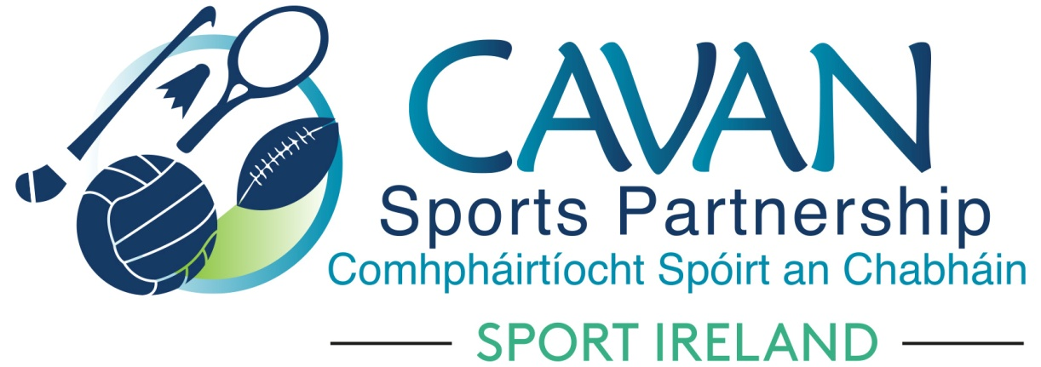
Date of Meeting: 13th Oct 2020 |  | Venue: Online Zoom Meeting
Present: John Kearney, Cllr Madeline Argue, Cllr Paddy McDonald, Cllr Patricia Walsh, Cllr. Brendan Fay, John Donohoe, Enda O’Reilly, Brendan O’Reilly,
Apologies: Terry Hyland, David Cahill, Liam McCabe, Colm Casey
In Attendance: Nadine McCormilla, Regina Duffy,
Agenda Item | Discussion / Action
1. Welcome
John Kearney welcomed everyone to the meeting.
2. Matters arising from previous meeting
None
Minutes of previous Board Meeting
The minutes of the previous board meeting were adopted.
Proposed: Cllr Madeline Argue Seconded: Cllr Patricia Walsh
3. Dormant Account Funding 2020 update | Nadine outlined the €99,192 allocation received for Dormant Account Funding 2020:  - €30,000 for Belturbet Activity Hub Phase 3  - €20,000 for Kilnaleck Activity Hub Phase 4  - €15,000 for Sports Inclusion Capital Project - pool hoist for Bailieborough pool through the East Cavan Eagles/Sliver Finn swim club and sports wheelchairs in partnership with the IWA  - €19,702 for Urban Outdoor Adventure Cycle Hub in Killykeen Forest Park in partnership with Cycling Ireland  - €14,490 for Volunteer Supports for Community based training and coach education programme  Deadline for spend is July 2021. Nadine will request feedback from Sport Ireland on the unsuccessful Mullagh Activity Hub application.  New Dormant Account Funding Application 2021 deadline is Monday 2nd November.  Nadine advised that Mullagh Activity Hub will be resubmitted. Nadine encouraged board members to contact the LSP with potential project ideas. Given the focus of the strategy review there would be a emphasis on COVID 19 response, women in sport, training and education for the 2021 fund.
4. CSP Strategic Plan Review Update | Nadine gave an overview of the strategic plan review process which is being completed with the help of the Center of Competitiveness. ( Power point presentation). A meeting had also taken place with the CSP Chairperson John Kearney and a board session has been rescheduled ( due to COVID 19) for 12th November ( online).  The focus of the Strategic Plan will be on CSP’s response to COVID 19 along with key areas of outdoor recreation, Women in Sport, Community sports development & Governance. There will also be a stronger emphasis on the marketing and communications of CSP work.  Nadine sought approval from the board that the life of the strategic plan be extended to 2022 to allow for implementation in response to COVID 19 and to align itself with the Sport Ireland strategy timeline.  Proposed: Cllr Madeline Argue  Seconded: John Donohoe  John Kearny commended the strategic review process to date and requested Nadine to receive written approval from Sport Ireland for the timeline extension of the plan for auditing records.
5. CSP Sport Ireland Core 2021 funding application | Nadine outlined that €264,038 was applied for under the Sport Ireland Core Grant Application for 2021. This will cover staff salaries, other staff costs, office costs, marketing and training. Amount for WIS Programmes applied for was €2,100 and €6,830 for “other programmes”. Nadine advised that Sport Ireland has confirmed that allocation will be similar to last year. Due to action changes proposed in the review of the CSP Strategic Plan, CSP has applied for funding for a Women in sport Development officer.
6.CSP Return to Sport Grant Scheme 2020 | Nadine thanked the sub-committee for their work on the grant scheme.  The following was proposed by the sub-committee;  That SI club grant allocation of €8,660 and Cavan County Council Covid Grant ( €1,000) be allocated to the clubs that applied for participation. Equipment or coach/tutor costs involved to run a participation programme can be applied for. In total 48 clubs applied. Therefore, each club will receive €200. Clubs that applied for PPE equipment will be considered under the Sport Ireland Covid Grant Scheme. Clubs who did not apply under grant schemes can apply for PPE equipment from CSP. CSP have applied to SI under the Restart Grant to purchase a bulk supply of PPE equipment.  Proposer: Brendan O’Reilly  Seconder: Cllr Patricia Walsh  A list of successful clubs who received funding under the Participation Grant will be forwarded to Board Members
7. AOB | CSP Board Members Renewal 2021:  Letters to be distributed in November requesting nominations from your organisations to be members of the board for the next three years.  Cllr Paddy McDonald commented on how successful the walking programme “Your Way to 5K” was in Bailieboro and thanked the Development officer for organizing it.  John Kearney sent his congratulations to Crosserlough on winning the Senior Football Championship Final.
8. Date of next meeting | Online Zoom meeting Tuesday 1st December at 11am

