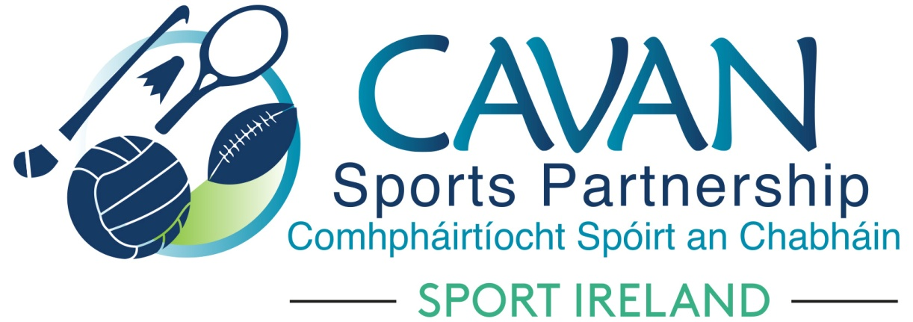
Date of Meeting: 10th Sept 2020 |  | Venue: Online Zoom Meeting
Present: John Kearney, Terry Hyland, Cllr Madeline Argue, Cllr Paddy McDonald, Cllr Patricia Walsh, Cllr. Brendan Fay, Cllr Craig Lovett, John Donohoe, David Cahill, Liam McCabe, Colm Casey
Apologies: Enda O’Reilly, Brendan O’Reilly
In Attendance: Nadine McCormilla, Regina Duffy,
Agenda Item | Discussion / Action
1. Welcome
John Kearney welcomed everyone to the meeting.
2. Matters arising from previous meeting
None
Minutes of previous Board Meeting
The minutes of the previous board meeting were adopted.
Proposed: Cllr Madeline Argue Seconded: David Cahill
3. CSP Financial Return 2019 | Nadine outlined the Financial Report for 2019 and Dormant Account Report 2019 and advised that Head of Finance in Cavan County Council had confirmed figures on attached spreadsheet matched Agresso figures. These spreadsheets had been forwarded to the Board prior to this meeting. Nadine advised that these reports will now be forwarded to Sport Ireland to release the remaining 25% Core Grant and 10% DAF.  Financial Report 2019 : Proposed Terry Hyland Seconded Colm Casey  Dormant Account Fund Report 2019: Proposed David Cahill Seconded: John Donohoe
4. Sport Ireland Covid 19 Club Grant Scheme | Nadine thanked the Grant Sub-Committee for their work so far in relation to the Sport Ireland Covid Club Grant Scheme. CSP Return to Sport Scheme was put on hold until SI Covid Grant Scheme was assessed. A maximum of €1,500 could be applied for. 61 Clubs applied through Cavan Sports Partnership with a combined total of €71,793. There was one club from outside the county that applied. Criteria forwarded by Sport Ireland advised that initial assessment to take place by local sports partnership, followed by a Sport Ireland second stage assessment.  In addition to the club applications, Nadine outlined that CSP also applied for the following:  - Restart and Renewal Grant: To provide minority groups with PPE to support their return to sport & activity. €8,500 was sought  - Restart and Renewal Grant: To provide a 6 week swimming programme for women. €1,400 was sought  - Restart and Renewal Grant: Walk to Wellness programme for Secondary Schools. €13,500 was sought.  Proposer: Terry Hyland Seconder: Cllr Madeline Argue  There was concerns raised that some clubs applied but were not on the final list. Nadine advised for these clubs that CSP has applied for a stock of PPE equipment under the Restart and Renewal Grant and that any club can forward their requirements for PPE equipment through this channel.
5. CSP Work Update | Nadine discussed the attached CSP Work Update Document. The following is a brief summary:  - There will be a focus on “Special Weeks” (eg European Week of Sport) going forward  - Dormant Account Funding 2020 waiting on allocation announcement  - Dormant Account Funding 2021 funding application deadline 16th October 2020.  - 2021 Sport Ireland Core Funding Application deadline 16th October 2020.  - Nadine is part of the Sport Irelands ‘In this together’, return to sport committee.  - Aine O’Reilly, CSDO is delivering tutor training to CSP tutors on the National protocols for return to sport for local sports partnerships. Each CSP delivered programme requires a Covid Compliance Officer to be in attendance, this will have an impact on development officers capacity to deliver programmes.  - CSP Strategic Plan is in the process of being reviewed. CSP staff will take part in a full day strategic review session on 15th September with the Centre of Competitiveness. CSP Board review date 28th Sept.  - John Kearney acknowledged the level of work undertaken by Cavan Sports Partnership
6.AOB | John Donohoe thanked CSP staff for their work and commitment on the Cavan County Council Covid Community Helpline.  Nadine advised that CSP Staff have moved to Belturbet Area Offices, Creeny, Belturbet.
8. Date of next meeting | Proposed date Tues 13th Oct via Zoom online.

