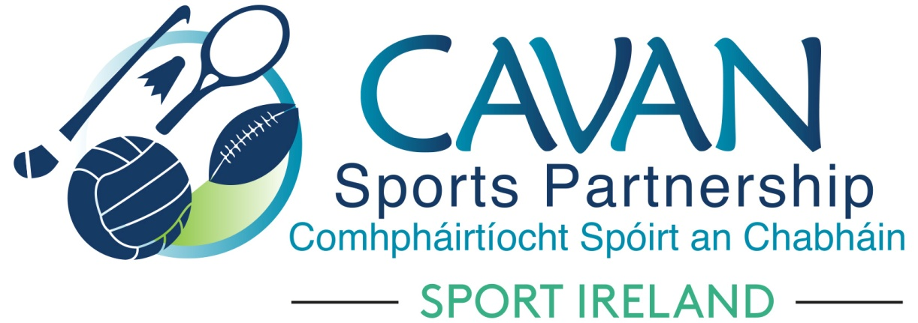
Date of Meeting: 4th August 2020 |  | Venue: Online Zoom Meeting
Present: Terry Hyland, Cllr Madeline Argue, Cllr Paddy McDonald, Cllr Patricia Walsh, Cllr. Brendan Fay, John Donohoe, Brendan O’Reilly, David Cahill, Enda O’Reilly,
Apologies: Liam McCabe
In Attendance: Nadine McCormilla,
Agenda Item | Discussion / Action
1. Welcome
2. Matters arising from previous meeting & minutes of previous Board Meeting
Due to the short notice and specific nature ( Covid 19 restart grants) of the board meeting, minutes from 23rd June and 4th August are to be approved at the board meeting on August 10th.
- Cavan Sports Partnership COVID 19 Club Small Grant Scheme Guidelines: | On Wednesday 29th July Sport Ireland announced the local sports partnerships participation in the administration of the DTTAS €5million restart fund for local clubs and groups. Sport Ireland held a webinar for LSP’s to outline the grant guidelines. Nadine went through this presentation. A discussion took place on the current CSP grant scheme. Nadine informed the board that Sport Ireland had advised LSP’s to put their own local grant schemes on hold until this National support fund had been administered. The board agreed to put CSP local grant scheme on hold until November 2020. The same grant scheme sub committee would remain to assess the grants.  Proposed by: John Donohoe  Seconded by : Cllr. Madeline Argue
- CSP Strategic review | Nadine informed the board that Tony Lenehan from the Centre of Competitiveness would conduct a board review session in the Council Chamber on Monday 28th September from 10am – 1pm.
- A.O.B. | Nadine informed the board that CSP were currently working on Local Sports Partnerships return to sport and physical activity guidelines document.
- Date of next meeting | Next board meeting will take place on Thursday 10th September at 11am via zoom.

