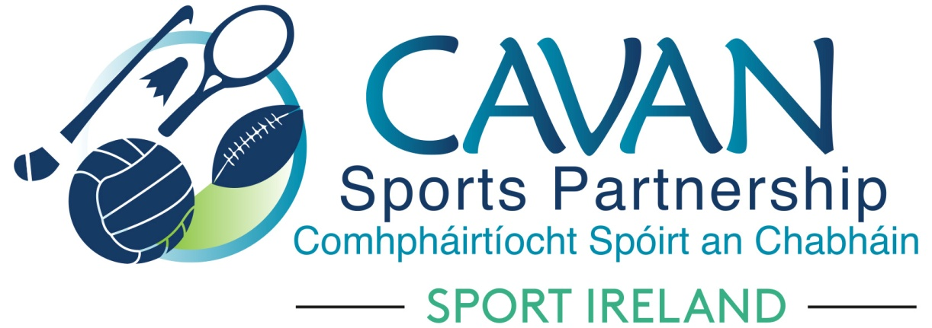
Date of Meeting: 23rd June 2020 |  | Venue: Online Microsoft Team Meeting
Present: Terry Hyland, Cllr Madeline Argue, Cllr Paddy McDonald, Cllr Patricia Walsh, Cllr. Brendan Fay, Cllr Craig Lovett, John Donohoe, Brendan O’Reilly, David Cahill, Enda O’Reilly,
Apologies: John Kearney, Liam McCabe
Due to technical difficulties Colm Casey and Enda O’Reilly could not attend and were briefed post board meeting
In Attendance: Nadine McCormilla, Regina Duffy, Dean McElroy
Agenda Item | Discussion / Action
1. Welcome
In absence of John Kearney, Terry Hyland was nominated to chair this meeting.
Terry welcomed everyone to the meeting.
2. Matters arising from previous meeting
None
Minutes of previous Board Meeting
The minutes of the previous board meeting were adopted.
Proposed: Cllr Brendan Fay Seconded: Cllr Paddy McDonald
3. Work Update  March to June | Nadine presented the Work Update from March to June.  Terry Hyland expressed his gratitude for the sports equipment which was distributed with the Food Cloud. He advised that they targeted urban based families. He also praised the “Virtual Explore Cavan Challenge” initiative.
4. Upcoming Programmes Update | Nadine presented the “Upcoming Programmes”.  Nadine outlined that Sport Ireland have released the 2021 Core Funding Application and 2021 Dormant Account Funding Application.  Nadine discussed the “Review of CSP Strategic Plan”. Sport Ireland has recommended the ‘Centre of Competitiveness’ to undertake the review of the CSP Strategic Plan. Nadine met with the Centre of Competitiveness and concurred with Sport Irelands recommendation. Nadine advised the board that the Strategic Plan will need to realign due to Covid 19 and that objectives will have to be geared towards seeking alternative funding streams.  The board approved appointing Centre of Competitiveness to complete Review of current CSP Strategic Plan.  Proposed: Cllr Madeline Argue  Seconded: David Cahill  David Cahill commented that Inclusive Fishing and Pound were great initiatives.  Cllr Madeline Argue & Cllr Brendan Fay acknowledged the number of programmes which was presented at the meeting and expressed “well done” to the staff of Cavan Sports Partnership
5. CSP Return to Sport & Activity Assistance Grant Scheme | Nadine proposed to the Board that Grant Scheme be brought forward this year due to the following:  - Sport Ireland has requested that Grant Funding be spent within current year  - Clubs require assistance now to help them return to activity due to Covid 19  Nadine proposed that Community Groups who undertake to host a participation programme are eligible to apply with the condition that they must be signed up to Cavan Public Participation Network.  It will also be a requirement that all clubs complete Sport Ireland Covid Online E-Awareness course.  Discussion arose and “CSP Return to Sports & Activity Assistance Grant Scheme” was to proceed.  Proposed: Cllr. Patricia Walsh Seconded: Cllr. Madeline Argue  Grant Sub-Committee  The following were elected to grant sub-committee:  Cllr Patricia Walsh, Cllr Brendan Fay, Cllr Craig Lovett, Enda O Reilly (following post meeting briefing)
6.Finance Update | Nadine outlined the attached Finance Update documents.  Total Income €438,938.11  Total Expenditure €153,061.26  Nadine reported that best and worst case budget scenario figures for 2020 were submitted to Sport Ireland.
8. Date of next meeting | Next board meeting will occur in July, confirmation of date to follow

