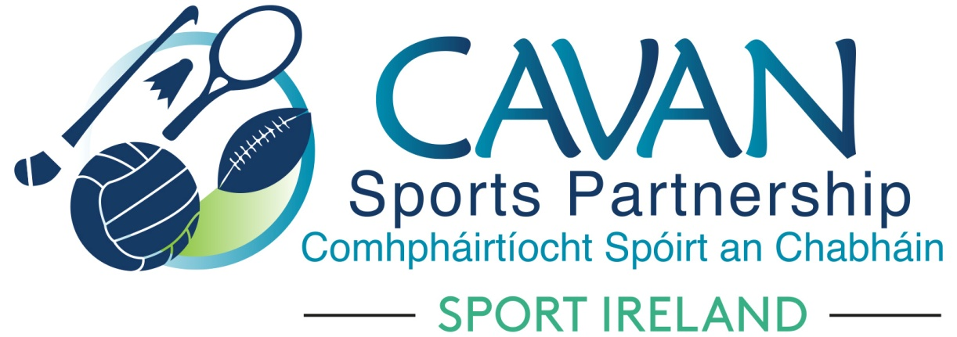
Date of Meeting: 25th February 2020 |  | Venue: Bridge Street Centre, Cavan
Present: Cllr Madeline Argue, Cllr Paddy McDonald, Cllr Patricia Walsh, Cllr. Brendan Fay, John Donohoe, Brendan O’Reilly, John Kearney, David Cahill, Liam McCabe, Enda O’Reilly
Apologies:, Terry Hyland, Colm Casey, Ronan Molloy
In Attendance: Nadine McCormilla, Regina Duffy

Agenda Item | Discussion / Action
1. Welcome
John Kearney, Chairperson welcomed everyone to the meeting
2. Matters arising from previous meeting
None

Minutes of previous Board Meeting
The minutes of the previous board meeting were adopted.
Proposed: David Cahill Seconded: Brendan O’Reilly
3. Workplan Update | a. Implementation Plan 2020:  Nadine outlined the Implementation Plan 2020 Quarter 1 Projects  John Kearney requested number of participants to be included under each programme.  b. Dormant Accounts Fund 2020 Application:  - Nadine outlined that Sport Ireland want to streamline when they release Dormant Account Funding to coincide with current year. Therefore 2020 Dormant Account Funding application is now open with completed Applications due back to Sport Ireland by 9th April. If successful 2020 funding will be released by June.  2021 Applications will be open in September 2020 with successful Applications receiving funding early 2021.  - Nadine outlined the 2020 Dormant Account Funding Application. Cavan Sports Partnership will be submitting funding application for Kilnaleck Hub Phase 4 and Belturbet Activity Hub Phase 3. Funding is also available under the following headings:  - (New) Community Sports and Physical Activity Hubs  - Urban Outdoor Adventure Initiative  - Youth Leadership  - Volunteer Supports  - Sports Inclusion Disability Plan (SIDP) Capital Supports  - Innovation for Sports Inclusion
4. Finance | a. Sport Ireland 2020 Funding Allocation  Nadine outlined the “Funding Sources for 2020” (Document attached).  b. CSP Finance 2019/2020  Nadine outlined Total Income for 2019: €615,358.31, Total Expenditure for 2019: €323,193.85, Carryover for 2019: €292,164.46 (Note AFS not completed yet)  Nadine outlined the Breakdown of CSP 2019 Carryover in code 45100019 – Pie Chart attached.  Process of Capitalisation of some of this Carryover will occur in 2020. The following will be sent to capitalisation:  - €36,000 Staff salary contingency (12%)  - €20,000 Seed funding for programmes (7%)  - €60,512 Programme Income (21%)  The remaining 60% will remain in Revenue  - Dormant Account Funding 43%  - Sport Ireland Core and Salary Funding 15%  - Revenue Other Funding 2%
5. CSP Governance | a. Board Member Skills Audit follow up  Nadine advised that any new policies from Cavan County Council will be brought to the attention of CSP Board.  b. Cavan County Council internal audit  Nadine outlined that concerns from previous board meeting was relayed back to Internal Audit Team regarding the Draft Internal Audit Report. Amended report was outlined by Nadine and Board were satisfied with changes.
6.A.O.B. | a. Nadine outlined letter from Benny Cullen in relation to Deloitt Audit Report. It stated that CSP has met all audit requirements. Nadine outlined that Sport Ireland has a different procedure for evaluation in place now. One aspect will be one to one evaluation with Coordinators. John Donohoe advised that new Governance Code from LGMA will be coming. John Kearney advised that the board avail of any training in relation to this.  b. Nadine advised that Sport Ireland will be hosting a meeting for all Director of Services & Chairpersons of Local Sport Partnerships – venue and date to be confirmed.
8. Date of next meeting | Tuesday 9th June at 10.00 am  Bridge Street Centre

