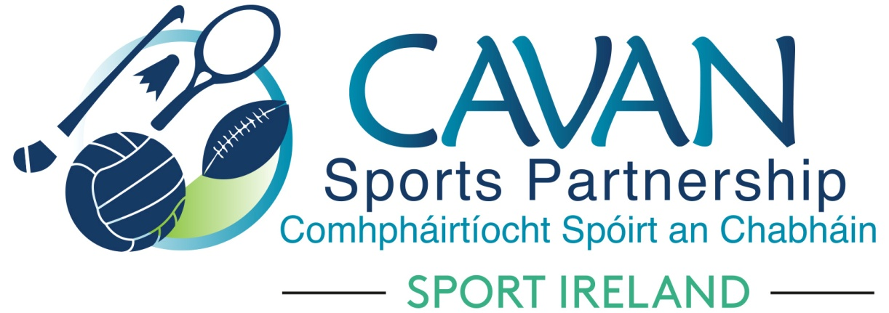
Date of Meeting: 19th November 2019 |  | Venue: Hotel Kilmore
Present: Cllr Madeline Argue, Cllr Paddy McDonald, Cllr Patricia Walsh, John Donohoe, Brendan O’Reilly, John Kearney, Colm Casey, David Cahill, Ronan Molloy, Liam McCabe
Apologies: Cllr. Brendan Fay, Enda O’Reilly, Terry Hyland
In Attendance: Nadine McCormilla, Regina Duffy

Agenda Item | Discussion / Action
1. Welcome
John Kearney, Chairperson welcomed everyone to the meeting
2. Matters arising from previous meeting
Nadine to follow up with Benny Cullen Sport Ireland regarding Performance Review Letter

Minutes of previous Board Meeting
The minutes of the previous board meeting were adopted.
Proposed: Colm Casey Seconded: David Cahill
3. Governance | a. CSP Board Member Handbook:  Nadine outlined the contents of CSP Board Member Handbook and requested each Board Member to sign this document. A copy will be sent to each Board Member  b. Sport Ireland Terms and Conditions of Grants 2020 update:  Nadine outlined the contents of Sport Ireland Terms and Conditions Sport Ireland Funding 2020. Chairperson of CSP Board to sign for funding to be released.  c. CSP Internal Audit Report by Cavan County Council 2019:  Nadine outlined the report and that findings would be sent to Cavan County Council Senior Management Team. Discussion arose regarding why procedure for Child Protection and GDPR were in the high-risk category. Clarification to be sought from internal audit committee. Draft report to be considered again at next meeting.
CSP Board | a. Skills Audit and identify areas for development;  Board Members Self Assessment Questionnaire was distributed to Board Members. This forms part of the annual Board Development Session and is an opportunity to identify areas for improvement.
CSP Finance | Nadine gave a brief update on CSP Budget.  Report attached entitled “Sport Ireland 2020 Core Grant Application dated 30th Sept 2019”.
CSP Club Grant Scheme | Nadine outlined minutes of CSP Grant Sub Committee dated 18th November 2019. Summary of successful and unsuccessful clubs was distributed to the board. Discussion arose and recommendations from Grant Sub Committee were accepted.  Proposed: John Donohoe Seconded: Ronan Molloy
CSP Staff Presentation and Q & A | Dean McElroy, Sports Inclusion Development Officer, Aine O’Reilly, Community Sports Development Officer, Aisling Maguire Hub Development Officer and Regina Duffy Administrator presented their work to the Board Members as part of the annual Board Development Session.
A.O.B. | None
8. Date of next meeting | To be confirmed.

