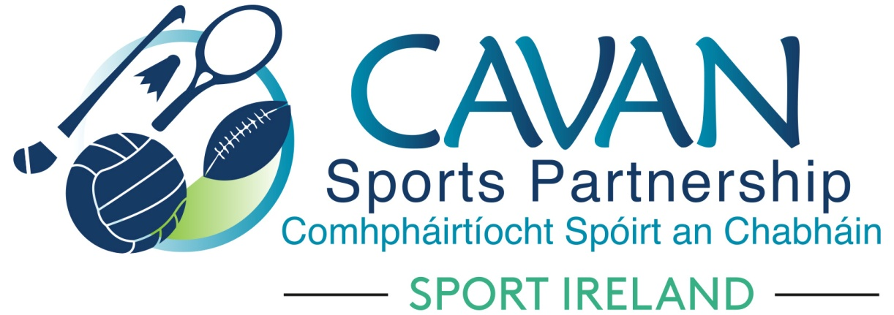
Date of Meeting: 16th October 2018 |  | Venue: Council Chamber, Courthouse, Cavan
Present: John Kearney, Cllr Madeline Argue, Cllr Paddy McDonald, David Cahill, Terry Hyland, John Donohoe, Enda O’Reilly, Carol Kiernan, Brendan O’Reilly, Colm Casey, Liam McCabe, Ronan Molloy
Apologies: Mary McMullen, Cllr. Philip Brady, Tom Downes
In Attendance: Nadine McCormilla, Regina Duffy.
Agenda Item | Discussion / Action
1. Welcome
Terry Hyland welcomed everyone to the meeting.
2. Matters arising from previous meeting
None

Minutes of previous Board Meeting
The minutes of the previous board meeting were adopted.
Proposed: Cllr Madeline Argue Seconded: David Cahill
3. Cavan Sports Partnership Annual Report 2017 | Nadine asked if board had any amendments to the Annual Report. All board members were happy with content.  Proposed: John Donohoe Seconded: Carol Kiernan
4. Sport Ireland 2019 Funding Application | N McCormilla informed the meeting that Sport Ireland has restructured the 2019 Sport Ireland Funding Application.  The Operational Plan 2019 outlining all CSP work must be submitted with the funding application. This plan must show how CSP are delivering their aims in their Strategic Plan. Sport Ireland want to capture the wide variety of work LSP’s are delivering locally. The hope is that by having access to this information they can support the securing of additional funding at a national level.  The National Sports Policy outlined that every Sports Partnership should have a full time SIDO officer in place. Sport Ireland will finance €25,000 towards this. Therefore €10,000 will be required from CSP. Colm Casey advised the Board that HSE could have funding available towards a full time SIDO officer. CSP will send an Expression of Interest to the HSE for this funding. Nadine proposed to have a backup plan incase HSE funding application was unsuccessful. Nadine proposed that the €10,000 from reserves which was allocated at the last CSP Board meeting for additional resources for the West Cavan Hub Co-ordinator be reallocated to full time SIDO position.  Proposed: Cllr Madeline Argue Seconded: Liam McCabe
5. Dormant Accounts Fund 2019 Application | N McCormilla outlined the following proposals that CSP are applying for funding under the Dormant Accounts Fund 2019  - Kilnaleck Activity Hub Phase 2  - Belturbet Activity Hub  - Youth Leadership  - Cavan’s Community Volunteer Support Programme  - Sports Inclusion Disability Project – to develop a new accessible horse riding trail  CSP board approval was required for these proposals.  Proposed: Ronan Molloy Seconded: Brendan O’Reilly  N McCormilla also informed the board that two NGB’s asked CSP to be a lead partner with them in their request for funding under the Dormant Accounts Fund 2019  - Ladies Gaelic Football Association – Project titled “Gaelic4Teens”  - Tug of War – Coach training (World TOW games taking place in Donegal 2020)  Nadine outlined NGB’s plans and how CSP will support them. This is a positive step forward for CSP in engaging with NGB’s and bringing them to Cavan. Board approval was sought to proceed with these.  LGFA Proposal - Proposed: Enda O’Reilly Seconded: Ronan Molloy  Tug of War Proposal - Proposed: David Cahill Seconded: John Donohoe
A.O.B. | Primary Schools Teachers  N McCormilla informed the meeting that she has a meeting with Cavan Monaghan ETB next week in relation to supporting a programme for in service day sport training for Primary Teachers.  Government’s National Policy for Sport 2018 - 2027  N McCormilla informed the meeting that she attended a Sport Ireland conference for 2 days for Sports Co-ordinators. The National Policy for Sport was discussed, and Sports Partnerships are a key partner in this Policy. This is very positive for Sports Partnerships.  Cavan Sports Partnership Budget January to 5th October 2018  N McCormilla went through the figures in attached budget sheet January 2018 to 5th October 2018.  Proposed: Cllr Madeline Argue Seconded: Terry Hyland  Kilnaleck Activity Hub  N McCormilla gave an update on the Kilnaleck Activity Hub.  - The BeActive Night and official opening of the Hub was very successful event. Over 600 people attended the event. Nadine thanked Cllr. Madeline Argue and Minister Heather Humphreys for officially opening the event and launching the hub.  - Upcoming Events in the Hub  - Sofa to Saddle Spin Class, Advanced Spin Class and Teen Spin Class  - LGFA Teen Skills Camp  - Multi Sport Halloween Camp  - Walk, Talk & Tone  CSP Grant Scheme 2018/2019  N. McCormilla thanked the Grant Sub-Committee for their work in relation to the attached Grant Guidelines and Application form. The Grants criteria will be under the following three headings;  - Club Coaching  - Club Equipment  - Event Sponsorship  Grants will be advertised 18th October 2018 and closing date 7th November 2018  Proposed: Cllr. Madeline Argue Seconded: Terry Hyland  Note of congratulations to our own Board Member Cllr. Philip Brady on winning the 2018 County Intermediate Football Championship with his club Mullahoran GFC.  Cllr Paddy McDonald also noted that it was very welcome to see Cavan County Council at their monthly meeting presenting U14 Cavan Ladies with a presentation for their achievements winning the All Ireland.
8. Date of next meeting | Tuesday 27th November @ 9.30 in Council Chamber, Courthouse, Cavan

