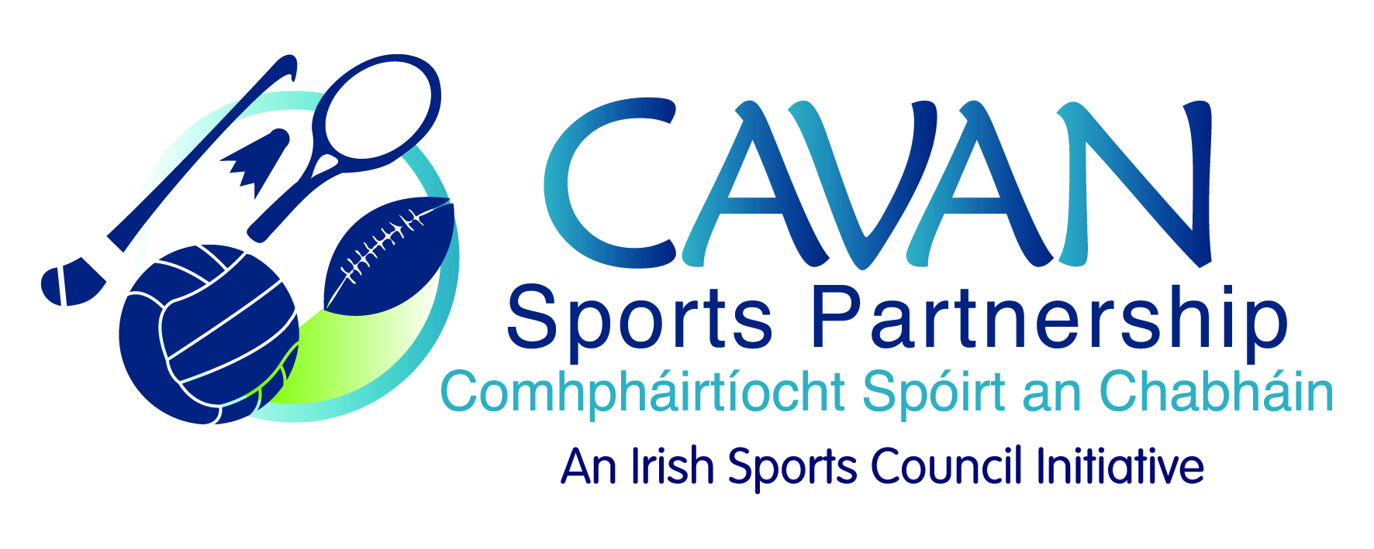
Date of Meeting: 21st June 2018 |  | Venue: Old Reference Library
Present: John Kearney, Cllr Madeline Argue, Cllr Paddy McDonald, David Cahill, Terry Hyland, Colm Casey, Ronan Molloy, Mary McMullen
Apologies: John Donohoe, Liam McCabe, Brendan O’Reilly
In Attendance: Nadine McCormilla, Regina Duffy.
Agenda Item | Discussion / Action
1. Welcome
J Kearney welcomed everyone to the meeting.
2. Matters arising from previous meeting
N McCormilla advised that no response was received from Primary Schools in relation to filling the position on CSP Board. She highlighted the need for gender balance on the board. N Mc Cormilla to identify primary school to target re nomination to the board.
N McCormilla thanked the board members for their response to the survey regarding timing of board meetings. Majority preference was morning time. N Mc Cormilla to liaise with M Mc Mullen in relation to timing of next board meeting in September..

Minutes of previous Board Meeting
The minutes of the previous board meeting were adopted.
Proposed: Cllr. P Mc Donald Seconded: D. Cahill
3. Measuring success – SPEAK Report 2017 | N McCormilla presented an outline of the SPEAK Report 2017  - The 2017 report highlighted two programmes from Cavan Sports Partnership – Community Transformation in Cootehill and the multi sport, sports inclusion programme.  - J. Kearney asked if CSP could report similar findings locally. N Mc Cormilla advised that local participation figures will be in 2017 annual report.
4. Mid term review – CSP Annual Implementation plan 2018 | N McCormilla presented an update on the Annual Implementation Plan 2018.  - N McCormilla advised that all programmes are up to date but work is required on Objective No. 3 – Marketing. Due to lack of administration support in CSP in 2017 work on this objective had not progressed as hoped.  - J. Kearney asked for the plan in relation to Marketing. Nadine advised the newsletter is in progress and social media will be continued to be used. But due to the new regulations in relation to Data Protection most of the emails used for E-shots cannot be used. Nadine advised that policy will be updated to ascertain what information can be stored and used.  - J. Kearney commented that the report was very comprehensive
5. Sport Ireland 2017 Financial Report and 25% draw down | N McCormilla informed the meeting that the 25% financial returns to Sport Ireland were underway with a deadline of 31st August 2018  - Nadine outlined the figures. (on attached presentation)  - T. Hyland advised of a new funding stream which in open – “Outdoor Rural Infrastructure Scheme”. This is available to Communities and Local Authorities for repair and upgrading of facilities. There are three varying levels/measures of funding available. N. McCormilla suggested that CSP could run programmes in any facilities upgraded from this funding.  - Mary McMullen outlined some difficulties that the school has in assessing Coilte owned grounds. N. McCormilla to liaise with M Mc Mullen and Coillte rep.
6. Dormant Accounts – Expressions of Interest received | N McCormilla informed the meeting that Sports Ireland will be announcing Dormant Accounts funding in Autumn. Three expressions of interest were received and N McCormilla outlined their proposals:  - Kilnaleck Community Sports Hub – Phase 2  - Virginia Rugby Club  - CMETB – Youth Sports Hub in Belturbet  Also a late expression of interest was received from Cavan Canoe Centre for a “Ballyconnell White Water Course”
7. A.O.B. | 1. Kilnaleck Sports Hub Launch Night  N McCormilla informed meeting that launch night for “Kilnaleck Sports Hub” is 29th September from 7pm to 10 pm and requested attendance from committee members  2. Darkness into Light Walk  Cllr Paddy McDonald remarked on the success of this walk and asked if CSP had any input. N. McCormilla advised that it is promoted through CSP facebook.  3. Cathaoirleach of Cavan County Council  J. Kearny thanked and congratulated Cllr Paddy McDonald on his successful term as Cathaoirleach over the previous year and wished Cllr Madeline Argue the very best in the coming year on her appointment as Cathaoirleach of Cavan County Council.
8. Date of next meeting | N McCormilla will inform board of time and date (after meeting with Mary McMullen)

