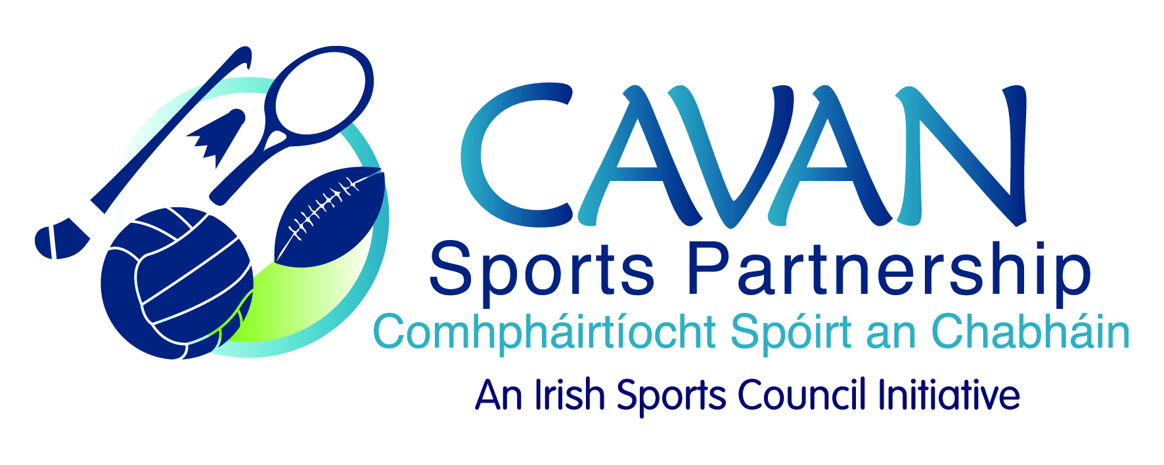
Date of Meeting: 26th September, 2017 |  | Venue: Council Chamber
Present: John Kearney, Cllr Madeline Argue, Cllr Paddy McDonald, Audrey King, John Donohoe, David Cahill, Liam McCabe, Terry Hyland
Apologies: Colm Casey, Tom Downes,
In Attendance: Nadine McCormilla, Siobhan Mulligan.
Agenda Item | Discussion / Action
1. Welcome
J Kearney welcomed everyone to the meeting.
2. Matters arising from previous meeting
N McCormilla was in contact with Sport Ireland in relation to training recommendations made in the 2016 performance review. The training and development section in Sport Ireland do not currently provide training under the area of impact, results based management and evaluation.
J Kearney proposed that a formal note be sent from the board to Sport Ireland expressing our dissatisfaction about this, M Argue seconded this.
3. Minutes of previous Board Meeting
The minutes of the previous board meeting were adopted.
Proposed: David Cahill Seconded: Terry Argue

4. CSP Workplan – | N McCormilla presented an update on the 2017 operational plan.  - Healthy Ireland Application €100,000 – CSP supported the application with a fit towns and fit schools initiative, targeting 5 areas in the County.  J Donohoe informed meeting that’s it a national policy through the LCDC, a healthy network in each county and will be launched later in the year. A sub group was set up through the LCDC, we will know by the end of October if the application was successful. It is seed funding for 2017 and maybe more to come, it has to be spent between October and March.  - Dormant Account funding from Sport Ireland, CSP have applied for  - Community Coaching – partnership with ETB and sporting NGB’s  - Community Sports Hub – Kilnaleck  - Sports Leader UK – sports leader level 1 training targeting young people in secondary schools.  - Garda Vetting – all our tutors have to be garda vetted through CSP but any tutors going into schools have also to be garda vetted through the schools. There will be a delay on the start of the schools programmes until we are sure all tutors entering schools are Garda vetted.  - Update on CSDO and SIDO update programmes and schools brochures. New NGB’s on board for programmes that were requested at our consultations by teachers.  J Kearney acknowledged all the work that has gone into organising the programmes.  - Budget – N McCormilla went through figures from June to August. Next budget figures will be up to 31st October. Budget has to be submitted to Sport Ireland by 14th November.  N McCormilla informed meeting that a new Sports Administrator, Diane McEnerney will be in place in October.
5. CSP Small Grant Scheme 2017-2021 | N McCormilla informed meeting that she met with Philip and Audrey from the grants sub committee to go through the scheme. There are 3 schemes that you can apply under  - Club Coaching max of €300  - Club Equipment for Minority Sports max of €300  - Community Mass Participation max of €1000  6 months to drawn down the grant and to have a reserve list incase some groups don’t draw it down  J Donohoe asked is there a limit how many times you can get a grant  N McCormilla informed meeting that for Discretionary 2 years in a row. John Donohoe suggested similar criteria be applied to the small grants scheme also.  N McCormilla informed meeting that we had €6,230 on grants last year and that there was €2000 left to spend. She suggested to add €2,500 to this, everyone agreed to this so total €4,500  Proposed: Madeline Argue Seconded: Liam McCabe
6. Sport Ireland 25% return draw down | N McCormilla informed the meeting that the financial report for 2016 is submitted to Sport Ireland and the final 25% of 2017 funding money has been received.  N McCormilla went through June to August accounts for 2017. Next budget figures will be up to 31st October. Budget has to be submitted to Sport Ireland by 14th November.
7. Strategic Plan 2017- 2021 | N McCormilla gave an update on the plan;. Presentiation to the elected members at their July meeting. The executive summary designed document was given to board members and feedback welcomed. N Mc Cormilla suggested to the board that the designed executive summary is printed (1000 copies) and distributed widely and the larger document of the full strategy is available online or in hard copy by request. All board members agreed to go with this format  Proposed: Madeline Argue Seconded: David Cahill  - Launch of strategic plan –  N McCormilla asked the members if they had any ideas for the launch any other nice activities going on. A discussion took place on using the launch as an opportunity to highlight some of the other work that was going on e.g. if we were successful with the dormant accounts sports hub application or the awarding of our sports club grant scheme.  L McCabe suggested that the plan could be launched in Breffni park  N McCormilla was in contact with Minister Humphrey’s office to see if she would be available for the launch, at the minute the week of the 6th November she is free. We will also invite John Tracey from Sport Ireland.  J Kearney suggested as a board we need to contact Sport Ireland and inform them of the development of the strategic plan, issue and invitation to the launch.
8. Board member review – feedback | N McCormilla went through the findings:  - Knowledge of sport very strong  - Research, media, fundraising and project management – weak areas  J Kearney acknowledged that the board has significant skills  J Donohoe we need to maintain this when going with a new board  N McCormilla – highlighted the need for skills within the branding and marketing area but suggested that these could be sourced externally rather than to look within the board for this resource.  J Kearney highlighted the need to emphasise the guidelines in relation to non attending board members within the staff handbook
9. A.O.B. | 1. Funding  N McCormilla informed meeting that Sport Ireland have suggested we have a number of “bottom drawer” projects that would be ready to go if a funding call was announced. It was decided to make a call to all clubs and organizations for such projects under an ‘expression of interest’ scheme in November.  2. GAA Camp  T Hyland thanked Nadine and Liam with all their help with the Congolese camp this year. It was a great event  N McCormilla said it was an example of good partnership working.  3. Run with Catriona  P McDonald asked if we are supporting them this year  N McCormilla CSP provided funding for the last 2 years. CSP are running the Couch to 5K programme at the minute and this will encourage numbers to attend the event. CSP are also promoting it on social media  J Donohoe Council have given sponsorship towards the prize fund  - Board Reconstitution  N Mc Cormilla informed members that the board three year term expires in October 2017. All board members will receive nomination papers to take back to their organizations. A sporting nomination evening will also be held.
6. Date of next meeting | N McCormilla suggested that the current and new members come together an hour before launch  J Kearney thanked Nadine and her colleagues for all the hard work this year.

