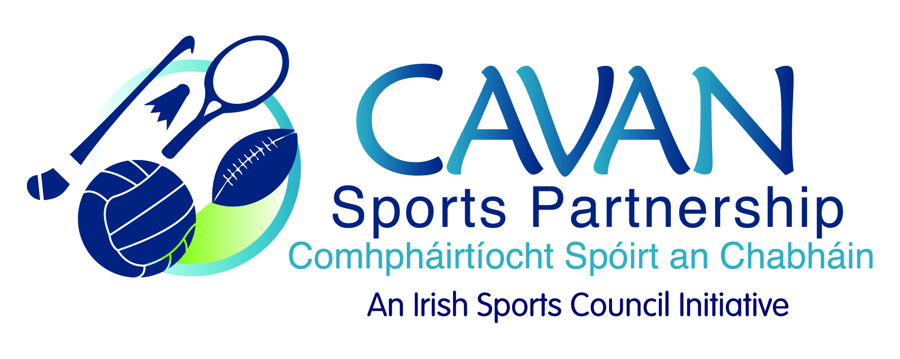
Date of Meeting: 8th June, 2017 |  | Venue: Council Chamber
Present: John Kearney, Cllr Madeline Argue, Cllr Paddy McDonald, Audrey King, John Donohoe, David Cahill
Apologies: James Sherry
In Attendance: Nadine McCormilla, Siobhan Mulligan.
Agenda Item | Discussion / Action
1. Welcome
J Kearney welcomed everyone to the meeting.
2. Formal adoption of new board members
a. James Sherry, Secondary Schools Representative
b. David Cahill, Disability Representative
Proposed: Cllr. Madeline Argue Seconded: Cllr. Paddy McDonald
3. Minutes of previous Board Meeting
The minutes of the previous board meeting were adopted.
Proposed: Audrey King Seconded: Cllr. Paddy McDonald

4. CSP Workplan – Mid year review | N McCormilla presented the mid year report on the 2017 operational plan.  - CSP are on track with all actions and are awaiting direction from the health and safety section of Cavan Co. Co. in relation to the development of the risk register (Deloitte Audit action outstanding).  - CSDO Traveller programme on hold as the group are not in position to take part until later in the year.  - CSP continue to evaluate programmes, N Mc Cormilla informed the board about the challenges faced in developing evaluation methods to suit the variety of groups/programmes and the various success measures in order to measure impact. CSP currently collate case studies of success.  J Kearney asked if CSP have received any guidelines from Sport Ireland for doing this, and suggested a request to be sent to SI seeking assistance in the development of appropriate evaluation methods.  J Donohoe emphasised the need to collect baseline data  Cllr. P McDonald asked if CSP has sufficient staff/resources to be able to do this  J Kearney reinforced the need something to show the work plan working and the data to show to Sport Ireland.  N McCormilla to contact Sport Ireland for assistance and to draw up costings for support to develop programme evaluation tools/templates.
5. Sport Ireland 25% return draw down | N McCormilla informed the meeting that notification had not currently been received from Sport Ireland for the financial report for 2016 to be submitted but that this document is almost complete and ready to be sent to the head of Finance for sign off.  N McCormilla went through January to April accounts for 2017.  N McCormilla Informed the meeting that there is a new agresso system in Cavan Co. Co. which will result in a number of changes in the procurement of goods and services for CSP.
6. Strategic Plan 2017- 2021 | N McCormilla briefed the board on the format and findings from the public, stakeholder, NGB and online consultation sessions.  N Mc Cormilla gave an outline of the first draft of the strategic plan and all board members received a copy of this and were asked to review and revert back with comments/amendments by Thursday 15th June.  The board requested the plan be presented in draft format to the elected members for the July Council meeting.  N Mc Cormilla following the presentation to elected members and draft submission to Sport Ireland, the final draft will be sent to the strategic planning sub committee for sign off and then sent for design and print with the aim to launch the plan in September.
7. Board member review – feedback  Sport Ireland Review | It was agreed to leave this item until the next meeting when all members were present  A discussion took place on ‘non attending board members’  N McCormilla current vacancies for members from PPN, National Schools and 2 sporting representatives.  J Donohoe to speak with PPN Co-coordinator about nominating a representative  J Kearney suggested addressing the issue of non attendance when the board is formally re-constituted in October 2017.  J Kearney informed meeting that a meeting with Sport Ireland took place on Friday 2nd June. John Donohoe and Nadine Mc Cormilla were present along with Ms. Una May and Ms. Gillian Costello from Sport Ireland. Sport Ireland have agreed to return to Cavan when our strategic plan is operational and conduct another performance review. In the meantime Sport Ireland will be conducting a review of the performance evaluation template currently in use in this performance review.
6. A.O.B. | 1.Bike Week  N McCormilla invited board members to a photocall for the launch of bikeweek 2017 in Cavan Canoe Centre on Tuesday 14th June.  2. Discretionary funding  N McCormilla expecting an application for Discretionary funding from Cavan Triathlon club for their event at the end of July. As this event was very successful last year and groups are allowed to apply for two years in a row for funding; this group was deemed to be successful for this years application also.  N McCormilla informed meeting that SI had made a call for dormant accounts funding under two measures  - €72,000 Community Sport hub  - Community Coaching - €16,000  A discussion took place among board members on the short time frame on which this money is to be spent, if the application is successful. It was decided that CSP would apply under both measures.  J Kearney thanked Nadine for all her work especially with the strategic plan and thanked everyone for coming.
6. Date of next meeting | Next board meeting; Tuesday 26th September at 9.30am

