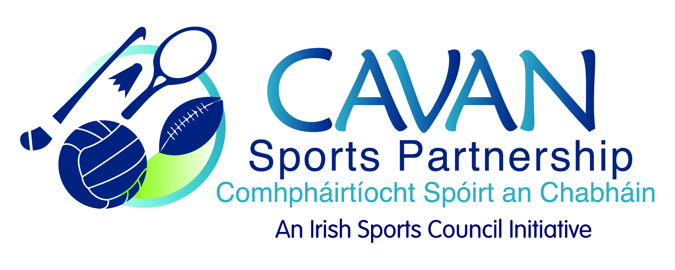
Date of Meeting: 14th February, 2017 |  | Venue: Breffni Integrated
Present: John Kearney, Cllr Madeline Argue, Tom Downes, Liam McCabe, Cllr Paddy McDonald, Audrey King, Cllr. Philip Brady,
Apologies: John Donohoe, Terry Hyland, Philip Mc Donald, Colm Casey
In Attendance: Nadine McCormilla, Siobhan Mulligan.
Agenda Item | Discussion / Action
1. Welcome
J Kearney welcomed everyone to the meeting.
2. Minutes of previous Board Meeting
Matters arising: N McCormilla informed the meeting that the Sport Ireland performance review had not been received to date and Sport Ireland have requested to attend the next board meeting and present their findings.

J Kearney requested that the board have a copy of the report before a meeting with Sport Ireland and acknowledged the preparation work by both CSP staff and board members for the review.
N McCormilla thanked everyone for taking part
The minutes of the previous board meeting were adopted.
Proposed: Audrey King Seconded: Cllr. Paddy McDonald

3. Sport Ireland 2017 Budget Allocation | N McCormilla informed meeting that Sport Ireland allocated CSP a 2017 budget of €171,505. N McCormilla went through the allocation in detail.  Cllr. M Argue complemented the CSP team on their work to date and acknowledged this significant budget increase was as a result of achievement’s to date.  N McCormilla informed meeting that CSP’s closing balance was approximately €83,458.78. CSP are awaiting Cavan Co. Co. 2016 financial returns and therefore accurate figures will be presented at the May board meeting.  N MCormilla sought approval from the board for a number of items for the 2017 budget:  Budget Spend needing approval from Board  1.Contingency fund: €2,500  Contingency fund balance currently at €17,500 and as per Sport Ireland recommendation CSP board agreed to transfer €2,500 into contingency each year to reach a fund of €30,000. Nadine Mc Cormilla to look at programme income from 2016 as a possibility of using this towards contingency.  Proposed: Cllr. Madeline Argue Seconded: Liam McCabe  N McCormilla  2. Walking Festival 2017- €1,000  Proposed: Cllr. Paddy McDonald Seconded: Tom Downes  3.Grants Scheme -  N.Mc Cormilla explained to the board that the smaller grant scheme is not proving effective with groups not drawing down grants awarded. Mass participation is working well. The grant subcommittee will meet and discuss all options with the board re 2017 grant scheme.  Grant Sub Committee – Cllr Philip Brady & Audrey King will stay in situ.  4.Strategic Plan - €2,500 awarded from Sport Ireland in 2015.  Strategic plan subcommittee: J Kearney, Cllr. Madeline Argue and J. Donohoe (previously expressed interest)
4. CSP Work Plan 2017 | N McCormilla stressed the importance of evaluation on all programmes and reporting our ‘good new stories’.  N McCormilla went through the plan under each of the headings and asked the board to read through it and come back with any comments.  J Kearney suggested the work plan to be included on the agenda for next meeting to allow time for board members to go through it.  J Kearney thanked Nadine for all her work and suggested an email to be sent to all board members with options of dates and times for the upcoming board development session.
5. Non Attending Board Members | N McCormilla went through the board members handbook and guidelines for non-attending members. There is currently no representation from PPN/community, Disability sector, Primary & Secondary schools.  J Kearney suggested these groups be contacted to nominate a representative  N McCormilla asked if times and format of meetings suited everyone. All agreed to keep meetings at 9.30am.  N McCormilla asked all board members to fill out the contact details form.
6. AOB | Cllr. Argue said that the Community Transformation launch in Cootehill was a great success  N McCormilla thanked everyone that represented CSP and supported the various community transformation launches.  N McCormilla thanked the board for their input and attendance.
6. Date of next meeting | Board development session; Thursday 6th April at 9.30am  CSP board meeting: Tuesday 30th May at 9.30am

