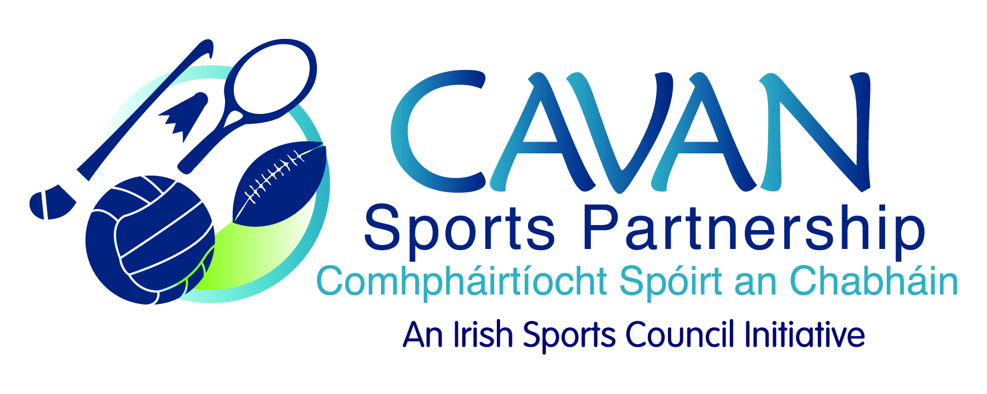
Date of Meeting: 2nd December, 2016 |  | Venue: Breffni Integrated
Present: John Kearney, John Donohoe, Terry Hyland, Cllr M Argue, T Downes, Cllr P. McDonald, Audrey King, Colm Casey, Philip Mc Donald
Apologies: Cllr P. Brady, Liam McCabe, Niall Smith
In Attendance: Nadine McCormilla, Aine O Reilly.
Agenda Item | Discussion / Action
1. Welcome
T. Hyland welcomed everyone to the meeting.
2. Minutes of previous Board Meeting
The minutes of the previous board meeting were adopted.

Proposed: Cllr. Madeline Argue Seconded: Tom Downes

3. (a) Sport Ireland Performance evaluation of Cavan Sports Partnership  (b) Deloitte Audit recommendations; document review and sign off.  (c) Cavan Co. Co. Internal audit report | N McCormilla CSP has now met all the recommendations from both the Deloitte 2015 and Cavan Co. Co. 2016 audits. N Mc Cormilla explained the background and process of the Sport Ireland performance review. The board members taking part in the sport Ireland interviews were thanked.  N McCormilla went through the draft audit documents previously provided to the board.  - CSP board member handbook  Proposed: Cllr. P McDonald Seconded: Tom Downes  Non attending board members to be included on the agenda for the next CSP board meeting.  - CSP board development documents (Effectiveness review and skills audit)  Proposed: A King Seconded: Cllr. Paddy McDonald  N McCormilla explained Cavan Sports Partnership has completed and implemented all Deloitte 2015 audit recommendations.  N McCormilla The board were given copies of the internal audit report conducted by Cavan Council and the recommendations from this were discussed. Cavan Sports Partnership has now completed and implemented all County Council internal audit recommendations.  Proposed: C Casey Seconded: Cllr. M Argue
6. Date of next meeting | J Kearney thanked the board for their input and attendance.  Friday 21st February at 9.30am in Breffni Integrated

