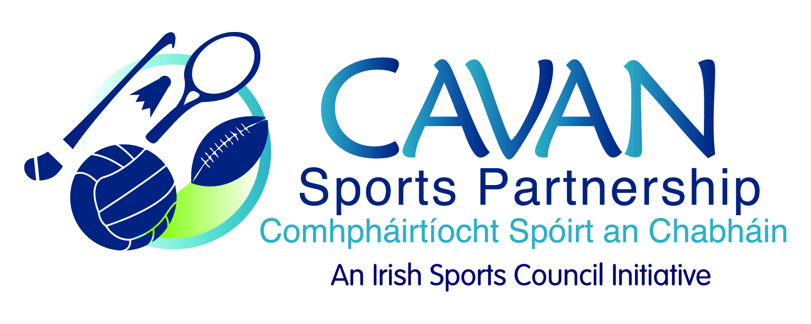
Date of Meeting: 26th September, 2016 |  | Venue: Council Meeting Room
Present: John Kearney, Terry Hyland, Colm Casey, Audrey King, Cllr M Argue, Cllr P Brady, T Downes, J. Donohoe, N Smith
Apologies: Cllr P. McDonald, L McCabe
In Attendance: Nadine McCormilla, Anne Marie Smith.
Agenda Item | Discussion / Action
1. Welcome
J Kearney welcomed everyone to the meeting.

2. Minutes of previous Board Meeting
Matters Arising : N McCormilla informed the board:
- Funding application to the HSE was unsuccessful.
- Sport Ireland application for Sports Development Officer was successful and Aine O’Reilly has taken up the position.
Cllr M Argue: Welcomed Aine and wished her well in her new position.
The minutes of the previous board meeting were adopted.
Proposed: T Hyland Seconded: A King
3. 2015 budget return & 25% drawdown for 2016 | N McCormilla presented the 2015 budget submitted to Sport Ireland and a handout was given to each board member.  N McCormilla also presented a handout detailing the allocation of the opening balance 2016 (€79,435.98).  Cllr M Argue enquired when the Inclusive Cycling programme took place and do CSP have inclusive bicycles for hire?  N McCormilla: The inclusive cycling programme was a six week programme which was delivered during Bikeweek 2016 but will be delivered again during the year and will be advertised in CSP e-shot and also the Anglo Celt. CSP has also submitted a funding application to IPB for the purchase of inclusive bicycles.  The 2015 budget return was adopted:  Proposed: Cllr P Brady Seconded: Cllr M Argue
4. CSP 2016 Grant Scheme | N McCormilla presented a summary of the grant scheme (handout).  A discussion took place in relation to the clubs who have not recouped monies which were granted to them.  N Mc Cormilla informed the board that the clubs had received a reminder letter and email in relation to the closing date for recoupment of the grant.  N McCormilla proposed closing off the grant scheme for 2016.  Proposed: J Donohoe Seconded: T Hyland  N McCormilla proposed to defer the next grant scheme until February, 2017 and keep the discretionary grant scheme open.  Proposed: C Casey Seconded: Cllr M Argue  Actions: CSP will follow up with BJD Celtic and Breifne Swim club as both have been granted extensions.
5. Discretionary Funding Support Criteria | N Mc Cormilla presented the amended criteria and application form as requested at the last board meeting.  The application form and criteria were adopted:  Proposed: Cllr P Brady Seconded: Cllr M Argue  N McCormilla presented two grant applications from Run with Catherina and Cavan Camogie Board. Both applicants requested €1000.00.  Following board discussion it was proposed that:  - Cavan Camogie board be granted €800.00  - Run with Catherina be granted €400.00  Proposed: T Hyland Seconded: Cllr M Argue  It was confirmed that the grant sub-committee would remain in situ and consist of N McCormilla, Cllr P Brady and A King.
6. Workplan Update | N McCormilla presented the workplan update: (Handout)
7. A.O.B. | The next meeting will be held on Tuesday 25th October, 2016 at 4pm.  The success of Leona Maguire was acknowledged by the board and  N McCormilla asked for suggestions on how CSP can recognise the achievements of the sports people in the county in the future.  Cllr P Brady suggested a presentation, as part of the Co. Co. Cathaoirleach awards. J Donohoe to explore this further.  Cllr M Argue congratulated J Kearney on his new position as Chief Executive of Cavan and Monaghan Education and Training Board.
7. Date of next meeting | J Kearney thanked the board for their input and attendance.

