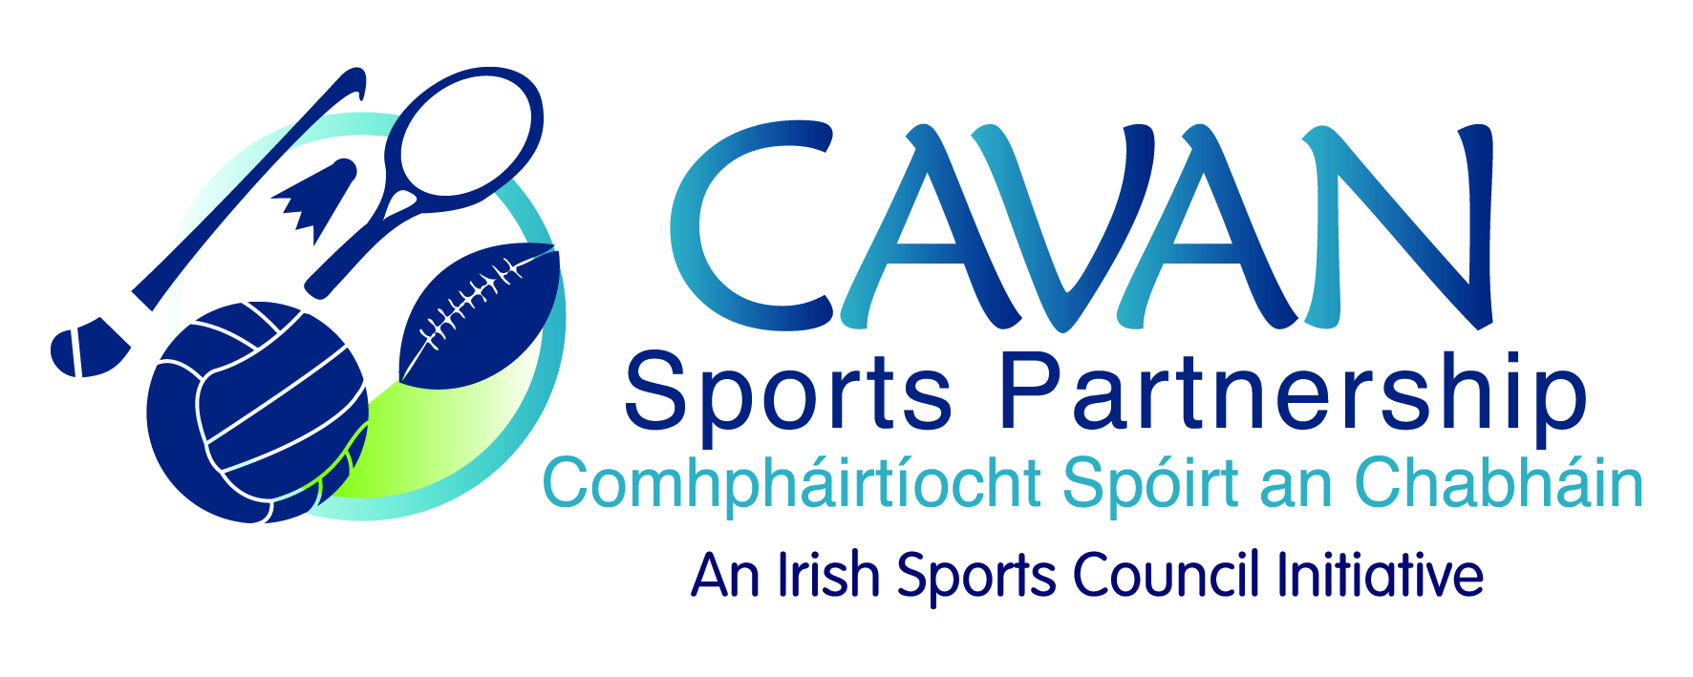
Date of Meeting: 7th November, 2016 |  | Venue: Breffni Integrated
Present: John Kearney, J. Donohoe, Terry Hyland, Cllr M Argue, Cllr P Brady, T Downes, Cllr P. McDonald,
Apologies: Liam MCCabe, Audrey King
In Attendance: Nadine McCormilla, Aine O Reilly.
Agenda Item | Discussion / Action
1. Welcome
T. Hyland welcomed everyone to the meeting.

2. Minutes of previous Board Meeting
The minutes of the previous board meeting were adopted.

Proposed: J. Donohoe Seconded: Cllr. Philip Brady
3. Sport Ireland Funding application | N McCormilla welcomed Aine O’Reilly as CSDO to the board and thanked Terry Hyland for the use of Breffni Integrated offices for the board meeting.  N McCormilla presented the 2017 funding application to be submitted to Sport Ireland and informed the board of application for Administrator maternity cover and extension of Community Development Officer position.  N McCormilla also gave a detailed breakdown of programmes to be applied for and informed the board that education and training reserves are to be spent.  Cllr M Argue stated that everything seemed to be covered and commended the variety of programmes, especially the ‘Yoga for Parkinson’s’ programme.  J. Donohoe concurred that the majority of population groups were being targeted.  A discussion took place on the delivery of the programme targeting traveller women  Cllr. M.Argue enquired how the ‘Move to Lose’ programme aimed at Traveler women would be delivered?  N McCormilla stated a partnership delivery with the HSE and Cavan Traveller Resource worker along with a consultation with the local traveller women would form the basis for this programme.  Sport Ireland 2017 Cavan Sports Partnership was formally adopted by the board.  Proposed: Cllr M Argue Seconded: P. McDonald
4. Sport Ireland performance evaluation of Cavan Sports Partnership | N McCormilla informed the board that Cavan Sports Partnership has been selected for Sport Irelands evaluation performance review. A list of documents on the review were circulated outlining the process involved and documents required by Sport Ireland to be submitted prior to Dec 13th. Sport Ireland will conduct 7 interviews with board members and staff of Cavan Sports Partnership on Dec 13th.  N McCormilla then thanked J. Donohoe, J.Kearney, T. Hyland and Colm Casey for agreeing to be interviewed and invited any other board members to be part of the interviewing process, if they so wished.  Cllr. M Argue: Wished Cavan Sports Partnership well with the review.  J. Kearney proposed a meeting to be held prior to this evaluation to go through all documents and to ensure all board members are familiar with them.  T. Hyland enquired if documents will be publicly accessible?  N. McCormilla will clarify this but a draft report will be presented to the Cavan Sports Partnership board for response prior to sign off.  J. Donohoe suggested documents be circulated electronically prior to submission.  T.Hyland made an enquiry in terms of the interviews, and any questions that may be asked?  N.McCormilla to contact previously interviewed Sports Partnerships re interview process.  N. McCormilla to circulate board documents electronically prior to submission.  Proposed: Cllr. M.Argue Seconded: T.Downes
5. A.O.B. | Contingency fund, proposed that as per Sport Ireland requirements €2,500 to be transferred from training and education to contingency fund.
6. Date of next meeting | J Kearney thanked the board for their input and attendance.  Friday 2nd December, at 9am in Breffni Integrated

