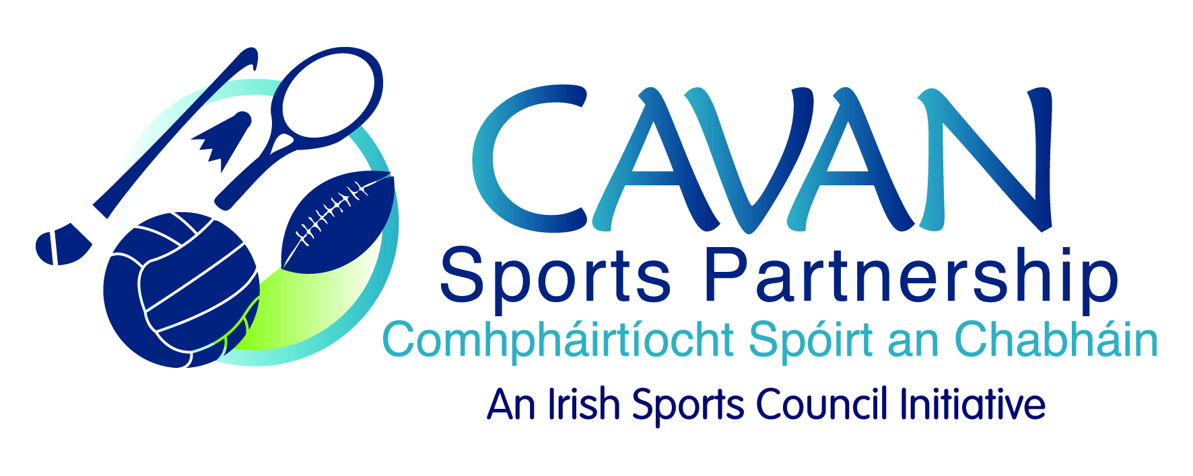
Date of Meeting: 31st May, 2016 |  | Venue: Council Meeting Room
Present: John Kearney, Liam McCabe, Terry Hyland, Colm Casey, Philip McDonald, Audrey King, Cllr Paddy McDonald.
Apologies: Cllr Madeline Argue, John Donohoe, Tom Downes.
In Attendance: Gráinne Boyle, Anne Marie Smith.
Agenda Item | Discussion / Action
1. Welcome
J Kearney welcomed everyone to the meeting.

2. Minutes of previous Board Meeting
Matters Arising : None
The minutes of the previous board meeting were adopted.
Proposed: L. Mccabe Seconded: A. King
3. Annual Report | G. Boyle presented the 2015 Annual Report and discussed the number of participants taking part in programmes compared with 2014.  The Annual Report was adopted:  Proposed: T. Hyland Seconded: Cllr. P. McDonald
4. Budget 2016 | G. Boyle presented the budget approved by Sport Ireland:  €138,948 is approved by Sport Ireland for 2016.  €134,998 is core funding which includes €2,500 for the Strategic Plan  €1,450 for Sport Ireland Women in Sport programmes, €2,500 for Sport Ireland programmes.  Reserves fund approval was sought for the following:  Sports Co-ordinator salary for Maternity leave cover from the 1st June – 13th July  Proposed: Cllr. P. McDonald Seconded: C. Casey  G. Boyle will circulate the budget document to the board members.
5. CSP Workplan update | G. Boyle presented the following:  - Walking Festival – took place from the 29th April – 8th May, 2016. Twenty nine walks held over ten days. This was a great event with positive feedback. A review with the partners will be held.  - Bikeweek 2016: The flyer has been distributed and the launch will take place on the 11th June. Bike week is funded by the Dept. of Transport, Tourism & Sports. There is a six week inclusive cycling course also taking place that will finish the week before Bikeweek.  - Community Transformation: Took place in Cootehill and finished in February. There was 190 participants and the programme was a great success.  - Sports Leader: St. Mogue’s Secondary School in Bawnboy took part in this programme and 25 students completed the course. There is additional funding available for this programme however a tutor has to be sourced to deliver the course as unfortunately the trained tutor is no longer available.  - Community Coaching: The second programme is currently running with eight participants taking part. The course is due to finish mid June and one participant who completed the first course will be doing work experience with CSP.  - Funding Applications: the following funding has been applied for:  - Sport Ireland – Development Officer 6 month Contract  - National Recreation Week – In conjunction with Taste of Cavan  - National Play Day – In conjunction with County Childcare Committee  - National Lottery Funding – Health & Well Being programme  - Bowling Green – has been officially opened and there is a programme being delivered at the moment for adults with a disability.  - Inclusive Cycling Programme: This is a six week programme which will be delivered in connection with Bikeweek.  - Active Adults: There are a number of programmes being delivered.
6. Discretionary Funding Support Criteria | G. Boyle circulated draft criteria and presented same.  A discussion took place in relation to the number of participants required to take part in an event in order for it to qualify as a mass participation event.  G. Boyle will clarify with Sport Ireland have they a number to define mass participation or is it at the discretion of the LSP.  J. Kearney requested that it should also be included in the criteria the application process will involve completing an application form which will be presented for Board consideration and approval.  G. Boyle will remove the Health & Safety from the heading ‘What you can apply for’ and add it in the terms and conditions.  G. Boyle will edit the criteria and circulate. This will be discussed at the next meeting.
7. A.O.B. | - G.Boyle presented details on the Regulation of Lobbying Act to the board.  “It was noted and agreed that the committee will comply with the Transparency code of the Public Lobbying Act 2015. The will be done by regular circulation of minutes and the agenda of committee meetings on the Council website. The website will also detail membership and terms of reference of the committee.”  Proposed: T. Hyland Seconded: Cllr. P. McDonald  - G. Boyle presented details to the board in relation to Town Team Meetings taking place in Virginia, Cootehill & Cavan.  - J. Kearney: Run with Catherina funding will be discussed at the next meeting.  - L. McCabe: Is CSP aware of any summer camps that are suitable for 15/16 year old students?  G. Boyle suggested that maybe an information guide listing all the sport related summer camps running within the County could be compiled as a guide for parents.
7. Date of next meeting | J Kearney thanked the board for their input and attendance. Next meeting date set for Tuesday 13th September, 2016 at 10.00am.

