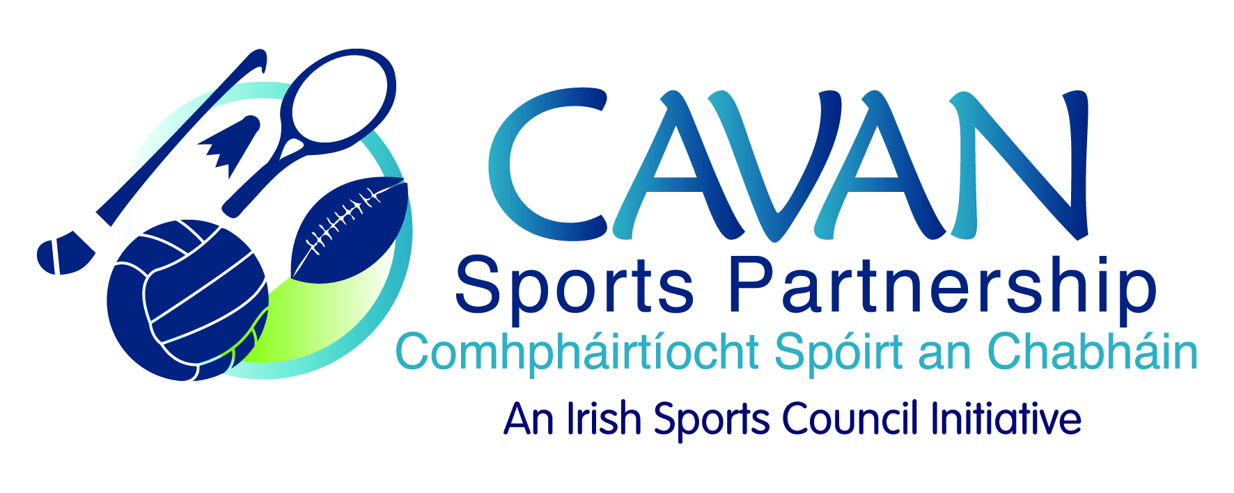
Date of Meeting: 16th February, 2016 |  | Venue: Council Meeting Room
Present: John Kearney, Liam McCabe, Niall Smith, John Donohoe, Terry Hyland, Colm Casey.
Apologies: Cllr Madeline Argue, Ray Verschoyle, Audrey King, Cllr. Paddy McDonald.
In Attendance: Gráinne Boyle, Anne Marie Smith.
Agenda Item | Discussion / Action
1. Welcome
J Kearney welcomed everyone to the meeting.

2. Minutes of previous Board Meeting
Matters Arising :
G. Boyle informed the board that confirmation of the 2016 budget from Sport Ireland had not been received to date.
The minutes of the previous board meeting were adopted.
Proposed: C. Casey Seconded: T. Hyland
3. CSP Workplan Update | G. Boyle presented a work plan update:  Dormant Accounts: One Sports Leader course is completed and two schools are interested in taking part in the next course. One Community Coaching course is completed and the next 10 week course will commence on the 28th March, 2016.  SPEAK: The SPEAK report has been compiled and an Annual report will be produced.  Newsletter 2015: Printed and circulated.  Courses: Safeguarding 1 & 2 courses are scheduled for 2016.  Walking Festival: Will take place 29th April – 8th May, 2016. The launch will take place on the 1st April at the Slieve Russell hotel. There are 28 walks registered and the Get Ready to Walk workshop will take place on the 24th February, 2016.  Operation Transformation Walk: Took place on the 9th January in Cootehill. There was a great turn out with 150 participants and this also kick started the Community Transformation programme in Cootehill.  Primary School Teacher Training Courses: Booklet of training courses forwarded to the primary schools.  Sports Inclusion/Active Adults: programmes scheduled. Grant of €1000 received from Go For Life.  Bikeweek 2016: expression of interest forms sent out to clubs and also cycling training offered to clubs.  L. McCabe to get Children’s Officer to link in with CSP in relation to training.
4. Run with Catherina | J. Donohoe presented the budget. He informed the board that Annalee Athletics Club is willing to take on the running of the event themselves this year. However they would require some assistance of financial support.  A discussion took place and a decision was made that as long as the event satisfies the discretionary fund criteria the club can present a proposal to the board requesting funding. A decision can then be made.
5. Budget 2016 | G. Boyle presented the following:  - CSP applied for €149,143.70 in funding support to Sport Ireland for 2016. No approval has been received to date.  - Reserves Fund Approval:  Contingency Fund approval - €2,500 to be taken from reserves to go into contingency fund  Proposed: C. Casey Seconded: L. McCabe  Maternity Leave Cover - €5,131.77 to cover the maternity leave post for the month of December  Proposed: C. Casey Seconded: T. Hyland  Cavan Walking Festival - €800 towards Cavan Walking Festival 2016  Proposed: N. Smith Seconded: C. Casey  - Request for funding support from groups:  Cavan night run - €400 fundraising event by local voluntary group.  Cavan Triathlon Club - €1,000 towards their first hosting of a National Triathlon Event within the county.  Proposed: L. McCabe Seconded: C. Casey  Discussion took place and it was decided that criteria needs to be drawn up in relation to groups requesting funding support.  G. Boyle will draft criteria for the next meeting.
6. A.O.B. | L. McCabe raised an issue where some players were being asked to decide between playing GAA or Soccer and asked if CSP could advise with the issue. L. McCabe will clarify the facts and then revert back.
7. Date of next meeting | J Kearney thanked the board for their input and attendance. Next meeting date set for Tuesday 31st May, 2016 at 10.00am.

