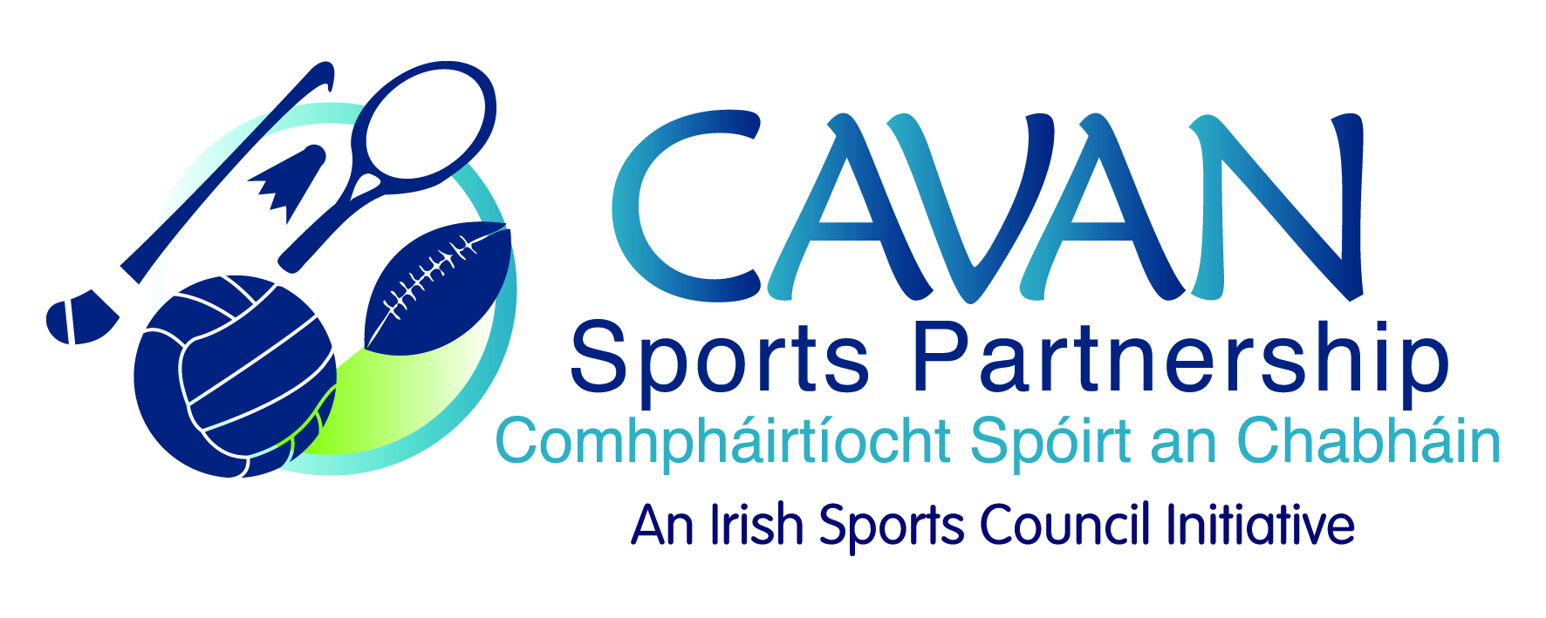
Date of Meeting: 17th November, 2015 |  | Venue: Council Meeting Room
Present: John Kearney, Liam McCabe, Audrey King, Tom Downes, Cllr Philip Brady, Cllr Paddy McDonald, Terry Hyland, Colm Casey, Cllr Madeline Argue, Philip McDonald
Apologies: Ray Verschoyle, Niall Smith, John Donohoe
In Attendance: Anne Marie Smith, Nadine McCormilla,
Agenda Item | Discussion / Action
1. Welcome
J Kearney welcomed everyone to the meeting.
2. Minutes of previous Board Meeting
Matters Arising : None
The minutes of the previous board meeting were adopted.
Proposed: Cllr P Brady Seconded: Cllr Paddy McDonald
3. ISC Grant application & CSP Workplan 2016 | N McCormilla presented a work plan for 2016 with finding column showing work areas being applied for through the Sport Ireland 2016 grant application. Main points from discussion:  - The budget allocation from Sports Ireland will not be known until February, 2016.  - The main piece of work for 2016 will be the development of Cavan Sports Partnership Strategic Plan for 2016-2018. As Sport Ireland is currently developing a new National strategy N McC recommended to the board that the new CSP strategic planning process does not begin until quarter 2 of 2016 to hopefully gain some national direction.  - Walking Festival: it is not envisaged that funding will be received for the walking festival 2016 and approval will be sought from the board in 2016 for funding reserves to be allocated to this project.  - Operation Transformation: National walk takes place January 9th and we plan to link with Cootehill Parkrun to deliver this. There will be a small amount of funding available.  - Bike week 2016: Funding of €5,000 from Department and also 2015 unspent funding for cycling programmes will be delivered.  - Communications: usually no budget from Sport Ireland so approval will be sought from the board for funding in 2016.  - N. McCormilla informed the board that at the last Sports Council meeting John Treacy acknowledged all the great work being done by the Sports Partnerships and said in 2016 Sports Ireland would be concentrating their support on the smaller Sports Partnerships.  - There will also be additional funding through dormant accounts.  J. Kearney complemented N. McCormilla on the range of programmes and asked if anyone had any questions or comments to make.  J. Kearney then updated the board on Run with Catherina 2015 the main points were:  - There was a difficult working relationship between the partners  - Unfortunately we are not in a position to present a transparent budget at this time.  - Event was showing a loss of approx €6,000.00  - meetings have taken place and the loss is now approx €3,000.00  - There is an agreement in place regarding the loss of €3,000.00 and when this is finalised a full budget will be presented to the board.  - Cavan County Council has signaled they will be stepping back from the event in 2016.  The following board discussion then took place:  N McCormilla agreed with all the points made and suggested the board should look at a number of points  - Why is Cavan Sports Partnership involved?  - Any event which CSP are supporting there should be an exit strategy so the event continues and CSP reduce the support given. This event has received support for 3 years and the work load for CSP has increased over the 3 years.  - CSP role is increasing participation in sport so should the club be given the opportunity to apply for a CSP discretionary grant?  Cllr P. Brady: what was the main expense?  N McCormilla: PR, marketing and the prize money were the largest expenses. CSP processes the invoices but the participant income and the sponsorship received by Annalee Athletics Club has not been disclosed.  J. Kearney: Unfortunately making the event larger did not attract more participants.  T. Downes: What income does the event gross?  N. McCormilla: CSP received a figure from Annalee Athletics of chipped time registrations. This is the only tangible figure that has been presented as the club has indicated that they were not in a position to give an accurate number of participants.  C. Casey: Chipped time figure would not cover all registrations.  N. McCormilla: CSP do not process registrations so we have to take the figure given.  J. Kearney: the issue of the budget was raised with Annalee Athletics after last year’s event.  Cllr P. Brady: Is it possible for another club to take the event on?  J. Kearney: A lot of time, effort and manpower were invested in this event.  C. Casey: This has to be done to see if an event works.  J. Kearney: Working relationships have to be productive.  C. Casey: Did Annalee Athletics Club lose any money with Precision Timing.  N.McCormilla: No not that we are aware of.  Cllr P. McDonald: There should be an element of trust and any event making a loss CSP cannot support for the betterment of the county.  C. Casey: The event may not be making a loss there is income.  J.Kearney: Annalee Athletics Club would not be making a fortune out of the event.  L. McCabe: If the County Council step back can Annalee Athletics Club run the event?  J. Kearney: May be not to the same scale. Maybe an event for 300/400 participants.  L. McCabe: If the County Council took on to deliver the event would that work? It’s a great event.  J. Kearney: That could be explored.  N. McCormilla: CSP and Cavan County Council could deliver the event but that is not our role. We could go through the county board and get more clubs involved in the event but only a small number of participants were from athletics clubs. Catherina is also affiliated to Annalee Athletics Club. This event could not be delivered without Cavan County Council manpower.  Cllr. M. Argue: If CSP step away we need to be aware of reports in the media. The board will be guided by what J. Kearney and N. McCormilla say.  T.Hyland: Has Annalee Athletics Club been spoken to?  J. Kearney: Yes they have been spoken to.  C. Casey: In my experience of running events like this the local County Council provided cones etc however it was club members who set these up never a county council employee. It is very unique that the county council support an event to this extent - the event is very fortunate to have this support.  N. McCormilla: Are the board happy if CSP step back from this event?  T. Downes: Need to present transparent accounts for this to work.  Cllr. M. Argue: can an auditor be appointed to analyse the accounts?  J. Kearney: This has been discussed but we would require more tangible information for the process to be effective and perhaps the bigger issue at play here is the lack of transparency and trust between the partners.  L. McCabe: Have you spoken to Catherina?  J. Kearney: Not yet. When we are clear on our actions going forward we will meet with her and explain the situation. This is not about the County Council or Sports Partnership stepping back from celebrating Catherina’s achievements, we need to find a way of doing this. Unfortunately after 3 years the current partnership is not working.  N. McCormilla: Cavan County Council own the “This is Cavan” branding so discussions will have to be held if this branding is to be used if Cavan County Council are not involved in the event.  C. Casey: Has a costing of Cavan County Council manpower been carried out?  N.McCormilla: We estimated BIK (man power etc, equipment, venue etc) in 2014 but not for this year. In our partnership agreement for this programme we did detail all the BIK by each party but it was not costed. It has escalated each year. This event would not happen without Cavan County Council staff.  C. Casey: This information needs to be presented to the club.  T. Hyland: Get an evaluation report and exit strategy prepared along with a media strategy.  J. Kearney: A comprehensive report and budget will be presented at the next meeting.  Actions:  J. Kearney to present a comprehensive report and budget will be presented at the next meeting.
4. Deloitte Audit Recommendations | J Kearney asked for comments and questions on the draft Board Members Handbook.  No comments or questions. The adoption of the Board Members Handbook was  Proposed by: T. Hyland Seconded: Cllr. P. McDonald
5. CSP Club Grant Scheme 2015/2016 | Cllr P. Brady gave an update on CSP Grant scheme 2015/2016.  - Two heading for clubs to apply under mass participation and Coach Education.  - A large proportion of forms were not adequately completed.  Cllr M. Argue: asked would club who were not successful be informed why there application was refused?  Cllr. P. Brady: yes all clubs will be informed. Some clubs applied for equipment and equipment was not a category under this year’s scheme.  J.Kearney: Suggested maybe holding a briefing session for clubs on how to complete the form.  Cllr. P. Brady: suggested maybe have a sample form on the website.  C. Casey: stated there was a good representation from clubs across the board.  N. McCormilla: Some clubs who have been granted money for Coach Education will have the approved courses specified. Not all courses will receive money.  The allocation of CSP grants were approved:  Proposed: Cllr. M. Argue Seconded: C. Casey
6. A.O.B. | N.McCormilla informed the board that John Donohoe, Chief Officer, Community & Enterprise wished them to know the Local Ecomonic Community Plan was open for consultation until the 23rd November and to inform the public. John Donohoe would be the main contact point for feedback.  Cllr. P. McDonald: inquired if there is a coordinator appointed to cover N.McCormilla maternity leave.  N. McCormilla: informed the board there will be and it is hoped that interviews will be held internally within the council in the next couple of weeks. However CSP will be seeking approval from the board for funding from reserves to cover the maternity leave for the month of December, 2015.
 | J. Kearney thanked everyone for their time.

