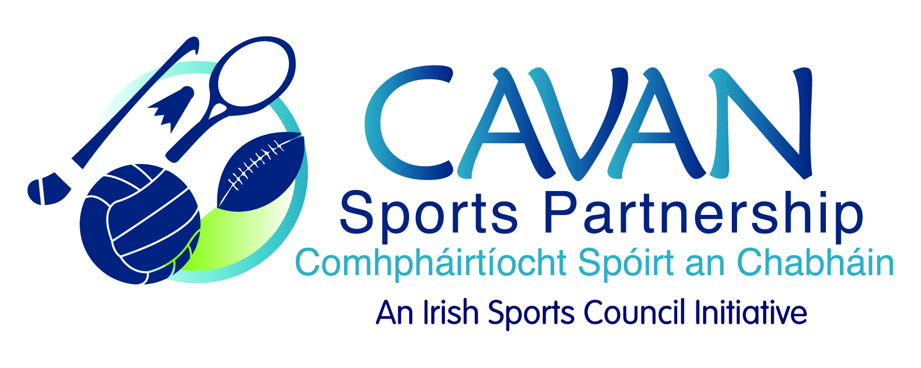
Date of Meeting: 6th October, 2015 |  | Venue: Council Meeting Room
Present: John Kearney, Liam McCabe, Audrey King, Tom Downes, Cllr Philip Brady, Niall Smith, Cllr Paddy McDonald, John Donohoe, Terry Hyland
Apologies: Cllr Madeline Argue, Colm Casey, Ray Verschoyle
In Attendance: Anne Marie Smith, Nadine McCormilla,
Agenda Item | Discussion / Action
1. Welcome
J Kearney welcomed everyone to the meeting.
J Kearney welcomed J Donohoe new Chief Officer of Community & Enterprise to the board and each member introduced themselves.
2. Minutes of previous Board Meeting
Matters Arising : None
The minutes of the previous board meeting were adopted.
Proposed: Cllr P Brady Seconded: L McCabe
3. CSP Workplan Update | N McCormilla presented a work plan update:  Run with Catherina  - The event has expanded into a weekend event which now includes Cycle Sportif (50k and 100k) on Saturday 10th October along with a fitness expo and speakers and a 5k and 10k race on Sunday 11th October.  - Precision Timing, the company providing the chip timing for the event had ceased trading. Annalee AC had sourced an alternative chip timing service. N.McC informed the board that Annalee AC had been informed of the vulnerable nature of the company prior to employing them to run the event.  - The number of participants taking part this year needs to be over 700 to justify the manpower and hours dedicated to this event.  L. McCabe commented that the County Board had to revert back to the original time of 3 o’clock for the Senior County Final which also takes place on Sunday 11th October due to Ireland playing in the rugby world cup on Sunday evening. He also suggested maybe next year Run with Catherina could be on the third Sunday in September which is when the all Ireland final is and there are no local GAA fixtures on that day so no clash could occur.  N. McCormilla added that the couch to 5k programme is delivered as a lead into Run with Catherina and this is a five week programme and is hard to fill until children are back at schools. For this reason the date of the Run in October suits this needed lead in time. L. McCabe’s suggestion will be noted for next year.  Cllr P. Brady commented that there was no advertisement on face book or the website listing the exciting speakers on the Saturday evening. Maybe send out a piece which could be shared on face book and circulated to contacts.  N. McCormilla added there is a dedicated Run with Catherina face book page but CSP would certainly send out an e-shot for circulation. Entry fee is €5 or free with proof of registration for cycle or race. Limited space 140.  Cllr. P. Brady suggested a bigger venue for next year.  L. McCabe asked who is running the event and where does the registration fee go?  J. Kearney stated Run with Catherina is a partnership with a central budget which will be reported on to the board at the next board meeting.  Community Sports Coach  - Interviews were held and ten participants have commenced the course. Nationally CSP is doing very well to have that number of participants, other counties in the LSP network are finding it difficult to run one course.  - The second course is to commence before the end of the year, N.McC asked board members for any suggestions on how to recruit more participants are welcomed.  - This course is the first of its kind for the county as it includes a sporting element.  L. McCabe added that the GAA also are experiencing the same problems filling some courses.  Couch to 5k  - Taking place in four venues around the county.  - Over 200 people taking part.  - Main benefit is using local community coaches and venues and so the programme is very successful.  Sports Inclusion  - 11 Older Adult programmes and 5 disability programmes.  Sports Leader  - Sports Leader UK course – CSP will deliver a pilot course with St. Mogues, Bawnboy after Halloween.  - Consultation for Leader 2014-2020 has taken place and we hope to apply for funding. One of the key areas is capital investment in a 4G sports facility.  Actions:  N McCormilla to circulate an e-shot with details of speakers on Saturday evening at expo.
4. Deloitte Audit Recommendations | N McCormilla reported that there were twelve recommendations set out in the Deloitte Audit report and seven of these recommendations have been enforced.  - A draft Board Members Handbook was circulated to each member present.  - Items number 10 Schedule of Matters Reserved For Board Decision, 3 Membership of the Board and 6 Code of Conduct were discussed.  - Also the disqualification of a member was discussed item 4 General Board Rules.  N. McCormilla added this has never been acted on before.  J.Donohoe suggested that since this protocol has come in after the members were elected maybe they should be written to first for an explanation.  T. Downes the suggestion to write to participants first.  - The quorum was also discussed. The quorum stated in the draft Board Members Handbook is one half plus one.  N. McCormilla added that would mean seven board members would have to be present.  J.Kearney asked each member to review the draft handbook and it will be revisited and ratified at the next meeting in November, 2015.  Actions:  J Kearney requested that each Board member review the draft handbook and it will be revisited at the next meeting in November, 2015.  N. McCormilla to write to Board members who have been absent from a number of Board meetings.
5. CSP Club Grant Scheme 2015/2016 | N McCormilla presented the draft Grant guidelines and application form.  - Two schemes which clubs can apply under  Coach Education  Community Mass Participation  - Irish Sports Council allocated €2,000 towards club grants and another €5,000 will be taken from reserves.  - Last year there were three mass participation grants given. Twenty six clubs received grants and two clubs did not recoup their grant allocation. It is proposed that money will return into the reserves.  - It is proposed that at the next board meeting the board can approve the grants allocated.  J Kearney asked was there any suggestions for the subcommittee?  T. Hyland asked is the form too long? Is there any way of making it easier for the clubs to apply and is the Coach Education payment paid to the club?  N. McCormilla added yes the money will be paid to the club for reporting purposes so it can be ascertained how many coaches were trained.  T. Downes suggested there should be a minimum grant of €300 taking into consideration the cost of processing the application.  Cllr. P. Brady agreed with this suggestion.  €5,000 to be taken from the reserves for the grant scheme.  Proposed: T. Hyland Seconded: A. King  Actions:  N McCormilla to change both schemes to a minimum grant of €300 and a maximum of €1,000.
6. A.O.B. | T. Hyland added that the Sports Capital Grants should soon be out.  N.McCormilla informed the board that the Irish Sports Council grant application will be released and she would inform board members of the criteria set out. N.McC will present the application at the next board meeting.
7. Date of next meeting | J Kearney thanked the board for their input and attendance. Next meeting date set for Tuesday 17th November at 9.00am.

