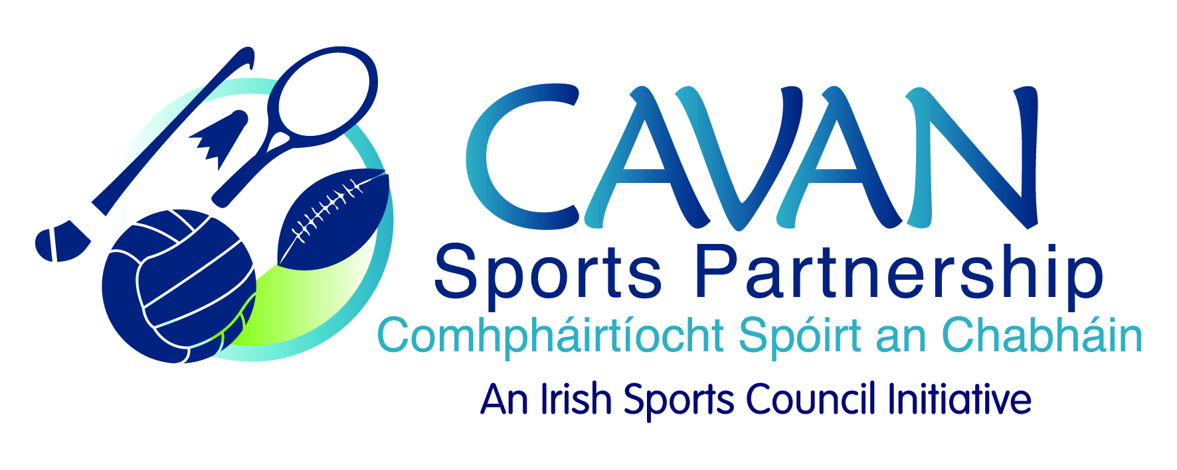
Date of Meeting: 30th June, 2015 |  | Venue: Council Meeting Room
Present: Colm Casey, John Kearney, Liam McCabe, Audrey King, Tom Downes, Ray Verschoyle, Cllr Philip Brady, Niall Smith, Cllr Paddy McDonald
Apologies: Caroline Brady, Terry Hyland, Cllr Madeline Argue
In Attendance: Anne Marie Smith, Nadine McCormilla,
Agenda Item | Discussion / Action
1. Welcome
J Kearney welcomed everyone to the meeting.
2. Minutes of previous Board Meeting
Matters Arising :
N McCormilla presented clarification on the contingency fund from ISC.
N McCormilla proposed €15,000 to be committed to contingency fund in 2015 and €2,500 each year thereafter.
Proposed: R Verschoyle Seconded: T Downes
The minutes of the previous board meeting were adopted.
Proposed: Cllr P Brady Seconded: T Downes

3. Budget 2015 – 25% drawdown and report on 2014 | N McCormilla presented on 25% drawdown and report on 2014.  The template includes three columns ISC allocation, actual and variance.  The completed template and agresso back up is submitted to ISC after it is signed by the Head of Finance of Cavan County Council.  N McCormilla explained all variances and any board member requiring further information can contact N McCormilla.  Closing balance of €54,625.54.  N McCormilla explained to board members that the balance carried forward is committed to programmes, core funding, contingency fund and CSP grant scheme.  Actions:  J Kearney asked for the report to be circulated electronically. N McCormilla will circulate same.  J Kearney requested this report be revisited at the next board meeting.  N McCormilla requested approval from the board to submit the report to the ISC.  Proposed: A King Seconded: Cllr P McDonald
4. CSP Workplan update | N McCormilla presented a workplan update:  - €5,000 under IPB grant scheme for a summer camp for adults with a disability.  - CSP grant Scheme – 17 clubs have drawn down funding, 8 clubs awaiting draw down. CSP grant committee to meet after the board meeting.  - Walking festival – over twenty walks over ten days. Partners included Cavan Heritage, Geopark and tourism. All partners contributed equal funding to the project.  - Bike week took place from 13-21st June. €5000 funding received from the Dept. of Transport. Six cycling clubs in Cavan and they ran events. Safe school cycling programme was also delivered in ten schools and a six week inclusive cycling programme was ran.  N McCormilla presented the board with a handout of bike week activities.  - Community Coaching Programme – have applied for €16,000 in funding from ISC.  Partners include – DSP, ETB, Breffni Integrated, GAA and FAI.  Three days a week for twelve weeks.  If successful the programme is to begin in September to be completed by the end of December.  C Casey stated that in order for people to gain employment in the sporting sector they need more than a coaching qualification.  N McCormilla explained that this programme aimed to provide participants with a pathway to further education or to gain employment.  N McCormilla added that the ISC have asked if there is the capacity for CSP to run a second programme so maybe there could be two levels of candidates.  C Casey suggested expanding the programme to include triathlon Ireland if funding allowed.  P McDonald asked when applications will have to be submitted and will it be advertised locally.  N McCormilla stated if and when funding is approved there will be a local media campaign and partners will also sign post participants to the programme.  J Kearney asked who will be involved in the recruitment process.  N McCormilla stated ETB will be the lead however all partners will be brought together if application for funding is successful.  J Kearney stated FAI and GAA should be included in the recruitment process and C Casey’s suggestion should be taken into consideration if there is a second programme.  - Run with Catherina – will take place on the 11th October and the partnership agreements have been signed.  Catherina’s ideas for growing the event include a 10km race and a cycle and expo.  N McCormilla stated that the sports partnership needed to be mindful of the fact that they have limited resources in terms of staffing and funding and that for 2015 while expansion of the event was welcomed that CSP was very limited in the support it can give to the cycle and expo.  N McCormilla outlined a series of participation programmes that the CSP will deliver in the lead up to run with Catherina with the aim of increasing participant numbers.  There is a media team on board this year also.  J Kearney stated that at the next Run with Catherina committee these concerns in relation to the cycling event and expo will be discussed and a final decision will be made if this event is to go ahead.  C Casey stated it could be a perfect time for a half marathon or a ten mile run.  L McCabe asked in relation to relay event is it for all the schools?  N McCormilla stated the relays would take place before the run maybe at the Con Smith Park and there would be a six week programme in schools before this event.  C Casey stated that there is an event held in Ballymote where each child from each school runs a certain distance and the distance totaled is greater than Sonia O’Sullivans record.  N McCormilla asked if anyone had further ideas on working with groups to let her know especially secondary schools.
5. CSP external auditor findings 2015 | N McCormilla presented the auditor’s report conducted by Deloitte.  A discussion took place on the recommendations as set out by the auditor’s and timelines to address each of these.  J Kearney stated it is important to implement changes by the target date given.  Actions:  N McCormilla to circulate the strategic review 2014 to the board members as per audit recommendations.  J Kearney requested that the auditor’s report is revisited at the next meeting.
6. A.O.B. | N McCormilla requested meeting with the grant subcommittee after this meeting.  Next board meeting to be changed to 6th October 5-8pm to include board induction, strategic plan review and Deloitte input.  J Kearney congratulated L McCabe and the County team on their recent achievements and wished them well for this weekend.
7. Date of next meeting | J Kearney thanked the board for the input and attendance. Next meeting date set for Tuesday 6th October, 2015 at 5pm.

