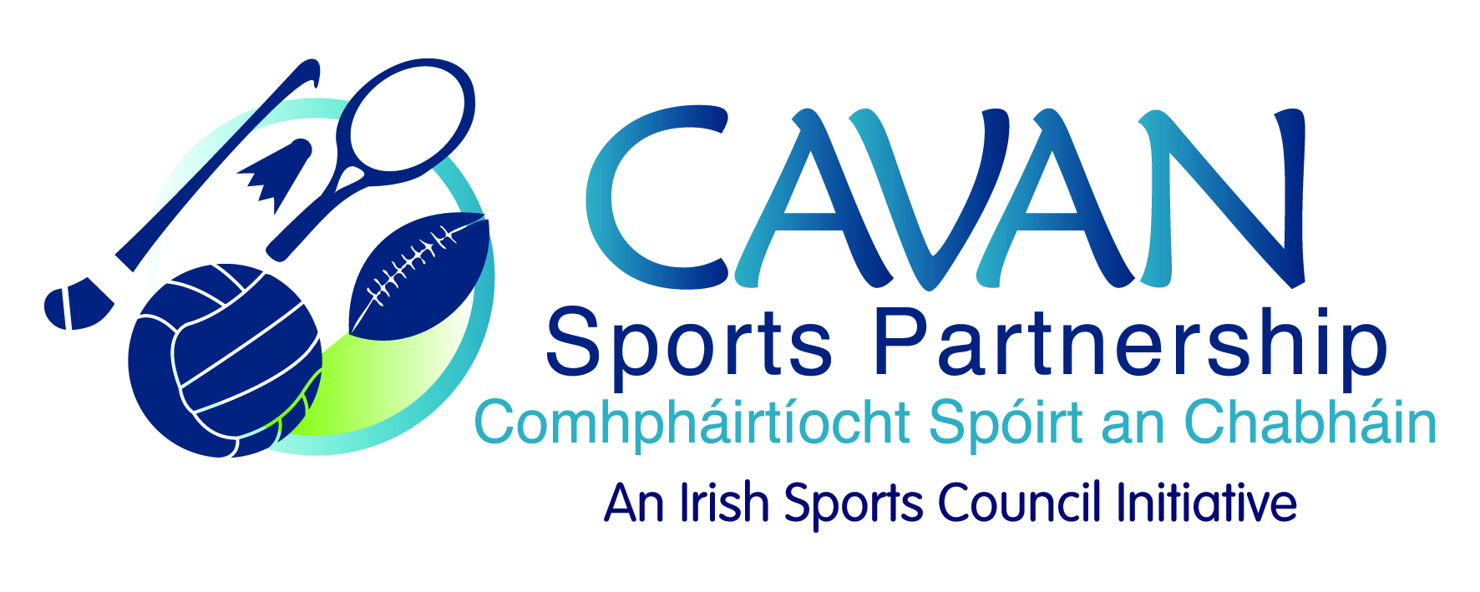
Date of Meeting: 21st April 2015 |  | Venue: Council Meeting Room
Present: Terry Hyland, Colm Casey,, John Kearney, Liam McCabe, Audrey King, Tom Downes, Ray Verschoyle, Cllr P Brady
Apologies: Caroline Brady
In Attendance: Blaithin O’Reilly, Nadine McCormilla,
Agenda Item | Discussion / Action
1. Welcome
J Kearney welcomed everyone to the meeting.
2. Minutes of previous Board Meeting
The minutes of the previous board meeting were adopted.
Proposed: T Hyland Seconded: Cllr M Argue

3. Annual Implementation Plan 2015 | The AIP had been forwarded to the board prior to the meeting for review prior to adoption.  N McCormilla presented on Q2 workplan.  Highlights:  Cavan Walking Festival  SIDO Programmes – older adults & sports inclusion direct delivery programmes.  DCYA Local Authority Fund Application  €5,000 Bike Week Funding  Changes to Code of Ethics & Children’s Officer – Safeguarding 1 & 2  N McCormilla informed the board that CSP were preparing to be externally audited by the Irish Sports Council on Monday 27th April.  Annual Implementation Plan  Proposed: T Hyland Seconded: Cllr M Argue
4. ISC Budget Requirements | N McCormilla presented information on recommendations from the ISC that each LSP should set aside a contingency fund. They currently recommended a fund of €30,000.  Proposal to the board was to use €6,000 from Training & Education reserves and €9,000 from Core reserves and in 2015 CSP would commit €15,000 to this contingency fund.  J Kearney – asked for clarification on why CSP needed contingency  R Verschoyle – questioned what would happened if funding was not available for CSP  Actions:  N McCormilla to ask auditors / ISC for further clarification on need for and purpose of reserves.  Proposed: €15,000 fund  Approved: Cllr M Argue Seconded: T Hyland
5. Board Review Recommendations | Review document from H Murphy Consultant had been forwarded to the board prior to board meeting.  - Additional Partners  CSP currently have a wide and varied range of working partners and the level of partnership working was acceptable.  - Formal Service Level Agreements with Partners  The board felt that formal SLA were not required for CSP projects with partners.  J Kearney proposed that Memorandums of Understanding were developed for partnership working.  Recommendations: CSP to use MOU and / or partnership agreements  - Use of word “sport” as opposed to recreation and/or physical activity  The board agreed this was a valid query, however, the use of the word “sport” is reflective of a national brand and the association with The Irish Sports Council.  Recommendation: to continue using “sport” as a descriptive term.  - Additional information re grant  Board agreed that is to be stressed grant guidelines that acknowledgement of CSP is required.  Recommendation: to continue the increase of CSP branding and public awareness through CSP grant scheme  - Club & Individual Sports  The board acknowledged the importance of the CSP grant scheme and its importance to the work of the sports partnership.  Recommendation: to continue grant scheme. Grant scheme working group to propose further recommendations.  - Sports Forum: Development and special initiatives  The need to re-establish sports forums was highlighted. N McCormilla explained to board members that they had been held in the initial CSP years and agreed there was a need in the county.  C Casey proposed: Funding Workshop; Relevant Speakers; Event Planning  Recommendations: for Sports Forums to be revisited at further board meetings with an event in October time.  - Formal Induction Process for new board members  Recommendation: A formal induction process to be developed for new board members. This is scheduled for Sept / Oct time.  - Do CSP hold sufficient board meetings  Recommendation: It was agreed by all that 4/5 board meetings per year held by CSP were sufficient.  Action: Place further discussion re CSP review on next agenda
6. Annual Report 2015 | Annual Report had been forwarded to board members prior to the meeting for submissions.  Action: Approval of Annual Report 2015  Proposed: T Hyland Seconded: Cllr P McDonald
7. CSP Grant Sub Committee 2015 | N McCormilla requested nominations from the board for members of the Grant Sub- committee.  Nominated:  Colm Casey  Cllr Philip Brady  Audrey King  Caroline Brady  Proposed: J Kearney Seconded: T Hyland  It was proposed that the sub-committee develop policies regarding CSP grant scheme.  J Kearney: suggested two options for discretionary funding: (1) a sub-committee meeting is called which are given certain levels of grant approval by the board or (2) a chairperson is appointed who along with the co-ordinator can make decision re discretionary funding scheme. Options will be taken into consideration by sub-committee.  Action: N McCormilla to arrange sub-committee meeting to develop policies.
8. A.O.B | N McCormilla distributed forms relating to the board and asked them to fill in confidentially and forward to ISC auditors in preparation for CSP audit.  J Kearney thanked Blaithin O Reilly for her work with the sports partnership and wished her well in her new role.
9. Close of Meeting & Next Meeting | J Kearney thanked the board for the input and attendance. Next meeting date set for 30th June 2015 at 9.30am.

