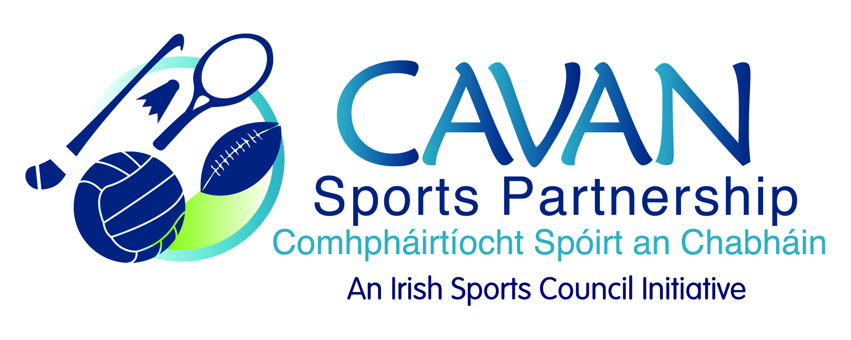
Date of Meeting: 23rd February 2015 |  | Venue: Hotel Kilmore, Cavan
Present: Terry Hyland, Colm Casey, Caroline Brady, John Kearney, Liam McCabe, Audrey King, Tom Downes, Niall Smith, Ray Verschoyle, Niall Lynch, Cllr P Brady,
Apologies:, Cllr. Madeline Argue, Cllr P McDonald
In Attendance: Blaithin O’Reilly, Nadine McCormilla, Dean McElroy
Agenda Item | Discussion / Action
1. Welcome
J Kearney welcomed everyone to the first meeting of 2015.
2. Minutes of previous Board Meeting
The minutes of the previous board meeting were adopted.
Proposed: L McCabe Seconded: T Hyland

3. Budget 2015 | ISC have awarded CSP a budget of €124,750.  N McCormilla explained that CSP had applied for €125,735. The ISC will forward a full breakdown in due course.  N McCormilla to present Annual Implementation Plan at next board meeting.  N McCormilla informed the board that the ISC had requested that €30,000 be set aside by each sports partnership as a contingency fund.  N McCormilla to present options to finance this from reserves at next board meeting.
4. CSP Programmes / Workplan 2015 | N McCormilla outlined programme’s prioritised for 2015:  ISC general participation fund  - Multi Sports Programme – School Completion Programme  Primary and Secondary Schools : Cavan Town, Cootehill, Bawnboy  - Inclusive cycling programme – children with a disability and local cycling clubs  Multi sports club – young adults with a disability  - Women in Sport  - Teenage girls physical activity programme – Secondary schools  - Line Dancing – older women  - Get Ireland Active  - Couch to 5km – community based learn to run x 5 areas  - Meet and train – disadvantaged communities (Killeshandra & Cavan Town)  - Sprocket Rocket – cycling programme for primary school aged children (local cycling clubs)  - Bike for life – training up of two Cavan leaders and delivery of a Cavan based programme in two communities through local cycling clubs.  N McCormilla presented to the board on CSP 2015 initiatives and outlined where extra finance from reserves was required.  Reserves requested for:  - Run with Catherina 2015 €1000  Board Discussion: board members discussed CSP involvement and raised concerns and questions on the sustainability of RWC and the amount of resources CSP committed to the event (financial and staff).  CSP to ensure all parties engage with partnership agreement.  The ability to financially support the event will be reviewed for 2016.  Proposed: T Hyland Seconded: N Lynch  - Walking Festival 2015 €1000  Proposed: C Brady Seconded: A King  - Ulster Sports Museum update €500  CSP to explore options for a wider audience for sports museum.  Proposed: L McCabe Seconded: P Brady
5. AOB | Correspondence:  Request for financial support for Cavan Night Run from volunteer group.  €400 -500 requested.  Request from secondary schools PE forum to support athletics event.  €200 requested.  C Casey: proposed €2,000 be set aside from grant scheme each year and to be available as discretionary funding for the board in order to support special initiatives during the year. This fund is to have a separate application form and to have strict criteria.  N McCormilla to draft application form for board approval  Amounts proposed:  €400 for Cavan Night Run  €200 for secondary school athletic programme.  Proposed: Colm Casey Seconded: L McCabe
6. Close & Date of Next Meeting | J Kearney thanked the board and staff of the sports partnership for their attendance. Next meeting set for 21st April at 9.30am.

