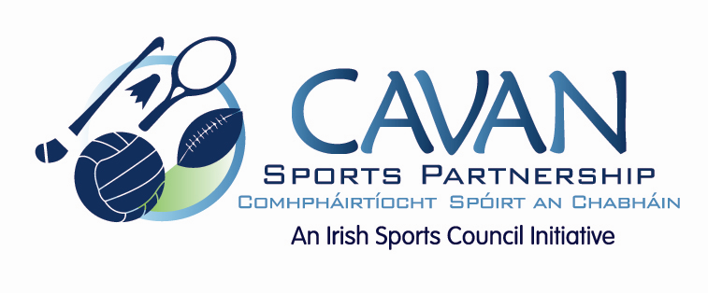

Cavan Sports Partnership Board Meeting
Tuesday 31st May 2016
10am
Old Reference Library, Environmental Offices, Cavan County Council

Agenda

- Welcome

- Matters arising and adoption of minutes from previous board meeting 16 February 2016

- Annual Report 2015

- Budget 2016

- CSP workplan update

- Discretionary Funding Support Criteria

- A.O.B.

- Date of next meeting

