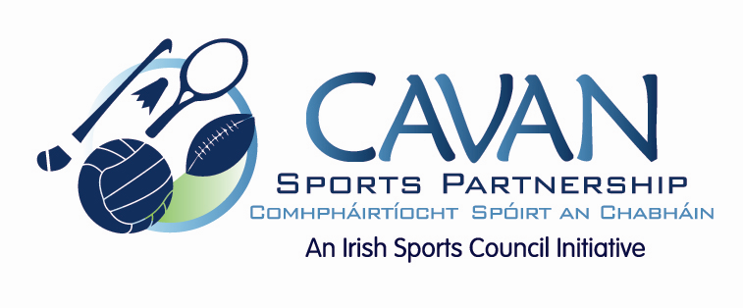

Cavan Sports Partnership Board Meeting
Tuesday 16th February 2016
10am
Old Reference Library, Environmental Offices, Cavan County Council

Agenda

- Welcome
- Matters arising and adoption of minutes from previous board meeting 17 November 2015
- CSP workplan update

- Run With Catherina – Report & Budget

- Budget 2016

- A.O.B.

- Date of next meeting

