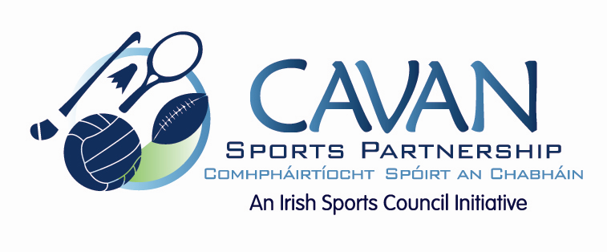

Cavan Sports Partnership Board Meeting
Tuesday 17th November 2015
9am Old Reference Library

Agenda

- Welcome

- Matters arising and adoption of minutes from previous meeting.

- ISC Grant application 2016

- CSP workplan 2016

- Deloitte Audit recommendations

  - Board member handbook / update memorandums of association

- CSP club grant scheme 2015/2016

- A.O.B.

  - LECP ( John Donohoe)

- Date of next meeting

