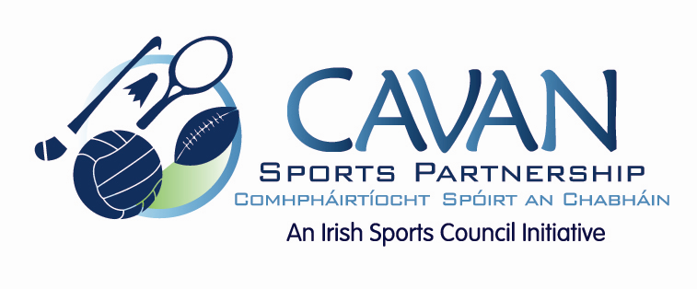

Cavan Sports Partnership Board Meeting
Tuesday 6th October 2015
5pm Old Reference Library

Agenda

- Welcome

- Matters arising and adoption of minutes from previous meeting.

- CSP workplan update

- Deloitte Audit recommendations

  - Board member handbook / update memorandums of association

- CSP club grant scheme 2015/2016

- A.O.B.

- Date of next meeting

