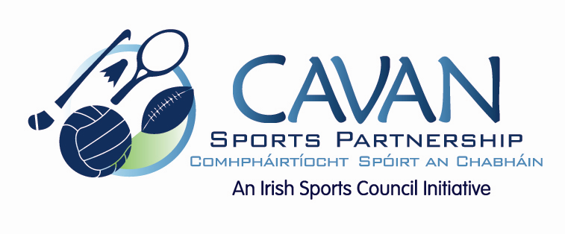

Cavan Sports Partnership Board Meeting
Tuesday 30th June 2015
9.30am

Agenda

- Welcome

- Matters arising and adoption of minutes from previous meeting.

- Budget 2015 – 25% drawdown and report on 2014

- CSP Workplan Update

- CSP external auditor findings 2015

- A.O.B.

- Date of next meeting

