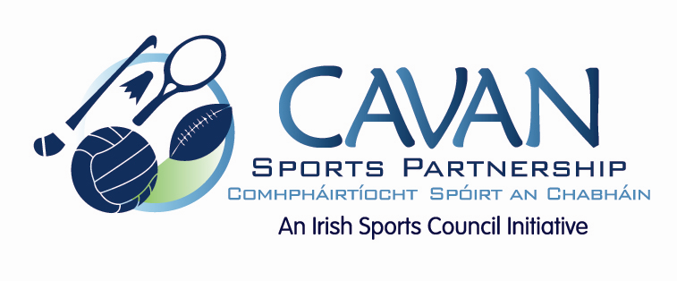

Cavan Sports Partnership Board Meeting
Tuesday 21st April 2014
9.30am
Old Reference Library, Cavan County Council

Agenda

- Welcome

- Adoption of Minutes

- Annual Implementation Plan 2015

- ISC Budget Requirements

- Board Review Recommendations

- Annual Report 2014 Feedback

- CSP Small Grant Sub Committee 2015

- A.O.B.

- Date of next meeting

