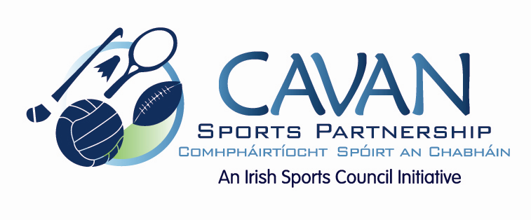

Cavan Sports Partnership Board Meeting
Monday 23rd February 2014
5.30pm
Killygarry Suite, Hotel Kilmore, Cavan

Agenda

- Welcome

- Adoption of Minutes

- Budget 2015

- CSP Programmes / Workplan 2015

- A.O.B.

- Date of next meeting

