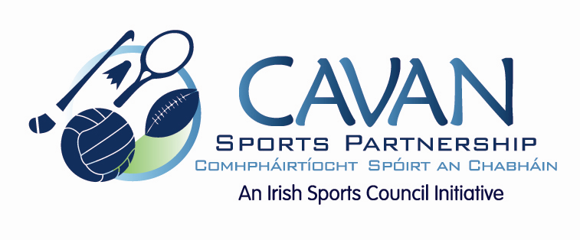

Cavan Sports Partnership Board Meeting
Monday 26th September 2016
9.30 am
Old Reference Library, Environmental Offices, Cavan County Council

Agenda

- Welcome

- Matters arising and adoption of minutes from previous board meeting 31st May 2016

- 2015 budget return & 25% drawdown for 2016

- CSP workplan update

- CSP 2016 Grant Scheme

- Discretionary Funding Support Criteria

- A.O.B.

  - CSP Auditors report – proposal of additional meeting to review.
  - Discretionary funding criteria

- Date of next meeting

