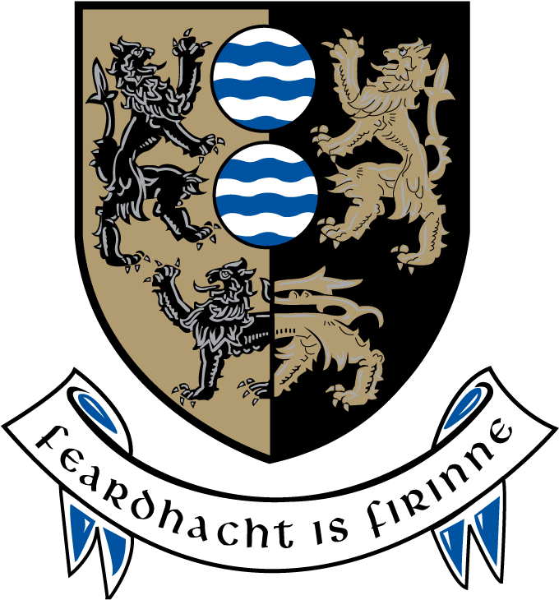

Cavan County Council

Cavan Belturbet Municipal District

16th March 2015

To/Cathaoirleach and Each Member of The Municipal District

Dear Councillor
The monthly meeting of Cavan Belturbet Municipal District will be held in the Market House, Blacklion on Monday 23rd March 2015 at 3pm.

Agenda is attached.

Yours sincerely

__________________
Meetings Administrator

Agenda – Clár
    - Minutes of the last meeting held on 19th January 2015.

    - To note progress report on Roadwork’s Programme

Members’ Items
- Safety Measures on the Bridge in the Con Smith Park, Cavan. Councillor (Cllr) M Argue
- Signs with contact details for Irish Water. Cllr. M. Argue
- Traffic calming measures in housing estates Cllr. E. Greenan
- Social Housing Cllr. E. Greenan
- Protestant Graveyard at Tullacmongan, Cavan. Cllr. M. Argue
- A.O.B.

.

