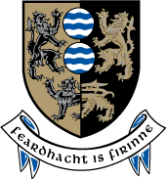
Cavan County Council

Ballyjamesduff Municipal District

16th June 2015

To/ The Elected Members of Ballyjamesduff Municipal District

Dear Councillor,

The Annual General Meeting of Ballyjamesduff Municipal District will be held in the Show Center Virginia on Monday 22nd June 2015 at 11am.
The Order of Business is as follows:-

- To elect a Cathaoirleach for the coming year.

- To elect a Leas Chathaoirleach for the coming year.

- To approve the Minutes of Annual General Meeting held on 13th June 2014.

4. To set a date and time for monthly meetings of the Council.

Yours sincerely

Bernice Smith
Meetings Adminstrator

