Background

The findings of the 2001 strategic study for the East West Dundalk to Sligo was published in a report in December 2001. The route corridor with the greatest potential to meet the objectives and to serve the needs of the study area was identified as Sligo to Manorhamilton to Enniskillen (N16/A4) to Belturbet (A509) to Cootehill to Carrickmacross to Dundalk (see Figure 1).

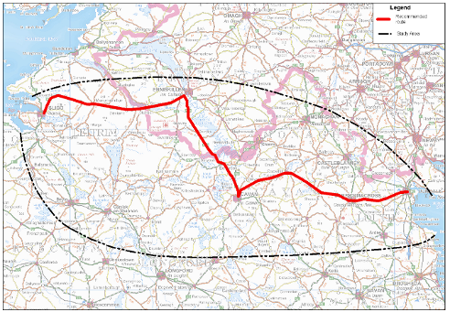
Figure 1

In March 2009 the Roughan & O’Donovan – AECOM Alliance JV was appointed by Cavan County Council to carry out the required consultancy services to:
- Review the 2001 strategic study of the development of an east west link road connecting Sligo to Dundalk and validate or revise the conclusions of the study as necessary
- Carry out a Constraints Study, Route Selection and Preliminary Design for the Cavan-Dundalk strategic route improvement element of the Sligo to Dundalk route, in accordance with Phase 2 to Phase 4 of the NRA Project Management Guidelines

Scheme Progress

- Previous studies and policy documents have highlighted the need for improved road infrastructure in the Border Region as being vital for future economic development and the Cavan to Dundalk route has been identified as strategically important in this regard.
- In 2010 Cavan County Council, in conjunction with Monaghan County Council and Louth County Council, commenced the process to advance the improvement of the Regional Roads that form this strategic route (i.e. via Cootehill, Shercock and Carrickmacross).

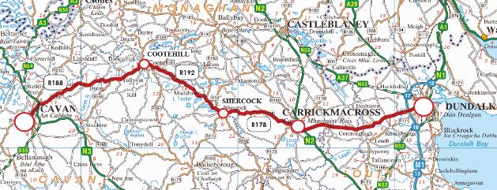
Figure 2

- In 2010 a Feasibility Study and a Constraints Study were undertaken to confirm that improvements were feasible and to identify the nature and extent of significant constraints along the route.
- The improvement strategy for the route was presented to the public in February 2011 and at present we are in the process of developing the Preliminary Design for the preferred scheme.
- Public information evenings have been organised at this time to advise the public of progress to date and to highlight that a number of surveys will be carried out on site in the coming months;
- These surveys will allow the completion of preliminary designs for the improvements.
Objectives

- Address the deficiency in the transport network in the region and help connect the local population to the Gateway town of Dundalk, the Hub town of Cavan and the key transport corridors (M1, N2, N3);
- Reduce the travel times and improve access to regional, national and international markets, as well as education, employment and other services;
- Deliver improved road network in a cost effective manner while minimising adverse environmental impacts;
- Support effective and efficient operation of public transport services;
- Reduce the length of poor quality roads used by traffic and hence reduce the number of road traffic accidents.

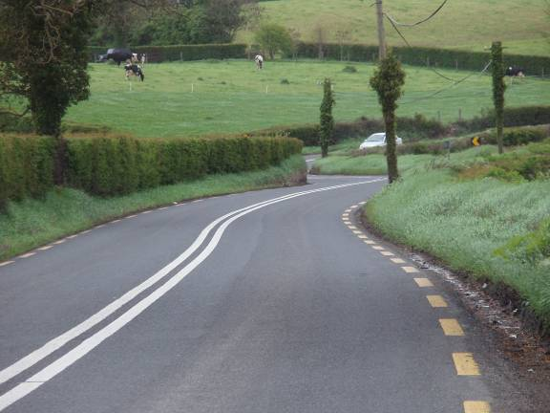

Why Are Improvements Necessary?

- Previous studies and policy documents have highlighted the need for improved road infrastructure in the Border Region as being vital for future economic development;
- The Cavan to Dundalk route has been identified as strategically important in this regard;
- The existing roads on this route vary in standard and many sections are narrow, with poor alignment, little opportunity for overtaking and a bad accident record;
- As a consequence existing journey times along the route are poor.

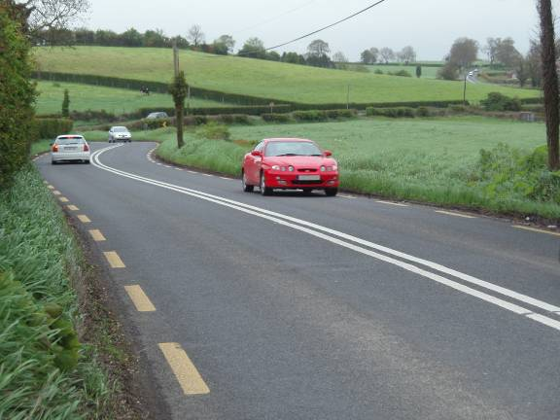

What Improvements Are Proposed?
- The roads along the route will be improved to provide a common standard in terms of width and alignment;
- In general the existing roads will be widened and improved between the various towns and villages;
- In some particularly bad locations new sections of road will be constructed away from the existing route;
- Opportunities to overtake safely will be provided at regular intervals;
- Facilities will be provided for cyclists and pedestrians throughout.
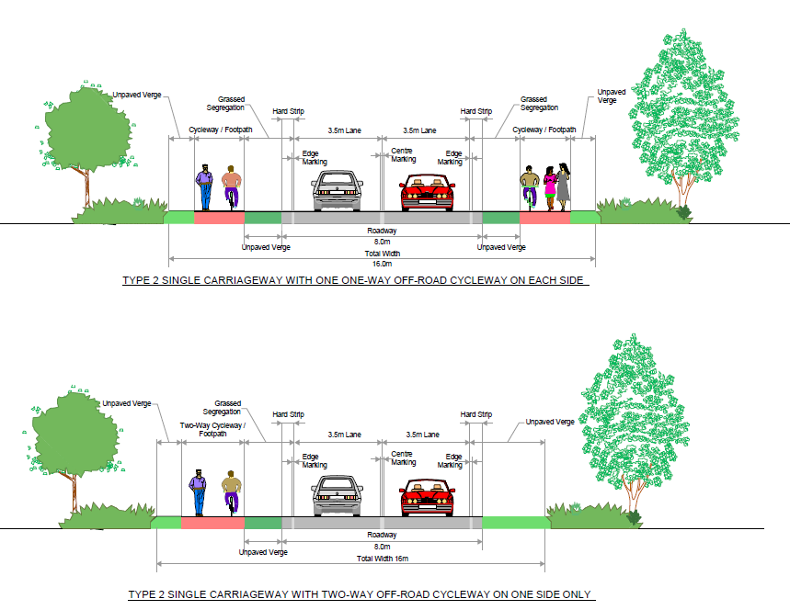

Benefits
- Improved journey times along the route;
- Consistent standard of road alignment and width, with safe opportunities for overtaking provided, leading to reliable journey times;
- Reduced number of accidents;
- Improved facilities for pedestrians and cyclists;
- Increased accessibility to facilities in Regional “Hub” (Cavan) and “Gateway” (Dundalk).

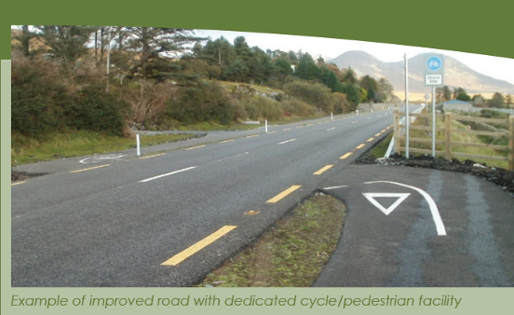

What Happens Next?

