Design Guide for
Single One-off Houses within Cavan Rural Countryside

Cavan County Council, January 2011
CONTENTS

Introduction

1.0 Site Selection
1.1 Siting and Location
1.2 Orientation
1.3 Contours

2.0 House Design
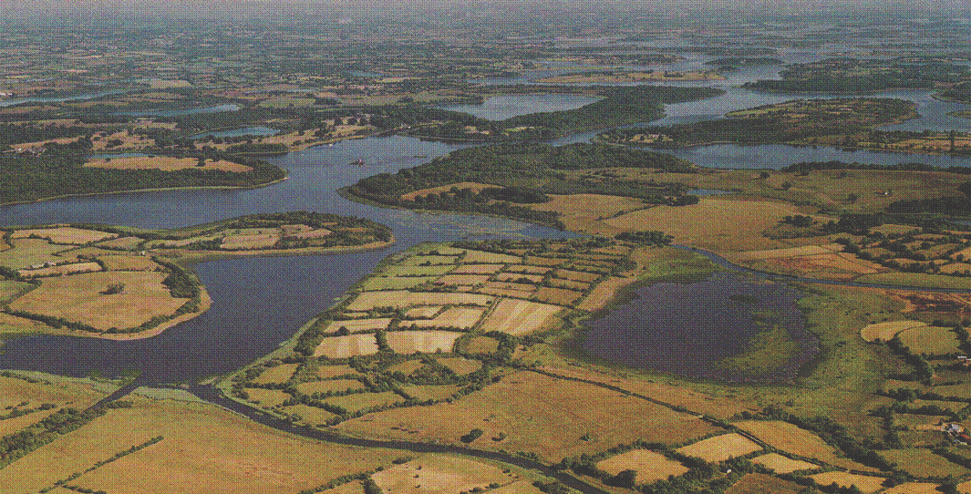

2.1 Shape and form
2.2 Proportions
2.3 Materials & Finishes
2.4 Contemporary Design

3.0 Landscaping
3.1 Landscape Design
3.2 Entrance boundaries

4.0 Sustainability
4.1 Renewable energy

5.0 Design Statement

Appendices

I. Check list for Planning
Applications
- List of native species
- Acknowledgements & accreditation
Introduction
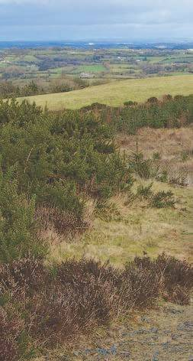

These guidelines have been prepared as a project for the Leadership Development Programme with Cavan County Council. This document aims to assist in the siting and design of one-off houses located within the rural environment of Cavan. Much of the rural house design throughout the county over the last few decades are a result of “catalogue” type housing, where new dwellings are randomly located on a site with no reference to existing site contours, orientation, boundaries, site surroundings or the individual needs of the applicant.

The guide does not aim to prescribe a certain type of house design but aims to highlight the benefit, to the applicant, of putting the time and effort into choosing the right site. Thereafter choosing the right design for that site based on its unique characteristics and individual needs of the applicant. This will result in a more satisfactory living standard for the applicant as well as ensuring that new dwellings will blend into the landscape.

This document should be used as a guidance only as each application will be determined on an individual basis. The guidelines offer potential applicants advice on siting and design of rural dwellings and does not cover every aspect of planning. For example, other considerations for planning would include traffic safety, public health and rural housing policy etc. For more information on these issues please refer to the Cavan County Development Plan or contact the Planning Office.

Design Guide for Single One-Off Houses within Cavan Rural Countryside 1
Introduction

Cavan Landscape

The Celtic origin of Cavan is “An Chabhán,” meaning “hollow” or “little hill”, a
description of the countryside, especially towards the northwest, where the landscape is covered by drumlins - oval clay hills of glacial origin between 80 to 100 feet high. In between these rolling hills, the valleys are poorly drained, with extensive bogs, swamps and lakes. This undulating topography means that visibility is frequently limited, often no more than a few hundred yards, giving the countryside an intimate feel.

A Landscape Categorisation of County Cavan is contained within the County Development Plan 2008-2014. Five main Landscape Character Areas have been identified as follows:

1. Cuilcagh – Anierin Uplands of West Cavan - mountainous region of north - west Cavan stretching from Blacklion and Dowra to Belturbet

2. The Lakelands - Lough Oughter lake system stretching from Belturbet to Lough Gowna

3. Lake Catchments of South Cavan - Lough Sheelin and Lough Ramor and their catchment areas in south Cavan

4. Drumlin Belt and Uplands of East Cavan - central area of the county stretching north-east from Shercock to south-west and Kilcogy

- Highlands of East Cavan - Kingscourt and Bailieborough area

(See map on following page)

Design Guide for Single One-Off Houses within Cavan Rural Countryside 2
Introduction

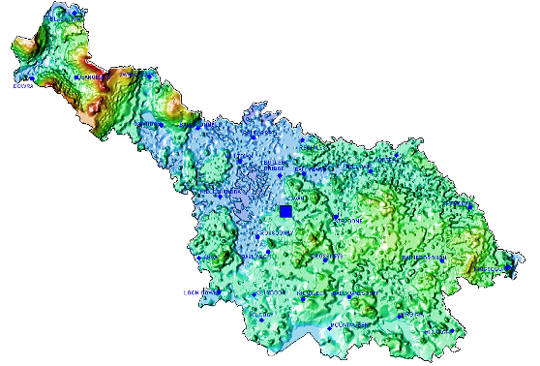
1

3
2

5
4

Source: P. 161 Cavan County Development Plan 2008-2014

Design Guide for Single One-Off Houses within Cavan Rural Countryside 3
Introduction

1. Cuilcagh – Anierin Uplands of West Cavan

This area stretches from Blacklion in the far north west of the county to the area west of Belturbet. West Cavan is an extensive expanse of hill and mountain country. It includes the upland valley of the Shannon and a range of mountains including Slieve Rushen, Benbrack and Boleybrack though to the Cuilcagh-Anierin Mountains which form the core of this upland area. The landscape character comprises of open, unenclosed, treeless, upland hill country with occasional isolated farms and outbuildings sited in shallow valleys or under the lee or ridge lines. The landscape is extremely fragile and sensitive to incompatible and unsympathetic development. The vernacular architecture of this area reflects this rugged exposed environment consisting mostly of single storey stone built cottages and farmhouses and farm buildings. Shelter from prevailing winds would have been an important consideration in the siting of dwellings rather than views which is more common today. Shelter would have been provided by choosing low lying locations, using outbuildings to surround dwelling and using existing hedgerow and trees for shelter.

2. Lakelands

The “lakelands” are an extensive area of inland lakes within the Erne
drainage system. This area lies west of Cavan and includes Belturbet, Butlersbridge, Killeshandra, Arva, Lough Gowna and Ballinagh. Much of this area lies within Natural Heritage Areas and the European Designations of Special Area of Conservation and Special Protection Areas. Dwellings in the lakelands area should be sympathetic to the scenic beauty and natural heritage value of these lakes.

Design Guide for Single One-Off Houses within Cavan Rural Countryside 4
Introduction

3. Lake Catchments of South-East Cavan

Lough Sheelin and Lough Ramor are the largest lakes in this region. These major lakes have notable amenity value due in part to their size and
location within a scenic landscape and their intrinsic recreational value. They also provide valuable habitats which are of great ecological importance and are protected nationally as proposed Natural Heritage Areas; Lough Sheelin is also identified as a Special Protection Area under European Legislation.
The lakes of County Cavan are very important for their scenic and
ecological value and development in or around the lakes should be carefully and sensitively designed. Development on lakes skyline and in the vicinity of the lakes should be restricted and where permitted should be designed and located to minimise visual intrusion.

4. Drumlin Belt and Uplands of East Cavan

This area stretches from Redhills to Cootehill in north-east Cavan through the county taking in east of Cavan Town, Stradone and Crosskeys to Killydoon and Kilcogy in south-west Cavan. This area is typical of the Drumlin landscape with many inter-drumlin lakes distributed throughout the region.
Dwellings in this area should avoid breaking the skyline and should integrate into the drumlin landscape through good siting, landscaping and design.

5. Highlands of East Cavan

This is the area around Bailieborough and Kingscourt which consists of drumlins and highlands.
Dwellings in upland areas should be sited so as not to break the skyline.

Design Guide for Single One-Off Houses within Cavan Rural Countryside 5

1.0 Site Selection

The character of County Cavan, its
topography, vegetation cover, field and hedgerow patterns determine to a considerable extent the type of new development that can be accommodated within the landscape.

Integrating a new building unobtrusively into the countryside can be aided by
utilising the existing sites natural features.

Design Guide for Single One-Off Houses within Cavan Rural Countryside 6
1.0 Site Selection

1.1 Siting and Location

Proposed site
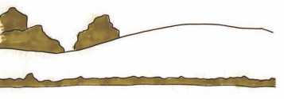

Poor Siting - building placed on most exposed area of site
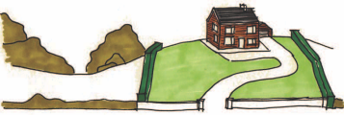

Good siting - sheltered hollow, excellent use of existing vegetative cover
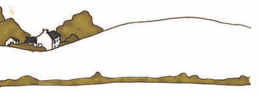

In areas of enclosed fields with hedgerows or stone walls, or drumlin country with its intimate rolling landscapes, good use of a site’s natural features can help to integrate a new building unobtrusively into the countryside.
Areas of enclosed fields or drumlin landscape can also absorb buildings without damaging the rural quality of the area better than the open landscapes.

Poor Siting
Construction of houses on elevated and exposed sites which will be obtrusive and which will reduce the visual character of the rural area will not be permitted.

Photographs below are examples of traditional dwellings that are well sited.

Design Guide for Single One-Off Houses within Cavan Rural Countryside 7

1.0 Site Selection

Scale and Plot proportion

The size of the building should have respect and be sympathetic to its surroundings. Its mass should relate proportionately to the landscape and setting and site size.

•Larger buildings are incompatible with smaller enclosed sites.

House too big in
scale for the size of the site

•Larger sites must carefully consider the landscape and siting.

50m

60m

•Larger houses should be located set back from the road within mature lands and be well integrated into the landscape – similar to traditional estate houses.

•Replacement dwellings should take into account the size and scale of an existing dwelling.

60m

138sqm max

3/4 acre site

183sqm max

100m

1 1/2 acre site

Plot ratios:

Where a new site is situated among existing
buildings choose a scale and form that is appropriate

The site should be of sufficient size so that the building can be set well back from the road and full use made of its natural features.
• 3/4 acre site - max. area for house 4.5% (138sqm)

• 1 1/2 acre site - max. area for house 3.0% (183sqm)

Design Guide for Single One-Off Houses within Cavan Rural Countryside 8

1.0 Site Selection

Utilise natural hollows and dips in the landscape. Align driveway with
existing hedgerows.

Avoid removal of
existing hedgerows.
Avoid dividing the site with driveway.

The building should not break the skyline. Avoid dividing the site with driveway.

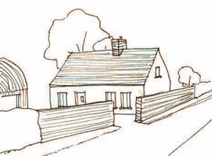

The front of the building line of the house need not necessarily be parallel to the public road. The building line may be influenced by
existing development in the area.
Cavan’s natural topography should be carefully used to obtain natural shelter, avoid north facing slopes and elevated areas exposed to
prevailing winds. The landscape can create shelter and a sense of space.

Seek a location where the house blends well into the landscape to utilize the landscape and hedgerows. The traditional siting of houses provides a good reference as they normally sought a sheltered location rather than a visually prominent one.

Use should be made of a backdrop of rising land, trees or hedgerows or a siting which interacts with existing buildings softening the visual impact.

Design Guide for Single One-Off Houses within Cavan Rural Countryside 9

1.0 Site Selection

Summer
Sun

Winter
Sun

North-facing slope

South-facing slope

Summer
Sunset
Summer
Sunrise

Shadowing on a North-facing slope versus a South-facing slope N

1.2 Orientation W E

Orientation is very important.
Exploit the sun – choose a good orientation, this will help
produce comfortable and sustainable living conditions.

Winter
Sunset
Winter
Sunrise

Sun path diagram placed over site map

By choosing a sheltered location for the building heat loss can be
reduced.

Design Guide for Single One-Off Houses within Cavan Rural Countryside 10

1.0 Site Selection

1.3 Contours

The gentlest part of the slope should be utilised in order to minimize earth moving and to avoid
making permanent scars in the landscape. Typical 1990’s approach - wide house, deep excavations

‘Narrow’ plan

House sits perpendicular to slope and absorbs level changes

Design Guide for Single One-Off Houses within Cavan Rural Countryside 11

2.0 House Design

Good design is at the core of creating a good quality family home that suit the needs of the applicant. There is no requirement to apply any particular style, traditional or contemporary, but buildings should be kept simple in terms of elevational features and materials.

Design Guide for Single One-Off Houses within Cavan Rural Countryside 12
2.0 House Design

2.1 Shape and Form

The shape, form, proportions and materials of a new dwelling are key elements in the overall design, which determine the dwelling’s visual impact on the surrounding area and landscape. New dwellings are encouraged to incorporate simple forms and proportions which integrate effectively into their rural landscape.

Whilst traditional shapes and forms such as those shown below are encouraged, this does not mean that new houses have to replicate older dwellings. In skilled hands it is quite possible for traditional shapes and forms to be translated into new houses that are contemporary and can accommodate modern family requirements.

Doubled cottage
Long
House

T shape
Cottage

Two Storey extended
Two
Storey
1 & Half
Storey Dormer
1 & Half
Storey No Dormer

Courtyard
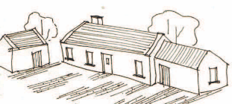

Inverted pitched
‘Slipped’
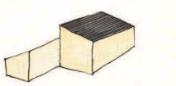

roof

Courtyard

Design Guide for Single One-Off Houses within Cavan Rural Countryside 13

2.0 House Design

General points to consider in house design:

• Ensure massing is right and avoid one bulky structure.

• Reflect scale, form and proportioning of older traditional architecture of the immediate area.

• Break dwelling into smaller elements with simple forms.

• Gables should be predominantly solid with relatively small openings.

• Narrow plan houses maximise solar heat and light gain.

Ill designed dwellings in terms of roof pitch, window design, scale, mass and bulk.

Things to avoid in house design:

• Bulky forms
• Large, wide, ill designed gables
• Wide and deep plan houses
• Large roof spans and foreign roof forms ie Dutch hipped.

Design Guide for Single One-Off Houses within Cavan Rural Countryside 14

2.0 House Design

2.2 Proportion

The proportions of a dwelling are determined by its height, gable depth, doors, windows and chimneys.

In general, good design features are pleasing to the eye due to their traditional proportions and uncomplicated design. With all aspects of the design features an effort should be made to keep the design and proportions traditional and simple.

Chimney too large Site too small

Too many windows
Too low wall to window ratio
Too many vari- ations on win- dow form

Photographs above are good
Too close to symmetrical
Windows can be randomly placed

Too many large voids

Large void is possible when balanced by

examples of well proportioned dwellings
small openings

Design Guide for Single One-Off Houses within Cavan Rural Countryside 15

2.0 House Design

Windows

Windows with a vertical emphasis generally work better and windows which have a wide horizontal emphasis should be avoided as well as elaborate and excessive windows such as ‘Georgian style.’

Windows have horizontal emphasis

Windows have vertical emphasis

Symmetrical across both axes
Symmetrical across both axes
Symmetrical across both axes
Simple rectangle
/square

Unsymmetri- cal across horizontal axis

Bay Windows

Unsymmetri- cal across horizontal axis

Unsymmetri- cal across horizontal axis
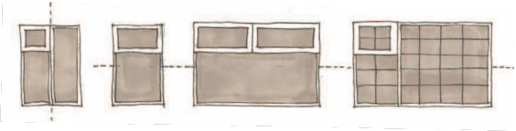

Unsymmetrical across horizontal axis and mock Georgian panes
2 storey bay windows are unacceptable in the vast majority of cases as they add undue emphases to the window feature.

Bay windows should be kept simple in form; roof finish and pitch should match that of the dwelling. They should only be to the ground floor of the dwelling and not of two storey design.

Single storey bay windows are acceptable - providing that they are designed in proportion with the overall design of the dwelling, having regard to the roof design and
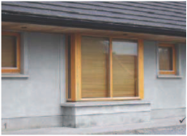

details of both the dwelling and the window. A well incorporated bay window

Design Guide for Single One-Off Houses within Cavan Rural Countryside 16

2.0 House Design

Chimneys

Chimneys should be located through or as close as possible to the ridge line.

Dormer Windows

Avoid tall, thin
‘extruded’ types

Avoid postitioning chimneys on slope of roof
Each dormer window style maybe appropriate in certain cases, however it should be the general principle to use Traditional/Wall dormers or gable fronted dormer. In all cases the dormer windows must be appropriately placed on the dwelling and maintain the principles of good proportion and balance.

Doors
Chimney flush with gable

Door design shall be of traditional design and be of hardwood finish. Over elaborate design are discouraged.
The doorways shall be symmetrical, vertically sheeted and glazed
paneling may be considered to be inappropriate.

Avoid elaborate ornate doors, PVC
and aluminium doors.

Traditional hardwood doors are recommended
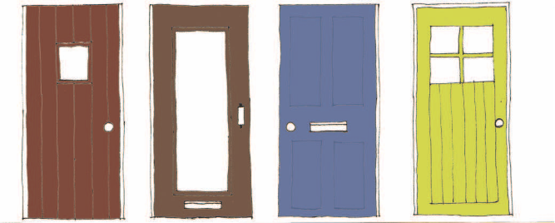

Design Guide for Single One-Off Houses within Cavan Rural Countryside 17

2.0 House Design

Porches

An entrance “porch” should be of solid construction and be in character and
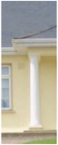

proportion with the dwelling. Balconies

Balconies on the front or side elevations of dwellings are generally considered to be unacceptable.

Cosmetic Features

In all cases cosmetic features such as mock classical columns, Spanish arches, verandas, balustrades to the front/side elevation should be
avoided
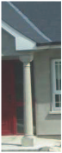

Log Cabins
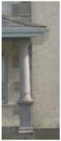

Log Cabins (completely finished timber buildings) are considered suitable in woodland or edge of woodland areas only.
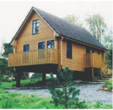

“Tower Features”

“Tower features” on dwellings are generally unacceptable. This and the use of oversized windows on stairwells create an over-complicated design feature.

Design Guide for Single One-Off Houses within Cavan Rural Countryside 18

2.0 House Design

Roof Design

With traditional construction the roof of a dwelling was generally low and at a pitch of approximately 30º. This is as a result of the single room depth of a dwelling. The deeper the dwelling the higher the pitch of the roof and the greater the overall height of the dwelling.

Excessive roof heights and excessive roof proportions should be avoided.

Only blue/black slates/tiles will be acceptable.

Simple edged roof

- no edge trim

Coped Gable - Concrete/Plaster carried over gable to edge the roof

Avoid ‘boxy’
fascia and soffit

Avoid rooflights standing proud of roof

Avoid random shaped and sized rooflights
Similar rooflights flush with roof

Flat Roof and Parapet roofs may be used where there is high quality design and construction

30º

House in Shercock, Co. Cavan, Frank Cooney Architects - a good example of simple traditional roof design
A 30 degree roof
pitch is recommended

Design Guide for Single One-Off Houses within Cavan Rural Countryside 19

House Design

2.3 Materials

•External materials are best kept simple in order to ensure that the finished dwelling will integrate well into the landscape.

•Care should be given to the selection of external materials as some are unsuited to certain rural areas e.g. brick, dry dash, artificial stone etc.

•The use of nap/smooth plaster and natural stone is encouraged.

•Natural slate should be used - slates should be dark in colour.
When using stone as an external material create
‘3d’ elements (by using 3 to 4 faces of part or all of the building) rather than cladding one face.

Avoid the use of

‘2D’ stone cladding on external walls as it can detract from the look of a house

‘3D’ stone is
Design Guide for Single One-Off Houses within Cavan Rural Countryside 20
r e c o m m e n d e d where the stone

becomes a structural external leaf

2.0 House Design

2.4 Contemporary Design

Dwellings of high quality contemporary architectural design can be incorporated into the Cavan landscape if sensitively sited, scaled and detailed.

Goulding House, Scott Tallon Walker,

Co. Wicklow

Mimetic House, Dominic Stevens, Co. Leitrim

Design Guide for Single One-Off Houses within Cavan Rural Countryside 21

3.0 Landscaping

Landscaping may take many years to become fully established, especially on exposed sites.
It is therefore preferable to make use of existing boundaries/hedgerows and to incorporate new planting of natural species to assist with screening.

Design Guide for Single One-Off Houses within Cavan Rural Countryside 22

3.0 Landscaping

Trees, shrubs and hedgerows help to make a proposed development more attractive in the countryside by adding screening, colour and texture to the proposed development.
If landscaping is carefully planned and integrated into a site, it will enhance a proposed development. Landscaping can also provide shelter and privacy to a development.

All applications should be accompanied by a Landscaping Scheme which will include details of:

•any new boundaries

•front boundary treatment

•entrance elevation including gates and piers

•trees to be retained or types of new trees to be planted

Where there is an abundance of tree, hedgerow and vegetation coverage, it may be necessary to submit a detailed survey of the exact location & proposed retention of same.

Design Guide for Single One-Off Houses within Cavan Rural Countryside 23

3.0 Landscaping 3.2 Entrance/boundary

Avoid replacing indigenous boundaries with
insubstantial fencing, blockwork walls, post and wire fencing, concrete balustrading, Leylandii or other dense conifer planting.
- Hedgerows should be retained where possible, so as to add to the visual attraction of a proposed structure. Good design and siting can be destroyed by inappropriate front boundary treatment. The boundary should be appropriate to its rural context; to retain the existing front boundary where possible by just making a simple splayed or bell mouthed opening. If traffic safety requires that it must be set back, always aim to re-establish what is existing i.e. hedgerow for a hedgerow, rubble for a rubble wall. Random rubble walls are more preferable as they help encourage nesting/plant growth - biodiversity.
- Plant new native hedgerow at the commencement of building works. Remember that native hedgerows as well as being visually attractive and offering screening and privacy are important wildlife corridors. New hedgerows should be linked to existing to facilitate this. Where there is more than one boundary type, existing boundaries should be continued rather than introduce a new boundary type.

- Stone walls should be retained where possible.

- Fencing should be timber post and rail; PVC is not generally

acceptable.

Design Guide for Single One-Off Houses within Cavan Rural Countryside 24

3.0 Landscaping

Gates

Gates should be of a simple design – metal or wood and with a strong horizontal emphasis.

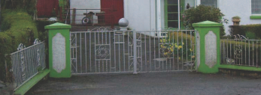
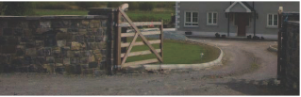

Design Guide for Single One-Off Houses within Cavan Rural Countryside 25
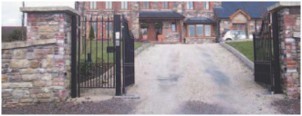

4.0 Sustainability

The installation of renewable energy sources such as solar panes, domestic wind turbines and geothermal heating
systems are encouraged as it should contribute towards the reduction in the consumption of fossil fuels and production of C02 emissions.

Design Guide for Single One-Off Houses within Cavan Rural Countryside 26
4.0 Sustainability
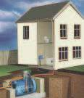

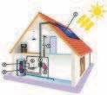

The EU Directive on the Energy Performance of Buildings (EPBD)
contains a range of provisions aimed at improving energy performance
of residential and non-residential buildings, both new-build and existing. This Directive was adopted into Irish law in 2006.
As part of the Directive, a Building Energy Rating (BER) certificate, which is effectively an energy label, will be required at the point of sale or rental of a building, or on completion of a new building.
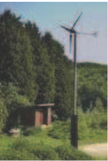

The installation of renewable energy sources are encouraged in principle on existing or new dwellings.

Renewable energy resources are abundantly available. The main sources are:

- The sun (solar energy)
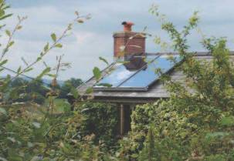

- The wind
- Water (hydropower, wave and tidal energy)
- Heat below the surface of the earth (geothermal energy)
- Biomass (wood, waste, energy crops).

Use of Local Craftsmen
It is also beneficial to sustainable development, and the economy of the locality, if use is made of local materials and local craftsmen. Through utilizing the skills of the craftsmen in the locality the distinctiveness of local workmanship and the elements of craft they bring will be valuable in the development of the project.

Design Guide for Single One-Off Houses within Cavan Rural Countryside 27

5.0 Design Statement

Every application for a one off dwelling in the Cavan countryside should be accompanied by a design statement. The design statement should demonstrate how the site was chosen and how the site layout and house design took into consideration the advice in these guidelines.
Including a design statement with your application will enable the Planning Authority to suitably assess your application for a house in the Cavan countryside.

Design Guide for Single One-Off Houses within Cavan Rural Countryside 28
5.0 Design Statement

The Design Statement shall include the following:

1. Site Location
Indicating site location in context of overall land holdings

2. Site Analysis
Provide site analysis in terms of location, aspect, views, slope, prevailing winds, sun path, shelter, screening, site entrance, existing buildings and features etc

3. Site layout
Indicating location of dwelling on the site
in terms of sun path, shelter, screening, views and aspect etc.

4. Concept Sketches
The starting point for the design process –
providing sketches of house type
5. Justification for locating and siting of dwelling

6. Sustainable design
- How sustainable design features will be incorporated into the dwelling using
- Renewable energy eg solar panels, wind turbines etc.
- Using natural materials such as slate and timber, lime and water based paints
- Reducing energy requirements for the dwelling
- Maximizing natural sun light, natural ventilation

- Landscaping plan shall include
  - details of any new boundaries front boundary treatment
- entrance elevation including gates and piers trees to be retained
- types of new trees to be planted

Design Guide for Single One-Off Houses within Cavan Rural Countryside 29

Appendices

Design Guide for Single One-Off Houses within Cavan Rural Countryside 30
Appendix I

Check list for Planning Application

1. Application form fully completed, signed and dated
2. Appropriate fee
3. Relevant page of approved newspaper in which notice was published
4. copy of site notice – signed and dated (date erected)
5. 6 copies of location map
6. 6 copies of plans, including site or layout plan and drawings of floor plans, elevations and sections
7. Rural housing application form
8. Site suitability assessment report
9. Design statement including landscaping plan

Please note this is not a definitive checklist – onus remains on applicant to ensure that applications are in full accordance with Planning & Development Regulations.

Design Guide for Single One-Off Houses within Cavan Rural Countryside 31
Appendix II

List of Native Species

Trees

English

Sessile Oak Pedunculate Oak Wych Elm
Ash
Silver Birch Downey Birch Alder
Common/Wild Cherry
Bird Cherry
Aspen
Goat Willow Grey Willow Bay Willow Eared Willow Holly
Rowan Whitebeam Crab apple Yew
Juniper
Scots Pine Strawberry Tree

Latin

Quercus petraea Quercus robur Ulmus glabra Fraxinus excelsior Betula pendula Betula pubescens Alnus glutinosa Prunus avium Prunus padus Populus tremula Salix caprea
Salix atrocinerea Salix pentandra Salix aurita
Ilex aquifolium Sorbus aucuparia Sorbus hibernica Malus sylvestris Taxus baccata Juniperus communis Pinus sylvestris Arbutus unedo
Irish

Erica luscitanica Dair ghaelach Dair ghalida Leamhán sléibhe Fuinseóg
Beith gheal
Beith chlúmhach
Fearnóg
Crann silín fiaín
Donnroisc
Crann creathach Saileach dubh Saileach portach Cuileann Caorthann Fionncholl
Crann fia-úll
Iúr
Aiteal eireann Giúis albanach Crann caitne Fraoch crann

Design Guide for Single One-Off Houses within Cavan Rural Countryside 32

Appendix II

Shrubs

English

Hazel Hawthorn Blackthorn or Sloe Guelder Rose Spindle
Alder Buckthorn Purging Buckthorn Elder
Broom
European Gorse Irish Gorse Creeping Willow Common Privet
Latin

Corylus avellana Crataegus monogyna Prunus spinosa Viburnum opulus Euonymus europaeus Frangula slnus Rhamnus catharticus Sambucus nigra Cytisus scoparius
Ulex europeaus
Ulex gallii
Salix repens
Ligistrum vulgare
Irish

Coll
Sceach gheal Draighean Caorchon Feoras
Ramhdhraighean fearnóg Rahmdhraighean cuiteann Tromán
Giolcach shléibhe Aiteann coiteann Aiteann eireann Saileach Beag Prímhéad

source: www.crann.ie
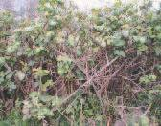

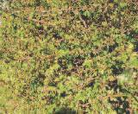
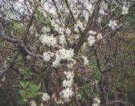

Hawthorn
Blackthorn Guilder Rose Bramble

Design Guide for Single One-Off Houses within Cavan Rural Countryside 33
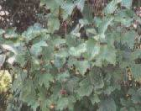

Appendix III

Acknowledgements & accreditation

These guidelines have been prepared as a project for the Leadership Development Programme with Cavan County Council. The Leadership Group members for this project were:
Brian Hora, Cavan Town Council
John Lovett, Fires Services, Ballyjamesduff
Gary Boyd, Water Services Section
Noeleen Shannon, Planning Section
Vincent Craig, Water Services Section
We would like to acknowledge and extend a sincere thanks to the following people who helped with this project:
- Jennifer Allen (B. Arch.) who worked very hard on the layout, design and sketches included in these guidelines.
- our Project Facilitator, Eve Harrison, Planning Section and our Project Sponsor, Ger Finn, Director of Services and all the planners in the Planning Section of Cavan County Council who contributed to this document.
- the architects who were involved in the workshop in the early stages of this project, which greatly informed and influenced the thinking behind these guidelines.
- the members of the Economic, Rural Development and Planning Strategic Policy Committee for their advice and input

Design Design Guide for Single One-Off Houses within Cavan Rural Countryside 34

