STRATEGIC ENVIRONMENTAL ASSESSMENT
INITIAL SCREENING
FOR THE PROPOSED
VARIATION TO
Cavan County Development Plan
2008-2014
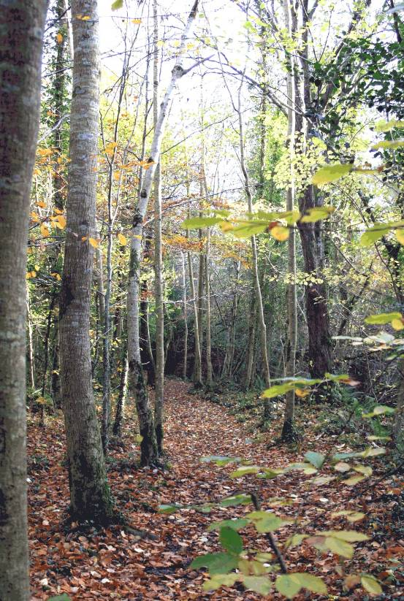

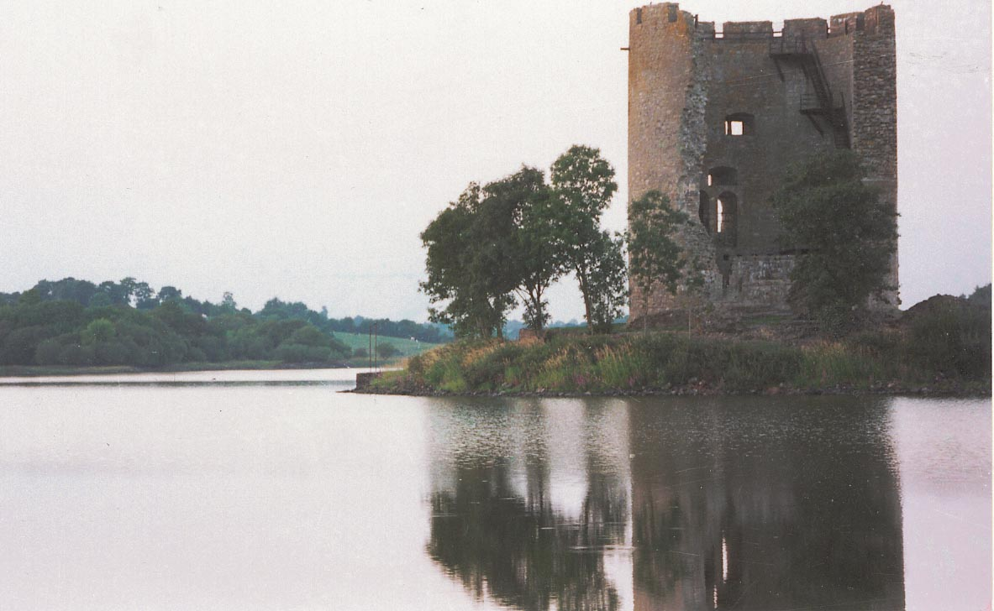
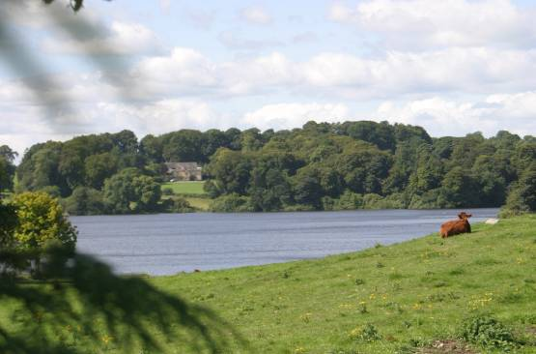
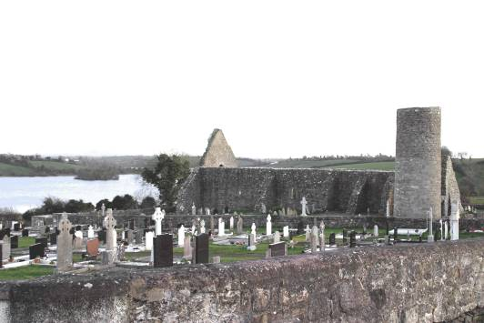

Table of Contents

- Introduction
  - Aim and Purpose of Report
  - Context of Variation
  - Reason for proposed Variation
  - Mandatory Requirement under SEA Directive

- Screening
  - Characteristics of the plan
    - Degree which Plan sets framework for other projects
    - Degree which plan influences other plans
    - Relevance of Plan
    - Environmental Problems relevant to the plan
    - Relevance of plan for implementation of EU legislation on the environment

  - Characteristics of the effects an of the area likely to be affected
    - Probability, duration, frequency and reversibility of effects
    - Cumulative Nature of effects
    - Transboundary nature of effects
    - Risks to Human Health or the environment
    - Magnitude and spatial extent of the effects
    - The value and vulnerability of the area
    - Effects on areas or landscapes which have recognised National, European Union or International Protection Status

- Initial Determination of Cavan County Council

- Statutory Consultation

- Determination for an Appropriate Assessment

- Decision of the Planning Authority
6.1 SEA – Legal Requirements
6.2 Response to Notification
6.3 Considerations
6.4 Final Determination of Cavan County Council

1.0 INTRODUCTION

  - Aim & Purpose Of The Report

The Planning and Development (Strategic Environmental Assessment) Regulations (S.I. 436 of 2004) came into force on 21st July, 2004 (and subsequently amended by SI No. 200 of 2011 and SI No. 201 of 2011 in May 2011) following the EU Directive on Strategic Environmental Assessment (SEA). Section 13K of the 2004 Regulations (as amended) set out when a Planning Authority is making a variation that it shall consider whether or not the proposed variation would be likely to have significant effects on the environment
Accordingly a planning authority shall, prior to giving notice under section 13 of the Planning and Development Act (2000-2010), prepare a report of the likely significant effects on the environment of implementing the variation. If it is determined that significant effects would be likely, then the variation will be subject to a full Strategic Environmental Assessment and an Environmental Report must be prepared.

The aim of this report is to consider whether a variation for the insertion of the Core Strategy and associated amendments to the Cavan County Development Plan 2008-2014 would require a Strategic Environmental Assessment (as set out in the SEA Guidelines and Annex II of the Directive). This report shall investigate the likely significance of environmental effects.

  - Context of Variation

The type of plan in question which requires a Variation is the existing Cavan County Development Plan 2008-2014. This plan sets out the overall strategy for the proper planning and sustainable development for its functional area with an intent to offer the public a well thought out, consistent and purposeful framework for a future successful County. The making of the County Development Plan has been informed by the Housing Strategy, Retail Strategy, Strategic Environmental Assessment and Appropriate Assessment Screening. The Plan came into effect in October 2008 and has a 6 year lifespan.

  - Purpose of the proposed Variation

The reason for the proposed variation is to incorporate a Core Strategy as set out in Section 10 (1b) of the Planning and Development (Amendment) Act 2010. It is now a requirement in the preparation of a development plan to prepare core strategy which shows that the development objectives in the development plan are consistent, as far as practicable, with the national and regional development objectives set out in the National Spatial Strategy and Regional Planning Guidelines. It is a requirement that a Core Strategy shall be prepared not later than a period of one year after the making of the Regional Planning Guidelines which in the case of the Cavan County Development Plan is not later than 1 year after the making of the Border Regional Guidelines which was on 29th September 2010.

The Core Strategy will
- Recognise Cavan Towns Hub status as indicted in the Border Regional Guidelines 2010-2022.
- Will set out population growth framework, housing targets and Housing Land Requirement for County Cavan
- Include a settlement strategy which outlines a settlement hierarchy

  - Mandatory Requirement under SEA Directive

The Strategic Environmental Assessment Regulations (as amended) require that ‘Screening’ be carried out in the case of ‘Variations to Development Plans’. The Screening Report can be used for appropriate consultation with the designated authorities. If it demonstrates that a SEA is necessary, the Screening Report will inform the Scoping and Environmental Report.

If the Planning Authority is uncertain as to the need for a SEA, the designated environmental authorities will be formally consulted during this exercise. The designated authorities are:

    - The Environmental Protection Agency (EPA)

    - Minister for the Environment, Community and Local Government;

    - Where it appears to the planning authority that the plan or programme, or modification to a plan or programme, might have significant effects on the fisheries or the marine environment, the Minister for Agriculture, Marine and Food and the Minister for Communications, Marine and Natural Resources.

    - Where it appears to the competent authority that the plan or programme, or amendment to a plan or programme, might have significant effects in relation to the architectural or archaeological heritage or to nature conservation, the Minister for Arts, Heritage and Gaeltacht.

    - Any adjoining planning authority whose area is contiguous to the area of a planning authority which prepared a draft plan, proposed variation, or local area plan.

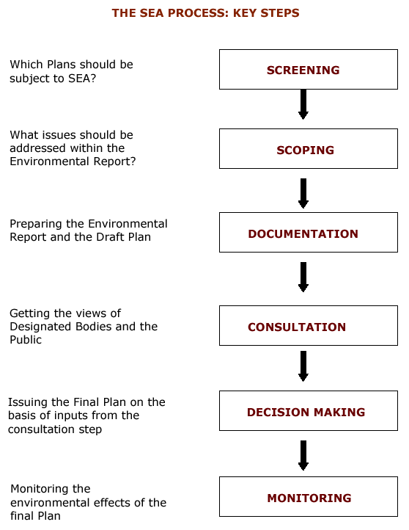
Should the Variation to County Development Plan be subject to SEA?

What issues should be addressed within the Environmental Report?
Preparing the Environmental Report and the Variation

Getting the views of Designated Bodies and the Public

Issuing the Final Variation on the basis of inputs
from the consultation step

Monitoring the environmental effects of the
Variation
MONITORING
DECISION MAKING
SCOPING
SCREENING
DOCUMENTATION
(ENVIRONMENTAL REPORT)
CONSULTATION
THE SEA PROCESS: KEY STEPS
In the case of a ‘Variation’ the Environmental Authority/ Authorities will have 3 weeks to make a response to the completed Screening Report.

Figure 1: Key Steps within the SEA Process

Figure 1

2.0 Screening
Schedule 2A of the Planning and Development (Strategic Environmental Assessment) sets out the criteria for determining whether a plan is likely to have significant effects on the environment. This proposed variation so is assessed against these criteria

2.1 The characteristics of the plan having regard, in particular, to

2.1.1 The degree to which the plan sets a framework for projects and other activities, either with regard to the location, nature, size and operating conditions or by allocating resources,
The existing county development plan sets out the blueprint for the proper planning and sustainable development of the county and indicates for each serviced town and village a land use planning map indicating types of suitable development for lands. This existing plan was subject to a full SEA and AA Screening process to examine the environmental impacts of the plan.
The introduction of Core Strategy’s will ensure closer alignment of the County Development Plan to the Settlement Strategy and Population as contained in the Regional Planning Guidelines 2012-2022. The existing Cavan County Development Plan 2008-2014 has a significant overprovision of zoned land within the County Development Plan.
The proposed variation will therefore set out Cavan County Development Plans settlement strategy in accordance and consistent with the Border Regional Guidelines 2010-2022. This settlement strategy will in turn set out balanced growth in the County and encourage future growth to occur in a sustainable and well planned manner. The population targets set in the Regional Planning Guidelines will be consistent with the population targets set out in the proposed draft variation and thus result in this closer alignment in terms of population growth. The Regional Planning Guidelines population targets are well below what is catered for in the existing County Development Plans landuse plans. These targets include a 50% overprovision and are considered over optimistic. The alignment of available zoned residential land to the populations targets set out will result in a net reduction of the residential zoned required.

Cavan County Development Plan 2008-2014 contains the 8 Local Area Plans of the larger towns in the County as well as all (18 no.) small town and village plans and thus it is necessary in this proposed Core Strategy, to vary each of these plans to ensure that they are consistent with the population target set out in the Regional Planning Guidelines.

2.1.2 The degree to which the plan influences other plans, including those in a hierarchy,

Figure 2: Levels of Plan Making
EU
POLICY DIR
EUROPEAN SPATIAL
DEVELOPMENT PERSPECTIVE

NATIONAL SPATIAL STRATEGY

OTHER NATIONAL STRATEGIES (e.g. NDP)

REGIONAL PLANNING GUIDELINES (BORDER REGIONAL AUTHORITY)

COUNTY DEVELOPMENT PLAN - TOWN DEVELOPMENT PLAN

LOCAL AREA PLAN - VILLAGE PLAN – VARIATION TO PLAN

As indicated in figure 2, the variation to the plan is at the lower level of the hierarchy of plans within the state. The varied plan will however influence local area plans and town and village plans and the locations and types of new development on zoned land and thus will influence the need for investment in infrastructure such as the location of roads, sewerage treatment plants, water supply and social services in the towns and villages. All of the town and village plans variation to comply with the Core Strategy is contained in this current Variation of the County Development Plan because of the fact that these plans are within the existing County Development Plan and were not stand alone Local Area Plans or town or village plans. The County Development Plan will undergo a full review in October 2012, in accordance with Section 11 of the Planning and Development Act.

2.1.3 The relevance of the plan for the integration of environmental considerations in particular with a view to promoting sustainable development,
The development plan (as varied) will act in the interests of promoting the proper planning and sustainable development of the county. A key element of the existing County Development Plan was the promotion of sustainable development. The county development plan has an SEA and AA screening completed during its preparation and the proposed variation aims to align the amount of zoned residential land in the county towns and villages so that it is in accordance with the population targets as set out in the Border Regional Guidelines. This essentially will reduce the area of residential land that is immediately available for development from 1,197 ha to 91 ha. Existing environmentally sensitive lands currently zoned has also been rezoned to Amenity/Recreation due to flooding incidents since adoption of plan and topography of site. Existing areas of amenity/recreation located within and outside of development boundaries remain unchanged and all environmental standards previously set out in the County Development Plan remain. This ensures that the environmental considerations of all developments are carefully considered.

2.1.4 Environmental problems relevant to the plan,
The proposed variation will alter the zoning of existing residual land to a number of options. E.g.
- Residential Strategic Reserve
- Mixed Use Strategic Reserve
- Urban Agriculture e.g. acknowledgment of exixitng agricultural premises within towns and villages
- Recreation and Amenity e.g. where there has been incidents of flooding since adoption of the development plan.
This means that there will be a reduction in the lands available for development for residential purposes for the remaining duration of the plan period i.e. to October 2014. This reduction of available zoned land will ensure that residential development that is approved planning permission following adoption of the Core Strategy will be selected site that are sustainable in terms of proximity, services, access and suitable for residential development.

Areas that require environmental protection have been identified in the current County Development Plan and these are
- Protected Structures
- Archaeological Heritage
- Special Protection Areas
- Natural Hertiage Areas
- Heritage Gardens, Demenses and Parks
- Hedgerows, stone walls, woodlands and trees and wetlands
- Areas of High Landscape Value or Special Landscape Interest
- County Heritage Sites
- Scenic Views and Viewing Points
- Scenic Routes
- Forest Parks
- Major Lakes and Lake Environs
- Lakeside Amenity Areas
- Riverside Amenity Areas
- Walking Routes

It is considered that the Appropriate Assessment Screening that has been carried out alongside this SEA screening process will ensure the protection of Special Areas of Conservation and Special Protection Areas. All of the policies and objectives contained within the existing County Development Plan (Section 8.11 and 8.11.4, page133 and 137) will ensure the safekeep and protection of these environmental qualities in the county through this variation process.

Flooding
Data collected since the previous development plan adoption regarding flooding incidents in the county have been considered and will be dealt with using the re-zoning mechanism primarily from residential to recreational/amenity. All flooding incidents reports have been plotted on the GIS system. Most incidents during the 2009 floods were in rural locations. Adherence to the Planning System and Flood Risk Management Guidelines, November 2009 will continue to be applied to all planning applications. In assessment of planning applications throughout the county, on lands outside of zoned lands, applications will be based on three pillars of avoidance, reduction and mitigation of flood risk. In the absence of a comprehensive Floodrisk assessment for the County, floodrisk areas have been identified for the county based on the historical incidents of flooding in the County – Flooding Points, the details of which are available on the OPW website: www.floodmaps.ie and on the County Council website: www.cavancoco.ie The Map of Flooding post – 2009 table has also been created and all of these are available in Appendix 28-3 of the County Core Strategy document. The process of data collection in this county is not complete and this information is the most up to date at the present time.

Wastewater Treatment
Up to date data has been collected with regard to the existing capacity of wastewater treatment systems and due regard will be had to urban areas that are at capacity or overcapacity and no further development shall be permitted until such times as upgrading of the facilities is carried out. This element will be a consideration in the allocation of developable residential land and planning permissions are not permitted if a Wastewater Treatment System is at capacity. Core Strategy Policy 3 (Policy CSP3) ensures that infrastructure capacity is key in the assessment of new developments.

Policy CSP 3: Ensure that all new developments shall only be permitted where there is adequate and appropriate infrastructure capacity available.

2.1.5 The relevance of the plan for the implementation of European Union legislation on the environment (e.g. plans linked to waste-management or water protection).

Monitoring measures in terms of water protection are currently in place. Issues relating to European Union Legislation on the environment are considered to be enhanced because of the proposed variation. The 4 River Basin Management Plans approved since the adoption of the County Development Plan have been considered in the proposed Variation. The existing County Development Plan has been subject to a full SEA and as such the plan proposed to be varied has considered European Union legislation on the environment.
The available residential land for development within the lifetime of the plan has been reduced and thus the infrastructural requirements for new developments will be less.

2.2 Characteristics of the effects and of the area likely to be affected, having regard, in particular, to
The proposed variation will result in a reduction of area zoned for residential purposes. Zoned residential land can have an impact on an area e.g. Increase in human population
- Expansion of the built up area
- Protection of the wildlife e.g. protection along rivers and streams of the towns and villages
- Protection of built heritage and archaeology
- Protection of existing natural assets such as mature trees, hedgerows, forestry and river banks
- Protection of rural landscape

These effects however will be carefully assessed in the Development Management Role of planning applications and existing polices and objectives in the County Development Plan will have to be adhered to.

    - the probability, duration, frequency and reversibility of the effects,
The development of land is not a reversible change. Development on zoned residential land is sustainable when properly located close to services like schools, parks, shops, libraries etc. This results in the creation of communities who live and work on an area and have an excellent quality of life. The preparation of the County Development Plan was subject to an SEA. The proposed variation by its nature will have a positive effect on the environment. The Core Strategy through its implementation will ensure that the population targets set for the County will be closely aligned with the land available for residential purposes in the county. This will result in a reduction of residential zoned land available for development, in this development plan period. The Core Strategy addresses the significant overprovision of zoned residential lands in the existing plan. The Core Strategy proposes to regulate the development of residential lands so that they are developed on a sequential basis in line with proposed infrastructure improvements. This will result in the proper planning and sustainable use of land in town and village cores.

2.2.2 The cumulative nature of the effects,
It is considered that the cumulative nature of effects on the environment from the proposed variation will have positive impact on the county as it will ensure town and village core concentration of development and ensure that development occurs sequentially from the town and village cores of the county. The sequential development from town and village cores will ensure that these town and villages grow in accordance with proper planning and sustainable development. The cumulative nature of effects will be positive as it will ensure planned growth in each town and village of the county.

2.2.3 The transboundary nature of the effects,
It is considered that there will be no transboundary effects of the proposed variation.

2.2.4 The risks to human health or the environment (e.g. due to accidents),
There are no SEVESCO sites in or near the county and as such the risk accidents to the environment or human health is low. Having regard to the nature of the proposed variation which will seek to ensure that the development of the towns and villages occurs in a planned and controlled manner, it is envisages that the variation will reduce the risk to human health or the environment due to accidents.

2.2.5 The magnitude and spatial extent of the effects (geographical area and size of the population likely to be affected),
The proposed variation affects the entire county of Cavan with the exception of Cavan Town and Environs. County Cavan occupies 1,931km2 with a population of 64,003 persons as per the 2006 census and 72,874 persons as per the initial results of the 2011 Census figure. The Border Regional Guidelines has projected a population in County Cavan of 77,378 by 2016. The County Development Plan 2008-2014 projected a population in County Cavan in 2016 of 76,500 persons. The insertion of the core strategy document which aligns the County Development Plan 2008-2014 with the Border Regional Guidelines and outlines clearly this alignment will have an effect on the development of housing in the county. As such, this will affect all the towns and villages of the county and the rural housing development policy of the county. The population of the county will be positively effected by the proposed variation as it will ensure the consolidation of the towns and villages of the county and promote sustainable development.

2.2.6 The value and vulnerability of the area likely to be affected due to:

- special natural characteristics or cultural heritage,

It is considered that the County Development Plan 2008-2014 has a positive impact on special natural characteristic of the county and cultural heritage. These have been identified in the county and protected by means of buffer and/or policies and objectives which ensures their protection. There will be no alteration to the existing polices and objectives containing in the County Development Plan that seeks to ensure the protection of the natural, built and cultural heritage of the county. It is considered that the existing polices and objectives in the County Development Plan are adequate to ensure the protection of the natural and cultural heritage of the County.

- exceeded environmental quality standards or limit values,
It is considered that the proposed variation to the County Development Plan will not exceed environmental quality standards or limit values as same seeks to consolidate towns and villages and will reduce the area of zoned residential land from the area proposed in the existing plan which has already been subject to a full SEA and AA screening. The capacities of all wastewater treatment plants in the towns and villages have been assessed and taken into consideration in the allocation of zoned residential lands for the towns and villages. The capacities in the towns and villages is located in Appendix 3 (Infrastructure Capacity) of the Core Strategy Document

- intensive land-use,
It is considered that the proposed variation will not result in a more intensive landuse than that already proposed in the existing County Development Plan 2008-2014. The process of zoning lands and identifying them suitable in principle for various uses does result in a more intensive use of land, however individual planning applications must consider polices, objectives and guidelines in relation to the form and nature of proposed development, thus ensuring that same are sustainable and in the interests of proper planning. For example
  - Sustainable Urban Housing: Design Standards for Apartments –Guidelines for Planning Authorities 2007
  - Sustainable Residential Development in Urban Areas 2008
  - Urban Design Manual –A Best Practice Guide 2008

The County Development Plan will continue to encourage proper planning and sustainable development. The proposed variation will create a distinction between the urban form and the rural landscape around the towns and villages.

2.2.7 The effects on areas or landscapes which have a recognised national, European Union or international protection status.
The proposed variation will have no effects on recognised National, European Union or International protection status. The Cavan County Development Plan 2008-2014 has already ensured that environmentally sensitive areas are afforded protection to areas so that they are protected and enhanced. The proposed draft variation, due to alignment with the Regional Planning Guidelines for Border Region will reduce the amount of land that is immediately available for residential purposes in the plan period.

- Initial Determination of Cavan County Council

On the basis of the above assessment and consideration of the criteria as set out in Schedule 2A of the Regulations, it is the opinion of the Planning Authority that the proposed Cavan County Development Plan Core Strategy (Variation Number 2) will not have any likely significant effects on the environment and therefore does not require a full SEA. The Planning Authority is satisfied that the Cavan County Development Plan 2008-2014 was carried out in accordance with the principles of sustainable development and the commitment to the enhancement and protection of the natural and built environment of the county. The Core Strategy does not propose to introduce any policies or objectives that would have a negative impact on the environment nor does it propose to include additional zonings in the plan area.

- Statutory Consultation

The specified environmental authorities which are requires to be consulted in accordance with Article 13A (4) of the Planning and Development (Strategic Environmental Assessment) Regulations are as follows
a) The Environmental Protection Agency (EPA)

b) Minister for the Environment, Community and Local Government;

c)Where it appears to the planning authority that the plan or programme, or modification to a plan or programme, might have significant effects on the fisheries or the marine environment, the Minister for Agriculture, Marine and Food and the Minister for Communications, Marine and Natural Resources.

d) Where it appears to the competent authority that the plan or programme, or amendment to a plan or programme, might have significant effects in relation to the architectural or archaeological heritage or to nature conservation, the Minister for Arts, Heritage and Gaeltacht.

e) Any adjoining planning authority whose area is contiguous to the area of a planning authority which prepared a draft plan, proposed variation, or local area plan.

- Determination for an Appropriate Assessment

The DoEHLG Circular Letter SEA 1/08 and NPWS 1/08 relates to the requirement to screen Land Use Plans for any potential impacts on areas designated as Natura 2000 sites (Special Areas of Conservation and Special Protection Areas). Where appropriate an assessment of the plan must be carried out.

There are 6 no. Natura 2000 sites located in County Cavan and as such a separate and complete Appropriate Assessment Screening Report has been prepared with regard to the conservation objectives of these sites against the proposed draft Variation to the Cavan County Development Plan.

DECISION OF THE PLANNING AUTHORITY - REGARDING THE NEED FOR STRATEGIC ENVIRONMENTAL ASSESSMENT OF THE PREPARATION OF THE FORTHCOMING VARIATION TO CAVAN COUNTY DEVELOPMENT PLAN 2008-2014.

- SEA – Legal Requirements
It was necessary to determine whether or not an environmental assessment of the proposed variation to the Cavan County Development Plan 2008-2014 needed to be carried out. Therefore, the principles of the proposed variation underwent a screening process to establish whether the Plan was likely to have significant effects on the environment. In doing so, the Planning Authority took account of relevant criteria set out in Schedule 2A of the Planning and Development (Strategic Environmental Assessment) Regulations 2004.

2. Response to Notification
There was no response from the Minister for the Environment, Community and Local Government;

A submission has been received from the EPA. This has noted the SEA determination made by Cavan County Council. The submission has recommended the strengthening of suggested areas in the Core Strategy document namely:
- Section 3.2 Issues, Problems and Challenges
- Section 3.3 Resources
- Flood Risk Management Guidelines shall be fully integrated.

A submission was received from Department of Communications, Energy and Natural Resources stating they have no comments/observations to make at this time.

3. Considerations
The above points will be taken on board in the Core Strategy document.

4. Final Determination of Cavan County Council
On the basis of the above assessment and consideration of the criteria as set out in Schedule 2A of the Regulations, it is opinion of the planning authority that the proposed variation will have an overall positive environmental impact on the environment and will not be likely to have any significant adverse effects. Accordingly it does not require an SEA.

August 2011

«Company»
«Address1»
«Address2»
«Address3»
«Address4»

Re/ Planning and Development (Strategic Environmental Assessment) Regulations S.I. No. 436 of 2004
Strategic Environmental Assessment (Screening Report)
Proposed Variation to Cavan County Development Plan 2008-2014

A Chara,

Notice is hereby given, in accordance with Section 13K of the Planning & Development (Strategic Environmental Assessment) Regulations 2004 that Cavan County Council intends to prepare Variation to the Cavan County Development Plan 2008-2014 and a SEA Screening Report has been undertaken in order to assess whether or not implementation of the variation would be likely to have significant effects on the environment.

Submissions or observations in relation to the proposed draft variation may be made in writing to the Marice Galligan, A/Senior Planner, Planning Department, Cavan County Council, Farnham Centre, Farnham Street, Cavan, within the period Week 18th July to 12th August 2011 (both dates inclusive, but excluding public holidays).

I enclose copy of the SEA Screening Report in accordance with Section 13K of Planning & Development (SEA) Regulations 2004.

Mise Le Meas

___________________
Marice Galligan,
A/Senior Planner.

