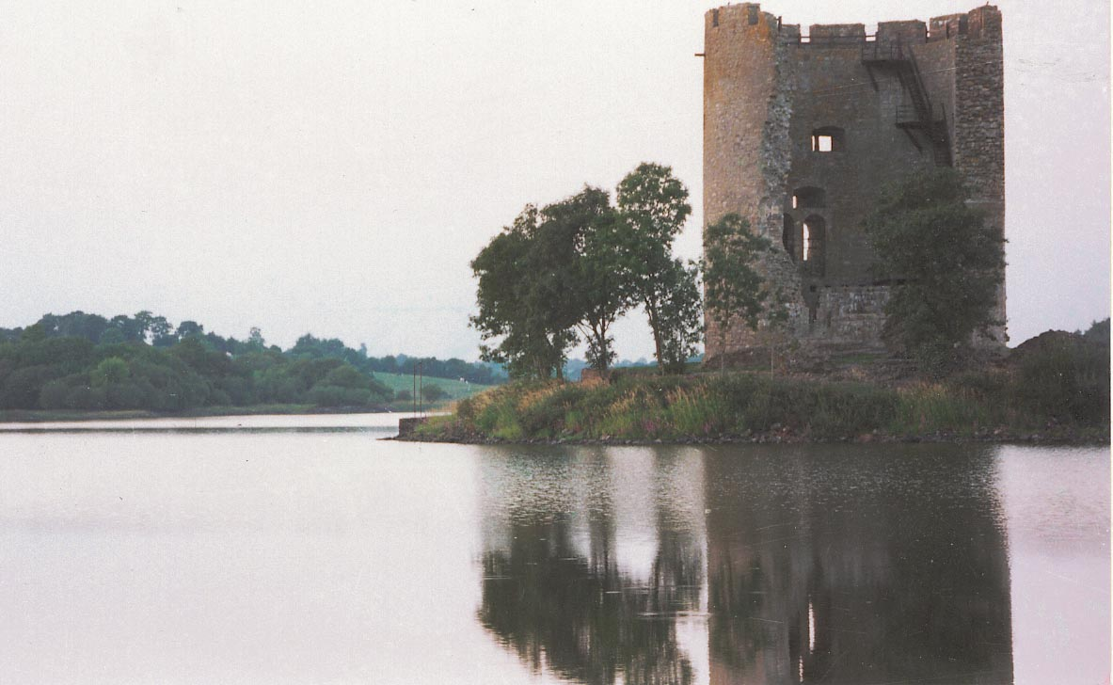


APPROPRIATE ASSESSMENT
INITIAL SCREENING
FOR THE PROPOSED
VARIATION TO
Cavan County Development Plan
2008-2014
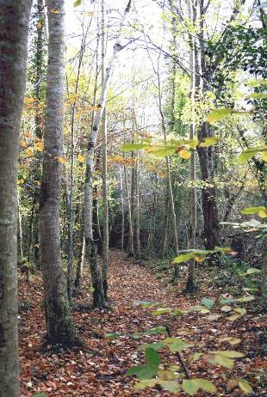

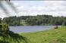
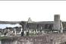

Table of Contents

1. Introduction……………………………………………………………................................1
2. Consultation…………………………………………………………………........................4
3. Brief Description of the Plan………………………………………………………………...5
4. Methodology…………………………………………………………..................................7
5. Natura 2000 Sites……………………………………………………………………………8
6. Policies and Objectives in Relation to Natura 2000 sites………………………………13
7. Screening Checklist/ Assessment Criteria………………………………......................15
8. Conclusion and Recommendations………………………………………………………19
Appendix 1……………………………………………...……………………………………...20

List of Figures
- The Stages of the Appropriate Assessment Procedure………………………….…3

List of Tables
- List of Natural Heritage Areas & Proposed Natural Heritage Areas, County Cavan…………………………………………………………………………………...11

List of Maps
- Special Areas of Conservation, County Cavan……………………………...………9
- Special Protection Areas, County Cavan………………………...……………...…10
- Natural Heritage Areas and proposed Natural Heritage Areas, County Cavan..................................................................................................................12

1. Introduction

This document concerns the Appropriate Assessment Screening Report on the proposed Variation –Variation Number 2 of the Cavan County Development Plan 2008-2014. The proposed variation is required to be made in accordance with the Planning and Development Act 2000 (as amended), which required each local authority to prepare a Core Strategy (Section 10) for insertion into the County Development Plan.

Article 6 (3) concerns the management of sites that make up the Natura 2000 network. The Natura 2000 sites are designed to form an ecologically coherent network of designated sites across the whole of Europe. These sites consist of Special Areas of Conservation (SACs) and Special Protection Areas (SPAs).

Article 6 (3) of the ‘Habitats’ Directive 92/43/EEC states that;

Any plan or project not directly connected with or necessary to the management of the site but likely to have a significant effect thereon, either individually or in combination with other plans or projects, shall be subject to appropriate assessment of its implications for the site in view of the sites conservation objectives…

The screening stage of the appropriate assessment will determine whether the Variation of the Cavan County Development Plan 2008-2014 is likely to have a significant effect, alone, or in combination with others, on a European site. Where there is doubt about the significant effects, the “precautionary principle” applies and further research will be undertaken. If significant effects are found, the plan must be subjected to the next stage of the appropriate assessment.

The screening is based on any ecological information available to the authority, giving a description of the plan and its likely environmental impacts.
The proposed Variation to the Cavan County Development Plan 2008-2014 has been evaluated to see if it needs to be subject to an appropriate assessment. This will be done in accordance with the methodological guidance on the provision of Article 6 (3) and (4) of the Habitats Directive 92/43/EEC.

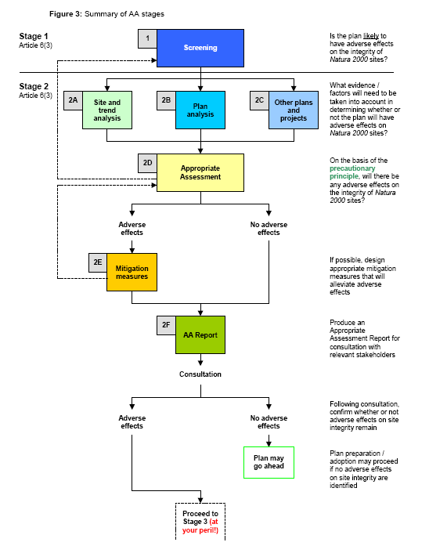
Figure 1: The Stages of the Appropriate Assessment Procedure
Source: Scott Wilson, Levett-Therivel Sustainability Consultants, Treweek Environmental Consultants and Land Use Consultants

In the preparation of the screening for an Appropriate Assessment for the proposed Variation to the Cavan County Development Plan 2008-2014, reference will be made to the following documents;

- Cavan County Development Plan 2008-2014
- Variation Number 2 of the Cavan County Development Plan 2008-2014
- Appropriate Assessment Initial Screening for the Draft Cavan County Development Plan.
- SEA Screening Repot for proposed Variation Number 2 of the Cavan County Development Plan 2008-2014.

2. Consultation
All prescribed bodies as well as National Parks and Wildlife Service will be forwarded the proposed Variation with the AA Screening. The AA Screening will be available for public inspection during the public consultation period for the proposed Variation.

3. Brief Description of the proposed Variation

The proposed Variation to the Cavan County Development Plan 2008-2014 is prepared in accordance with the Planning and Development Act (as amended) 2000 and will incorporate a Core Strategy. The purpose of a Core Strategy will be to demonstrate that the development objectives of the development plan are consistent, as far as practical, with the national and regional development objectives set out in the National Spatial Strategy and Regional Planning Guidelines. The Core Strategy will
- Recognise Cavan Towns Hub status as indicted in the Border Regional Planning Guidelines 2010-2022.
- Will set out population growth framework, housing targets and Housing Land Requirement for County Cavan
- Include a settlement strategy which outlines a settlement hierarchy

As well as this the Variation has considered
- Flooding incidents since the adoption of the County Development Plan 2008-2014
- Water Framework Directive and adoption of the 4 River Basin Management Plans in the County
- Any new planned road routes prepared since the adoption of the County Development Plan.

4. Methodology

The following methodology was adopted to undertake the screening process of the proposed Variation to the Cavan County Development Plan 2008-2014.

- Identification of Natura 2000 sites.
International sites within or in close proximity (15 km) to County Cavan were identified

- Compilation of Site Information.
Information was obtained on the European sites identified including any details or activities which may affect the conservation status of the designated site.

- Development Plan Policy Review.
A review was undertaken of the proposed Variation to the Development Plan and its likely impacts upon the European Sites identified.

- In combination effects.
Other plans and programmes were considered that might, in combination with the proposed Variation of the Cavan County Development Plan 2008-2014, have the potential to adversely impact on the European sites identified.

- Assessment of likely significant effects
The likely effects of the Variation of the Cavan County Development Plan 2008-2014 on the European sites identified were considered.

5. Natura 2000 Sites
Special Areas of Conservation (SACs)

Special Areas of Conservation are designated under the EU Habitats Directive (92/43/EEC Conservation of Natural Habitats and of Wild Fauna and Flora), this designation aims to protect habitats or species of European importance and form part of the Natura 2000 site network.

The purpose of the Habitats Directive is to promote and ensure biodiversity through the conservation of natural habitats and wild flora and fauna. It consists of two parts dealing with habitat protection and species protection. Each Member State must designate Special Areas of Conservation (SACs) as part of the Natura 2000 site network. This enables the natural habitat and species habitat to be maintained and restored if necessary to a favourable conservation status. Animals and plant species that are in need of strict protection are listed. The Directive was transposed into Irish Law through the E.U Natural Habitats Regulations, 1997. Candidate Special Areas of Conservation are fully protected under the EU Habitats Directive. Candidate sites refer to sites that are currently under consideration by the European Commission. In County Cavan there are six candidate Special Areas of Conservation (cSAC) which are listed below.

cSAC 000006 - Killyconny Bog (Cloghbally)
cSAC 000007 - Lough Oughter & Associated Loughs
cSAC 000584 - Cuilcagh - Anierin Uplands
cSAC 000979 - Corratirrim
cSAC 002032 - Boleybrack Mountain
cSAC 002299 - River Boyne & River Blackwater

This information is unchanged since the adoption of the County Development Plan.

Map 1: Special Areas of Conservation, County Cavan
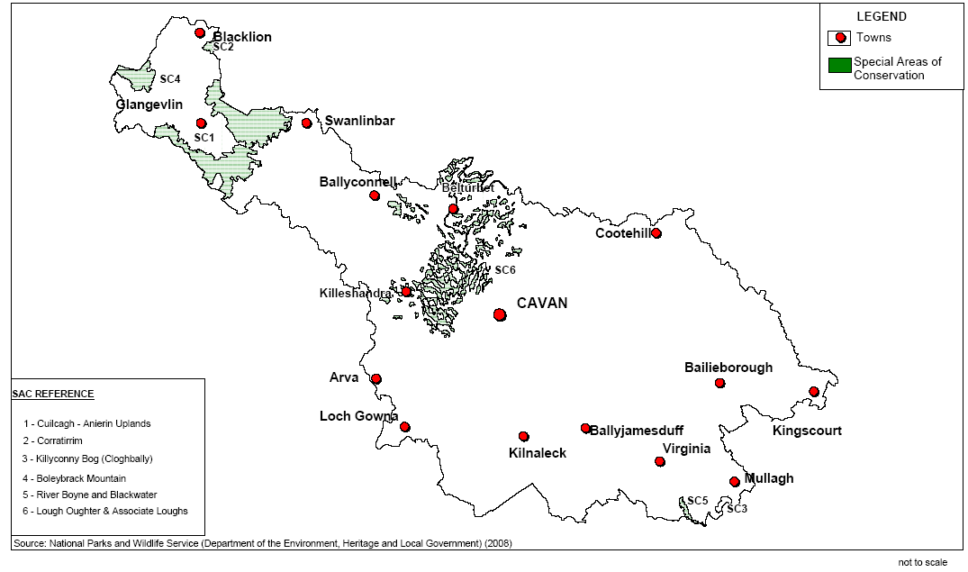

Special Protection Areas (SPAs)

Special Protection Areas are designated under the EU Birds Directive (79/409/ EEC). This designation aims to protect areas of importance for wild birds and relate to their breeding, feeding, roosting and wintering areas. These areas are designated for rare and vulnerable species, regularly migratory species, such as ducks, geese and waders and wetlands particularly those of international importance which attract large numbers of migratory birds each year.

In County Cavan there are three Special Protection Areas (SPAs) which are listed below.

SPA 004049 – Lough Oughter
SPA 004061 – Lough Kinale/ Derragh Lough
SPA 004065 – Lough Sheelin

Map 2: Special Protection Areas, County Cavan
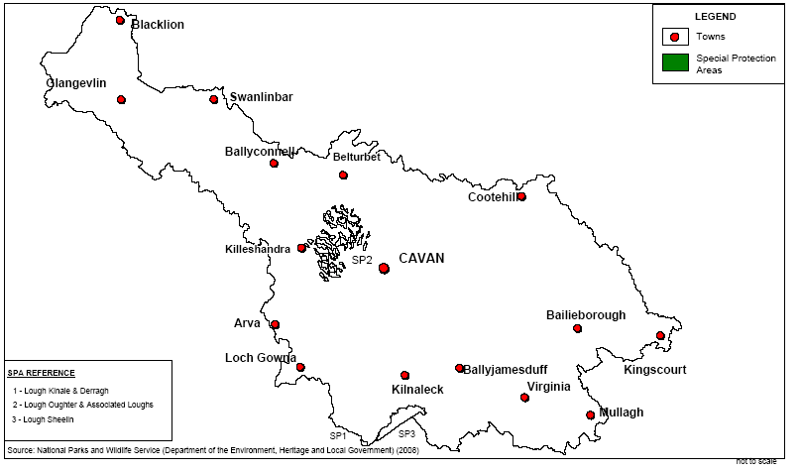

6. Policies and Objectives in Relation to Natura 2000 Sites in the Plan

This section sets out the policies and objectives of the Cavan County Development Plan 2008-2014 in relation to Natura 2000 sites

Extract from Cavan County Development Plan
Policies:
Section 8.11 Designated Sites (page 133 of Cavan County Development Plan 2008-2014)
- Development in National or EU designated sites or proposed designated sites of conservation will not be permitted unless:
-They comply with development management policies;
-The objectives of designation and the overall integrity of the area will not be compromised; or
-Any significant adverse effects on the qualities for which the area has been designated are clearly outweighed by social or economics benefits of national importance, subject to provisions of the European Community’s (Natural Habitats) Regulations, 1997, Wild Bird Regulations, 1985 and Wildlife Act as amended.

Section 8.11.4 Development in or near Heritage Areas (page 137 of Cavan County Development Plan 2008-2014)
- Ensure there are no adverse impact on the features for which the site has been designated;
- Require an ecological assessment, undertaken by a suitability qualified person, of the implications of the proposed development in or adjacent to a designated site; the assessment should also provide mitigation measures specified;
- Conserve and protect Special Protection Areas through the regulation of all development. Development that may threaten the integrity and value of designated sites will not be allowed. Development that is close to a designated Special Protection Area will be assessed rigorously and where it is deemed that it negatively impacts on the site such development may require an Environmental Impact Assessment;
- Regulate all development through rigorous assessment designated Special Areas of Conservation. The Planning Authority recognises that these sites are of utmost importance and therefore extends its site policy beyond the site boundaries in order to protect their locational context. Development that may detract from the intrinsic value of the site will not be allowed;
- Resist development which the Planning Authority considers to have a negative impact on the environment. The Planning Authority shall assess development close to an NHA rigorously and may deem this development unacceptable if it detracts from the intrinsic character of environmental quality of the area.

Objectives:

- Protect proposed and designated Natural Heritage Areas.
- Protect proposed and designated Special Protection Areas.
- Protect proposed and designated Special Areas of Conservation.
- Protect geological NHAs as they become designated and notified to Cavan County Council during the lifetime of the Development Plan.
- Have regard to Conservation Management Plans for designated areas for nature conservation when prepared by National Parks and Wildlife Service.

The above policies and objectives remain unchanged in the County Development Plan and thus the proposed Variation will not reduce the current protection in Natura 2000 sites.

7. Screening Checklist/ Assessment Criteria

Describe the individual elements of the project (either alone or in combination, with other plans or projects), likely to give rise to impacts on the Natura 2000 sites

The Cavan County Development Plan 2008-2014 recognises the unique character of the landscape and the rich biodiversity of County Cavan. The plan provides that the landscape and biodiversity within the area will be explored, managed and developed in a sustainable manner for residents and future generations through Development Plan objectives and policies and the development management function of the Planning Authority. Cavan County Council will ensure the conservation, protection and enhancement of Cavan’s unique and diverse natural heritage, biodiversity and landscape where possible. The County Development Plan 2008-2014 recognises the value of locally important sites that are our local habitats for nature and the biodiversity of the wider countryside. County Cavan contains some of the most important natural resources in terms of the natural environment and landscape as well as highly important elements of natural heritage.

Many protected species and habitats are found in County Cavan and some, such as blanket bog and raised bog are priority habitats because of their importance and rarity. The Plan covers the administrative area of County Cavan, excluding the Cavan Town area, which is an area of approximately 189,060 hectares (467,167 acres).

A Strategic Environmental Assessment Report on the County Development Plan 2008-2014 has been prepared in accordance with the requirements of the Planning and Development (Strategic Environmental Assessment) Regulations 2004 (S.I No. 436 of 2004). An AA Screening Report was also prepared as part of the preparation of the County Development Plan 2008-2014. A SEA Screening report in relation to the proposed Variation to the Cavan County Development Plan 2008-2014 has also been prepared. This report is a key mechanism in promoting sustainable development, raising awareness of significant environmental issues and in ensuring that such issues are properly addressed within the capacity of the planning system. The County Development Plan aims to achieve sustainable development in the County that can be absorbed into the landscape without causing adverse harm to the environment.
The County Development Plan 2008-2014 identifies Natura 2000 designated sites (SPAs and SACs), Ramsar sites, and Natural Heritage Areas and will ensure there are no adverse impacts on the features for which the sites have been designated. The Cavan County Development Plan 2008-2014 states that any development proposals which are likely to have a significant effect on a Special Protection Area, Special Area of Conservation, Natural Heritage Area or other areas designated under statute for the conservation of features of natural or geological interest, or other designated areas, will be authorized only to extent that the Planning Authority is satisfied it will not adversely affect the integrity of the area. Such proposals must be subject to an assessment of its implications for the area. All aspects of the proposal, which could, themselves or in combination with other proposals, affect the area’s conservation objectives will be assessed rigorously.

The proposed Variation to the County Development by way of the insertion of the Core Strategy aims to achieve closer alignment of national and regional policies with development plans. Population targets have been set out in the Regional Planning Guidelines for the Border Region and these population targets must be reflected in the area of land that is zoned Residential throughout the county. The existing (2008-2014) total area of zoned residential land in the county will not be required for the plan period and taking into consideration the existing un-commenced permissions and the vacant units in the county, there will be no additional land zoned for residential purposes in this variation. This will reduce significantly the amount of land that is available for the plan period for housing purposes.

The proposed Core Strategy also includes policies on the following
- Employment
- Shopping
- Transport
- Minerals
- Waste
- Biodiversity
- Renewable Energy

The proposed variation also includes the updated preferred route corridors which are
- N55 –Re –Alignment at Dundavan
- N-55 -Corduff Stage 3
- N-3 Belturbet By-Pass
- N-87 Minor realignment works

It is considered that the proposed Variation will have an overall positive economic, social and environmental effect and will have no significant impact on Natura 2000 sites

Describe any likely direct, indirect or secondary impacts of the project (either alone or in combination with other plans or projects) on Natura 2000 sites by virtue of:

-Size and scale
-Land take
The size and scale of the project will be less than that of the existing county development plan 2008-2014. The insertion of Core Strategy into the County Development Plan will ensure alignment of the population target figures with the land required for this population target. From findings and research into the Core Strategy for County Cavan, the Core Strategy will result in a reduced area of land available for residential purposes for the plan period and thus it is envisaged, that there are not likely to be any direct, indirect or secondary impacts of the proposed variation on Natura sites due to the nature, size and scale of the variation.

-Distance to Natura 2000 site or key features of the site
Some of the towns and villages have Natura 2000 sites within the development boundaries, however the AA screening for the County Development Plan has ensured that these lands are not zoned for any development purposes. This screening has included lands adjoining the development envelope or in close proximity. Throughout all the towns and villages in the county, any Natura 2000 sites in development boundary’s have been designated as ‘Designated Area (NHA, SAC, SPA)’. There will be no additional zoning of lands in the proposed variation and thus there will be no change in distance from Natura 2000 sites from the approved County Development Plan.

-Resource requirements (water abstraction, etc…)
There will no greater need for water and water abstraction as a result of the proposed variation as the land available for residential purposes will be reduced from that adopted in the county development plan. The lands not required for residential purposes will be de-zoned, re-zoned or placed in Strategic Reserve. Each of the towns and villages has been assessed in terms of capacity of water supply and effluent disposal and this is considered in the allocation of development lands or residential zoned lands.

-Emissions (disposal to land, water or air)
Wastewater Treatment Plants
The proposed draft Variation will result in a reduction of the area of available zoned residential lands and as such immediate pressures on wastewater systems will be reduced from the area of lands that were zoned in the county development plan. The capacity of sewerage treatment plants has been taken into consideration for each of the towns and villages. Proposed policy CSP4 indicates that proposed new developments shall make efficient use of existing and proposed infrastructure. This ensures that no developments shall be permitted unless there is capacity in the Wastewater Treatment System and thus this ensures the protection of receiving waters.

Surface Water Disposal
In accordance with the Water Policy Regulations and the recent Surface Waters and Groundwaters Objectives Regulations, River Basin Management Plans have been created & adopted for the four River Basin Districts located within the functional area of Co. Cavan. The process included the characterisation of water bodies (rivers, lakes & groundwaters) into water quality classifications i.e. bad, poor, moderate, good & high ecological status. The implementation of these plans and the associated programme of measures is a catchment wide approach allowing all activities with potential to impact both on waters & the associated habitats to be managed in an integrated manner. The implementation of these plans will lead to at least “good ecological status” for all our waters, which will provide and allow everyone long-term sustainable access to and use of our waters, to the benefit of the whole community. In addition to bringing about improvements to water quality where it is less than good, the plan provides for maintaining the status of good & high ecological status waters as is required by the Water Framework Directive & associated Regulations.

No project giving rise to significant adverse direct, indirect or secondary impacts on the integrity of any Natura 2000 sites having regard to their conservation objectives, arising from their emissions (disposal to land, water or air) are likely or have been identified

-Transport Requirements
Smarter travel
There is no local public transport system in County Cavan. There is no rail service however there is inter-county public bus service in the County. As such the proposed Variation seeks to further create sustainable towns and villages by consolidated Town and Village areas. No projects giving rise to significant adverse direct, indirect or secondary impacts on the integrity of any Natura 2000 sites having regard to their conservation objectives, arising from their excavation requirements are likely or have been identified

-Duration of construction, operation, decommissioning, etc…
The County Development Plan 2008-2014 expires in October 2014. Work will commence in October 2012 on the review of the County Development Plan.

Describe any likely changes to the sites arising as a result of
- Reduction of habitat area
- Disturbance to key species
- Habitat or species fragmentation
- Reduction in species density
- Changes in key indicators of conservation value (Water Quality)
- Climate Change
No objectives or policies contained within the draft Core Strategy shall give rise to reduction in habitat areas for Natura 2000 sites nor shall any changes be permitted on the basis of this strategy (either individually or in combination with other plans)

Describe any likely impacts on the Natura 2000 sites as a whole in terms of:
-Interference with the key relationships that define the structure of the site
-Interference with key relationships that define the function of the site

No significant impacts on Natura 2000 sites, arising from the implementation of the Core Strategy are likely or have been identified that would interfere with the key relationships that define the structure of the site and that define the function of the site.

Provide indicators of significance as a result of the identification of effects set out above in terms of:
-Loss
-Fragmentation
-Disruption
-Disturbance
-Change to key elements of the site (e.g. water quality)
The Cavan County Development Plan 2008-2014 has been subject to an AA screening on its policies, objectives and impacts of same on Natura 2000 sites. It is considered that the polices and objectives contained in the proposed draft Variation will not result in any loss, fragmentation, disturbance, disruption and change in elements of any Natura 2000 site. This is as a result of the polices and objectives that are contained in the plan to protect, enhance and preserve Natura 2000 sites and the boundaries that form same.

Describe from the above those elements of the plan, or combination of elements, where the above impacts are likely to be significant or where the scale or magnitude of impacts is not known
No significant impacts on Natura 2000 sites are likely or have been identified as part of this initial screening exercise.

Finding of no significant effects report matrix

• Name of project or plan
Draft Variation of Cavan County Development Plan 2008-2014 by insertion of Core Strategy

• Name and Location of Natura 2000 sites
The proposed draft Variation of the Cavan County Development Plan does not relate to any specific Natura 2000 site. The Core Strategy affects the population targets set out in the County Development Plan and each town and villages plan has been varied to comply with the new population targets set out in the RPGs for the Border Region. The Natura 2000 sites in the county are listed in Section 5 and Map 1 and 2. Details of the Natura 2000 sites are also detailed in Appendix 1 of this document.

• Description of the project or plan
Is this project or plan directly connected with or necessary to the management of the sites (provide details)?
The proposed variation of the Cavan County Development Plan is not directly connected with or necessary to the management of the Natura 2000 sites. The variation proposes to insert a Core Strategy document into the County Development Plan 2008-2014. The aim of this document is to ensure the alignment of the policies and objectives of the Regional Planning Guidelines with the County Development Plan. It will result in the planned and sustainable result of the towns and villages of the county. Each of the towns and villages residential lands has been carefully examined and only residential lands with necessary infrastructure will be available for development in this plan period. The area of available Residential Land in each town and village will be significantly less. The protection afforded to the county’s natural and built heritage remains as per the county development plan.

Are there other projects or plans that together with the project or plan being assessed could affect the sites (provide details)?
The proposed variation will form, when adopted, part of the Cavan County Development Plan 2008-2014. The County Development Plan sets the blueprint for the proper planning and sustainable development of the county over a 6 year period and provides for objectives and policies for the protection of Natural 2000 sites. The Core Strategy has been formulated to provide phasing and compliance with the population targets set out in the Regional Planning Guidelines. The County Development Plan adheres to European, national and regional plans and informs local plans in terms of environment protection. All Local Area Plans and Town and Village Plans are contained in the County Development Plan’s and so this Variation will include all alterations to all towns and villages in the county.

The assessment of significance of effects:
• Describe how the project of plan (alone or in combination) is likely to affect the
Natura 2000 sites
The proposed variation has been formulated to ensure that uses, developments and effects arising from the Plan (either individually or in combination with other plans or projects) shall not give rise to significant adverse impacts on the integrity of any Natura 2000 site. This is done through policies and objectives to protect these sites.

• Explain why these effects are not considered significant.
The policies and objectives of the Cavan County Development Plan 2008-2014 have been devised to ensure the protection of the Natura 2000 sites in the County. These policies and objectives state that new developments shall not affect the integrity of areas protected and designated as Natura 2000 sites. The draft Variation does not include additional zoning of Residential Land and there are no lands within Natura 2000 sites zoned for any purpose.

• List of agencies consulted.
Strategic Environmental Assessment screening reports were sent to the agencies below
• Department for Communications, Energy and Natural Resources
• Environmental Protection Agency
• Department of Environment, Community and Local Government
• National Parks and Wildlife Service

Appropriate Assessment Screening report consultation is now sent to:
• Department for Communications, Energy and Natural Resources
• Environmental Protection Agency
• Department of Environment, Community and Local Government
• National Parks and Wildlife.

Response to consultation.
N/A

Data collected to carry out the assessment
National and local data sources:
• Cavan County Council GIS data bases
• Up to date GIS data and site synopsis from National Parks and Wildlife Service,
Who carried out this assessment?
Forward Planning Section of Cavan County Council

Sources of data
National Parks and Wildlife
Cavan County Development Plan 2008-2014

Level of assessment completed
Desktop study

Where the full results of the assessment can be accessed and viewed?
This screening report is to be displayed along with the proposed Variation of the Cavan County Development Plan 2008-2014.

Conclusions
Following the review of the draft Variation in accordance with the ‘Methodological guidance on the provision of Article 6(3) and (4) of the Habitats Directive 92/43’. This screening process has been carried out to ascertain if the Core Strategy is likely to have significant effects on any Natura 2000 sites in situ and ex situ. If this were the case then it would be necessary to carry out Appropriate Assessment. The Cavan County Development Plan 2008-2014 was formulated to ensure that developments and effects arising from permissions based upon that plan (either individually or in combination with other plans or projects) should not give rise to significant adverse impacts on the integrity of any Natura 2000 sites. The result of this AA Screening is a Finding of No Significant Effects on the Natura 2000 network, both in situ and ex situ.

8. Conclusion and Recommendation

As stated already, the function of undertaking an Appropriate Assessment of a development plan is to ensure that there are policy safeguards to ensure that no development proposal is considered which may have an adverse effect on the features of interest for which the site is designated.

This Screening Report for the Appropriate Assessment of the proposed Variation to the County Development Plan 2009-2015, has been carried out in accordance with the Methodological guidance on the provision of Article 6(3) and (4) of the Habitats Directive 92/43/EEC as published by the European Commission.

The Screening Report finds that it can be objectively concluded that there are not likely to be significant effects on the network of Natura 2000 sites as a result of the draft Variation to the County Development Plan.
The Draft Variation to the County Development Plan has been formulated to ensure that uses, development and effects arising from permissions based upon this Variation (either individually or in combination with other plans or projects) shall not give rise to significant adverse impacts on the integrity of any Natura 2000 site.
Therefore, in accordance with the Methodological guidance on the provision of Article 6(3) and (4) of the Habitats Directive 92/43/EEC, it is concluded that the draft Variation to the County Development Plan does not require any further assessment to demonstrate compliance with the Directive.

Further Screening and a full assessment will be carried out (if required) during the next full review of the County Development Plan, in accordance with Section 11 of the Act and this procedure is due to commence in October 2012.

Appendix 1

County Cavan: Special Areas of Conservation (SACs)

County Cavan |  | Special Areas of Conservation (SACs)
Site code Site name | Qualifying interests [code] [habitat] [code] [scientific species name] [common name] | Conservation objectives | Threats to site integrity
000006 Killyconny Bog | 7110 Active Raised Bog  7120 Degraded raised bogs still capable of natural regeneration | To maintain the annex I habitats for which the cSAC has been selected at favourable conservation | Changes in local hydrology, peat extraction, overgrazing, forestry, burning, direct loss of habitat to development, arterial drainage/ water abstraction/ lowering of the regional water table, agricultural reclamation.  Introduction of alien invasive species  Illegal Dumping
000007 Lough Oughter & Associated Loughs | 3150 Natural euthrophic lakes with magnopotamion or Hydrocharition-type vegetation  91D0 Bog woodland 1355 Lutra lutra European Otter | To maintain the Annex I habitats for which the cSAC has been selected at favourable conservation status.  To maintain the Annex II species for which the cSAC has been selected at favourable conservation | Water quality/ pollution, changes in flow rates, arterial drainage/ abstraction/ lowering of the regional water table, siltation, loss of fringe habitat, changes in seasonal water levels, loading from effluents (WWTP), recreation/ amenity use, developments, lack of/ inappropriate woodland management.  Increased pollution/reduction in water quality  Felling/Removal of Trees
000584 Cuilcagh-Anierin Uplands* (Also in County Leitrim) | 7130 Blanket bog (*active only) 3130 Oligotrophic to mesotropic standing waters with vegetation of the Littorelletea uniflorae and/or of the lsoëto-Nanojuncetea 3160 Natural dystrophic lakes and ponds 4010 Northern Atlantic wet heaths with Erica tetralix 6230 Species-rich Nardus grasslands, on siliceous substrates in mountain areas  8220 Siliceous rocky slopes with chasemophytic vegetation  4030 European dry heaths | To maintain the Annex I habitats for which the cSAC has been selected at favourable conservation status. | Changes in local hydrology, peat extraction, overgrazing, forestry, burning, direct loss of habitat to development, arterial drainage/ water abstraction/ lowering of the regional water table, agricultural reclamation.  Introduction of alien invasive species  Illegal Dumping  Increased pollution/reduction in water quality
000979 Corratirrim | 8240 Limestone pavements | To maintain the Annex I habitat for which the cSAC has been selected at favourable conservation status. | Agricultural improvements/ reclamation, agricultural abandonment, overgrazing/ undergrazing, direct loss of habitat to development, quarrying on limestone pavements, bracken & scrub encroachment.  Introduction of alien invasive species  Illegal Dumping

Site code Site name | Qualifying interests [code] [habitat] [code] [scientific species name] [common name] | Conservation objectives | Threats to site integrity
002032 Boleybrack Mountain* (Also in County Leitrim) | 7130 Blanket bog (*active only) 4010 Northern Atlantic wet heaths with Erica tetralix 3160 Natural dystrophic lakes and ponds 4030 European dry heaths 6410 Molinia meadows on calcareous, peaty or clavey-silt-laden soils (Molinion caeruleae) | To maintain the Annex I habitat for which the cSAC has been selected at favourable conservation status | Changes in local hydrology, peat extraction, overgrazing, forestry, burning, direct loss of habitat to development, arterial drainage/ water abstraction/ lowering of the regional water table, agricultural reclamation.  Introduction of alien invasive species  Illegal Dumping  Increased pollution/reduction in water quality
002299 River Boyne & River Blackwater | 7230 Alkaline fens 91e0 Alluvial forests with Alnus glutinose and Fraxinus excelsior  1106 Salmo salar Atlantic Salmon 1099 Lampetra fluviatilis River Lamprey 1355 Lutra lutra European Otter | To maintain the Annex I habitats for which the cSAC has been selected at favourable conservation status.  To maintain the Annex II species for which the cSAC has been selected at favourable conservation | Water quality/ pollution (including groundwater), direct loss of habitat to development, invasive species, lack of woodland management.  Introduction of alien invasive species  Illegal Dumping
002299 River Boyne & River Blackwater | 7230 Alkaline fens 91e0 Alluvial forests with Alnus glutinose and Fraxinus excelsior  1106 Salmo salar Atlantic Salmon 1099 Lampetra fluviatilis River Lamprey 1355 Lutra lutra European Otter | To maintain the Annex I habitats for which the cSAC has been selected at favourable conservation status.  To maintain the Annex II species for which the cSAC has been selected at favourable conservation | Water quality/ pollution (including groundwater), direct loss of habitat to development, invasive species, lack of woodland management.  Introduction of alien invasive species  Illegal Dumping

Table 4.6 County Cavan: Special Protection Areas (SPAs)

County Cavan |  | Special Protection Areas (SPAs)
Site code Site name | Qualifying interests [code] [scientific species name] [common name] | Conservation objectives | Threats to site integrity
004049 Lough Oughter | Cygnus cygnus Whooper Swan Podiceps cristatus Great Crested Grebe Anas penelope Wigeon  Bucephala clangula Goldeneye Wetlands & Waterbirds | To maintain the special conservation interests for this SPA at favourable conservation status: Whooper Swan, Wetlands & Waterbirds. Great Crested Grebe, Wigeon, Goldeneye and Wetlands & Waterbirds. | Direct & indirect impacts to the habitats of the bird species of conservation interests (loss of habitat), direct loss of habitat to development, water quality/ pollution, disturbance including recreation/ amenity use.  Introduction of alien invasive species  Illegal Dumping  Disturbance from Recreational/amenity use  Inappropriate land management
004061 Lough Kinale/ Derragh Lough | Aythya ferina Pochard  Aythya fuligula Tufted Duck  Wetlands & Waterbirds | To maintain the special conservation interests for this SPA at favourable conservation status: Pochard, Tufted Duck and Wetlands & Waterbirds. | Direct & indirect impacts to the habitats of the bird species of conservation interests (loss of habitat), direct loss of habitat to development, water quality/ pollution, disturbance including recreation/ amenity use.  Introduction of alien invasive species  Illegal Dumping  Disturbance from Recreational/amenity use  Inappropriate land management
004065 Lough Sheelin | Aythya ferina Pochard Bucephala clangula Goldeneye Podiceps cristatus Great Crested Grebe Aythya fuligula Tufted Duck  Wetlands & Waterbirds | To maintain the speical conservation interests for this SPA at favourable conservation status: Pochard, Goldeneye, Great Crested Grebe, Tufted Duck and Wetlands & Waterbirds. | Direct & indirect impacts to the habitats of the bird species of conservation interests (loss of habitat), direct loss of habitat to development, water quality/ pollution, disturbance including recreation/ amenity use.  Introduction of alien invasive species  Illegal Dumping  Disturbance from Recreational/amenity use  Inappropriate land management

